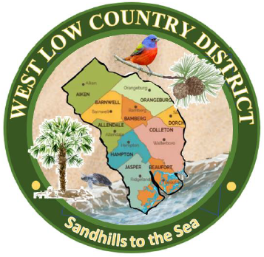

West Low Country District Handbook

2023-2025
“Preserving Historic Gardens While Creating New Ones”

History of the West Low Country District Logo

The logo was approved and accepted by GCSC President – David Stoudenmire, Jr., July 2023.

Graphicly designed and given as a gift to the District Director of West Low Country by Christy Sloan of Cereus Gardeners and Garden Makers Garden Clubs.

The idea of a logo for West Low Country was presented by Kathy New to the members of the West Low Country District in April 2023. She and Christy Sloan designed an initial logo and sent it out to be critiqued by the West Low Country members. It was suggested that the members be allowed to send in their ideas to create the logo, so Kathy sent out requests for logo submissions from members. Thirteen logos were submitted as possibilities by garden club members, and all 13 were sent to an art design team in Columbia labeled only with numbers. Four were chosen as possibilities, and the top three logos were then sent out to the presidents of the garden clubs/councils labeled only as A, B, and C. Twenty-five garden clubs/councils responded with a winning vote for the logo labeled C. The final tally of votes was received and counted in June 2023.

The artist design depicts a green outer circle with the name West Low Country District across the top. The lower portion has the phrase, “Sandhills to the Sea,” which was created by Kathy New and Christy Sloan to describe the physical expanse of the district from Aiken County to the coastal counties of Jasper and Beaufort. A map of the counties that make up the West Low Country District overlays a sand and sea background which flows left to right, and north to south, mimicking the transition from the Sandhills of South Carolina to the Coastal region of the state. A painted bunting rests on a longleaf pine branch, both of which are known to thrive throughout both the Sandhills region and the lowcountry. The state tree, the palmetto, represents the Coastal region, as does the sea turtle, crawling up the beach out of the sea.

TABLE OF CONTENTS

West Low Country District Director’s Message……………………………..……4

West Low Country District Director and Co-Director Bio’s…………….….……5

The Garden Club of S C, Inc. Mission, Objectives, Pledge to GC Flag….….…...6-7

Leaders and Themes – 2023 – 2025………………………………..………..……...8-11

West Low Country District Clubs and Councils…………………..……….…….12-13

Calendar of Events – 2023 – 2025…………………………………..…….……….14

Past WLC District Directors List………………………………………….………15

West Low Country District Awards……………………….…………….………..16-19

The Garden Club of South Carolina Awards……………….…………..………..20-35

The Garden Club of South Carolina Scholarships……………..………..……….37-42

High School Essay Contest……….……………………………….…….………….43-47

GCSC Smokey Bear & Woodsy Owl Poster Contest………………….…………48-53

GCSC Garden Poetry Contest………………………………………….………….54-57

GCSC Youth Sculpture Contest………………………………………….………...58-59

Camp Wildwood Info ……………………………………………………………....60

NGC Publication Release Form…………………………………………………....61-62

Membership ………………………………………………….………………..……63-65

GCSC Dues/Club & Council Presidents’ Reports.………………………………..66-71

SC Gardener……………………….………………………………………..……….72

IRS Information/501(c)3 Status………………………………………….…………73

Garden Club Schools…………………………………………………………..……74-75

GCSC & WLC Personnel Forms……………………………………….…………..76-79

GCSC Club/Council Leadership Guide…………………………………..……..…80-95

Please enroll as a member at the Garden Club of South Carolina, Inc. website: www.gardenclubofsc.org, Go to the members’ area and sign in. There are directions if you have never signed it. It is a secure website for members. You will have to scroll down to the bottom of the page to insert your username, which will be your email address.

WEST LOW COUNTRY DISTRICT DIRECTOR’S MESSAGE
“Preserving Historic Gardens While Creating New Ones”

It is an honor to serve as your Garden Club of South Carolina West Low Country District Director for 2023 – 2025. Your trust in my abilities to lead this district is greatly appreciated. Over the past two years, I have met many of you and I am inspired and grateful for all the effort, work, and talent that is given by the clubs to their community and surrounding communities. However, we can continue to build on what has been done and continue the successes. With that in mind, the following are the objectives that both myself and the Assistant Director, Christy Sloan, have set for the West Low Country District:

- Improve the submission of yearbooks by reviewing the evaluation form as to how points are used to determine the score.

- Increase garden club/council participation in submitting applications for state awards. It is important for the clubs to be recognized for the work they are doing in their communities. This will be a major topic at our District’s summer workshop on July 23, 2024.

- Develop a better understanding of the difference between District awards and State awards and the procedures involved in their awarding.

- Create a plan to garner support for submission of state scholarship applications from the West Low Country District as well as submission of essays for the State Essay contest.

- Continue to focus on communicating with the clubs by email, text, phone, as well as visiting each of the clubs for one of their meetings. It is so important for the club members to put a face with both the District Director and Assistant Director.

- Increase the awareness of the Club and Council Presidents about the wealth of information contained on the GCSC website and their ability to access and navigate the website. This will be a topic for the Summer Workshop.

- Encourage the District Clubs and Councils to embrace the GCSC President’s theme “Legacy Gardening” Past – Present - Future as well as the District’s theme of “Preserving Historic Gardens While Creating New Ones”.

- Ensure that club and council Presidents know that we are readily accessible to help them with projects, programs, information, and any other undertakings to make their terms successful.

- Try to increase the membership of the garden clubs. As an agenda item at the Summer Workshop, ideas will be shared on how membership can be increased.

- As a District Director, it is important to include the Assistant Director in all decisions and activities so they are being groomed to accept the responsibilities and role of District Director.

WEST LOW COUNTRY DISTRICT DIRECTOR - KATHY NEW
I grew up in a small mill town, with beautiful clapboard white houses that dated back to 1880-1930. Our home was at the end of the dirt street, lined with old oak trees. No one had grass in the front yard, because the grass was plucked. The yard was swept and raked with perfect lines. I can remember hydrangeas around all the homes. In the summer, the whole street would be lined with huge oaks and blue hydrangeas blooming. That was the front yard. The back and side yards would have vegetable gardens. You have to realize that most of the parents grew up during the Great Depression and World War II, when the whole yards were planted in “Victory” gardens to provide food for the families and neighbors. This is what I remember as a child, and this memory planted the seeds for loving natural, cottage gardens, and how to “Grow South Carolina.”

I am excited to be Director of WLC. I have been involved in a garden club for the past 22 years, thanks to an invitation by a sweet friend. I have served as Co-director of WLC, the president of Aiken Council of Garden Clubs, chairman of committees of the West Low Country, and in many positions with my local club (Garden Makers Garden Club). My favorite involvement has been working with membership. I love meeting people, helping to increase club memberships, and creating potential clubs. This next year, as Director, my goal is to continue to help your club in any way I can to keep your club strong and active.

The WLC goals are: to bring the 41 scattered clubs closer with communication. I am encouraging clubs to get back to normal--enjoying meeting as groups to share and support each other, increase membership, grow new Federated clubs, educate our community and youth--and don’t forget those “Victory” gardens.

I will continue to meet with garden club members of WLC District. I want you to contact me by phone, email or invite me to your meetings. The last goal is to keep you informed about your District, GCSC, on up to National level, by restarting an informative newsletter with participation from each club. Last but not least, I want each club to participate in the Award programs. Our club projects are outstanding, and you deserve the recognition from the West Low Country District to the National Garden Club level.

The Theme for WLC is to “Preserving Historic Gardens While Planting New Ones.”
Thank you for being on the WLC Team.

Happy gardening,
Kathy

WEST LOW COUNTRY ASSISTANT DIRECTOR - CHRISTY SLOAN
I learned at an early age that I loved flowers and working in the garden. My Nanny Green loved to garden, and I loved helping her in her yard. Her passion was azaleas, but she had beautiful hydrangeas, irises, crepe myrtles, and dogwoods. She planted beautiful flowerbeds, but also had a habit of plunking a flower or bush anywhere she had an empty space. Born in 1914, she would spend hours outside unaffected by the heat, and she was known to pull off the side of the road and dig up a plant if she thought it was pretty. She planted vegetable gardens every spring and spent days canning and freezing her harvests. Jams, beans, collard kraut, and corn lined the shelves of her basement, and I dreamed of learning those skills so I could be like her.

I grew up in Graniteville, South Carolina, attended USC-Aiken, and earned a BS in Elementary Education. In 1995 I married my high school sweetheart and moved to North Augusta. I taught middle school for 16 years and raised four wonderful daughters, now ages 16-24. In 2016, my late husband Greg and I built the home of our dreams on twelve acres. I am currently planting flowers and trees and trying to grow my own vegetables. If I can get vegetables to grow, I will fulfill my dream of lining my pantry shelves with my own canned goods. My next adventure is building a coup and raising my own chickens.

At the invitation of Kathy New, I joined Garden Makers Garden Club in 2020. I now serve as the Secretary for Garden Makers. In 2022, I agreed to serve as President of Cereus Gardeners to build back the club after 2020 caused the club to almost disband. We now have 12 members and two new community projects. I represent Cereus Gardeners and serve as Publication Chairman on the Aiken Council of Garden Clubs. I am active in my church and lead the Prayer Shawl Ladies Group in crocheting shawls and lapghans for sick and homebound church members. I am learning so much with Kathy New’s help, and I look forward to serving the next two years as Assistant Director of West Low Country District.

Christy Sloan
Assistant Director
West Low Country District

THE GARDEN CLUB OF SOUTH CAROLINA, INC.

MISSION: The Garden Club of South Carolina, Inc., a non-profit organization, is a force for good that promotes all aspects of gardening, focusing on preservation and restoration of historic garden, conservation and environmental protection of natural resources, education of members and youth organizations, civic beautification, horticulture, and floral design.

PLEDGE OF ALLEGIANCE TO THE FLAG OF THE GARDEN CLUB OF SOUTH CAROLINA:

I Pledge allegiance to the Flag of the Garden Club of South Carolina for the love of gardening for which it stands, for the promotion and protection of our environmental concerns, and for achievement in beautification and conservation in all phases of Garden Club service.
Written by Emily Floyd Stephens, President 1999-2001.

QUICK FACTS:

- We have 4,550 members.

- We have 173 clubs.

- We have 17 Governing Councils.

- We are a member of the National Garden Clubs, Inc. and the South Atlantic Region.

- We were first organized on April 22, 1930 and Federated with the National Garden Clubs, Inc. April 22, 1934.

- We are proud to have these Affiliate Members:
• Anne Springs Close Greenway
• Brookgreen Gardens
• Butterfly MonarchyClub
• Craig Farm Historic Preservation Foundation
• Moore Farms Botanical Garden
• Riverbanks Zoo and Botanical Garden
• South Carolina Botanical Garden at Clemson
• South Carolina Native Plant Society
• South Carolina Wildlife Federation
• Piedmont Physic Garden
• South Carolina Bluebird Society

OBJECTIVES:

- To encourage civic planting and beautification and the establishment and maintenance of roadside parks
- To promote the protection and conservation of our natural resources
- To maintain the Memorial Garden and establish roadside memorials on designated Blue Star Highways honoring our war dead and living veterans
- To further horticultural education, conservation, and landscape design through scholarships
- To advance the arts of gardening, landscape design, flower arranging, and horticulture through schools, symposiums and non-commercial flower shows
- To coordinate the interest and activities of this organization and to cooperate with other organizations in the furtherance of the aforementioned objectives in such activities as may be determined by the Board of Directors
- To give awards for achievement in beautification, conservation, and horticulture
- To encourage the love of all phases of garden club work among youth

SEVEN DISTRICTS:

- West Piedmont
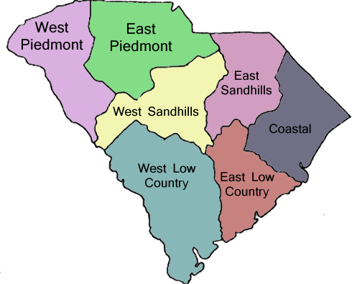
- East Piedmont
- West Sandhills
- East Sandhills
- Coastal
- West Low Country
- East Low Country

LEADERS AND THEMES


NATIONAL GARDEN CLUB:
2023-2025 President, Brenda Moore
“Go Green – Plant America!”
Bmoore@gardenclub.org


SOUTH ATLANTIC REGIONAL GARDEN CLUB
2023-2025 Regional Director, Carcille Burchette
“Go Green – Plant Native”
Carcillecburchette@hotmail.com
Cell 606-344-6164


THE GARDEN CLUB OF SOUTH CAROLINA, INC.
2023 – 2025 President, David E. Stoudenmire
“Legacy Gardening” (Past – Present – Future)
dstoudenmire@sccoast.net
cell 843-333-9642

THE GARDEN CLUB OF SOUTH CAROLINA, INC.
WEST LOW COUNTRY DISTRICT
2023 – 2025 District Director, Kathy New
“Preserving Historic Gardens While Planting New Ones”
222 Patricia Drive, North Augusta, SC 29841
knknew@comcast.net 803-215-5633 (cell)

2023 – 2025 Assistant Director, Christy Sloan
23 Emerald Drive, North Augusta, SC 29841
g.sloan21@comcast.net 803-215-6463 (cell)

THE GARDEN CLUB OF SOUTH CAROLINA, INC. EXECUTIVE BOARD 2023-2025

David E. Stoudenmire – President
Betty Jackson – First Vice President/Finance Chairmen
Jan Burch – Second Vice President/ Events Chairman
Sandie Duerksen – Third Vice President/Awards Chairman
Lynn Pode – Recording Secretary
Meg Lee – Corresponding Secretary
Marian Soule – Treasurer
Becky Crow – Parliamentarian
Dorothy Richardson – Historian
Graceann Phillips – Coastal District Director
Peg Benton – East Low Country District Director
Linda Hutchinson – East Piedmont District Director
Michelene Sheehy – East Sandhills District Director
Kathy New – West Low Country District Director
Dot Closs – West Piedmont District Director
Becky Fairey – West Sandhill District Director

Other Chairmen:
Margaret Graham – Webmaster, Five Star Honor Clubs, and Star Chapter Member
843-222-2548 jpgmcg69@gmail.com

Tara Ranson – Membership 803-487-3236 tdranson@yahoo.com

THE GARDEN CLUB OF SOUTH CAROLINA, INC.
PRESIDENT, David E. Stoudenmire 2023-2025 OBJECTIVES
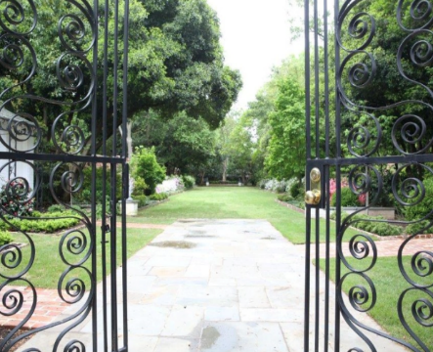
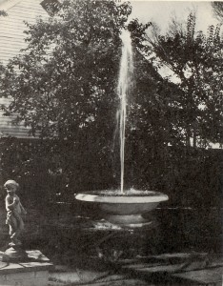

The Memorial Garden
1919 Lincoln St, Columbia, South Carolina

Legacy Gardening” Past - Present – Future

Past:

Sarah Bolyston deeded part of her property to the Garden Club of SC in 1944, which became the

only piece of property owned by GCSC and opened to the public in 1946.

The Memorial Garden is the first living tribute created to honor WWII service members.

Nationally known landscape architect, Loutrel Briggs’ design for this garden created an “outdoor cathedral” effect. It was later designated a National Historic Site.

Several major renovations have taken place over the years to enhance and be better stewards in conserving our natural resources and the environment.

Present:

Weekly maintenance and upkeep of the garden grounds.

Replacement of diseased and/or dead shrubs and trees.

Repairs completed on structures and a regular maintenance schedule established.

Future:

Conduct and implement a long-range plan that will guide the Memorial Garden into the next decade.

Design, raise funds, and build a handicap accessible ramp into the Memorial Garden.

Continue to adhere to, as closely as possible, the original design of Loutrel Briggs in replacing or adding to the landscaping and permanent structures in the garden.
MEMORIAL GARDEN - "LEGACY GARDENING" PRESIDENT'S PROJECT 2023-2025
The Memorial Garden, located at 1919 Lincoln Street in Columbia, South Carolina, was the first garden in the United States established to honor veterans of World War II. Located adjacent to the Governor's Mansion, it is made available for tours and private rental as well as GCSC special celebrations on Veteran's Day, Memorial Day and other important dates. Upkeep of this beautiful garden requires approximately $15,000 per year and all donations are restricted to this purpose. Donations of any amount to the Legacy Program for renovations and upkeep should be earmarked “Legacy Program”.
WOULD YOU LIKE TO REMEMBER A LOVED ONE WITH A SPECIAL HONORARIUM TO THE MEMORIAL GARDEN? WE HAVE TWO WAYS TO ASSIST YOU.
A $100.00 donation may be made in honor of a loved one here. Your loved one will receive special recognition from our Memorial Garden Trustees Committee and you will receive a tax deductible donation receipt.
You may also honor a veteran with an engraved brick with their name and service information. The brick will become a permanent part of our honor walk at the garden. To purchase a memorial brick for a donation of $500.00, Click here.
Donations may be made via credit card below or by mailing a check to:
Garden Club of South Carolina, Inc
71 Gervais St, Suite 150-142
Columbia, SC 29201
Earmark your check with: Memorial Garden honorarium
Chairman Peggy Little

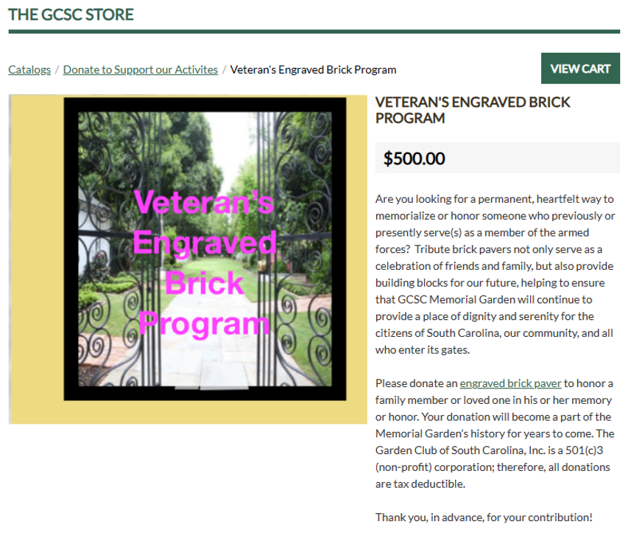





The Garden Club of South Carolina, Inc.
2024 – 2025 Calendar
 | 2024
July 23 | West Low Country Presidents’ Meeting
August 15 | Gardener Fall Edition Deadline
September 1 | Yearbooks Due to GCSC President and DDs
September 1 | Begin Sending State Award Applications
September 5 | Board of Directors Meeting, Columbia Council Bldg.
September 23-26 | Flower Show School III, Columbia
October 17-22 | Flower Show, Sumter
October 26-November 5 | Flower Show, Charleston
November 4 | Memorial Garden Veteran’s Event, Columbia
November 15 | Gardener Winter Edition Deadline
November 15 | High School Essays Due to Jacqueline Weinzierl
December 6 | Arbor Day
December 10 | All GCSC Award Applications Due
 | 2025
Ongoing throughout year | Ames Grant Deadline - NGC
Ongoing throughout year | Native Plants and Wildflower Grand Deadline - NGC
Ongoing throughout year | Natural Disasters Grant Deadline - NGC
Ongoing throughout year | Youth Grant Deadline - NGC
January 10 | District Youth Award Winners to Cathy Griffin
January 15 | Roster and Dues Letter Sent to Clubs
January 16 | Board of Directors Meeting, Columbia Council Bldg.
February 1 | President’s Reports Due to GCSC President & DDs
February 1 | Scholarship Applications Deadline, Electronically to Sandra Barker
February 15 | Gardener Spring Edition Deadline
March 1 | Final Date to Send in Dues/Rosters
March 1 | Juried Art Digital Entries Due to Sherri Bardsley
March 1 | District President Report Winners to GCSC President & 3rd VP/Awards Chairman
March 1 | 2025-2027 Slate of Officers Sent to All Members
March 24-27 | FSS School IV, John’s Island Art Center, Charleston
March 28 | West Low Country District Meeting, Dataw Island
March TBD | Youth Awards Celebration, TBD
April 28-30 | GCSC Convention, East Piedmont District, Embassey Suites; Election of 2025-2027 Officers; Installation of 2025-2027 Officers; State Flower Show;  National Garden Club President Attends/Speaks/Installs Officers
May 15 | Gardener Summer Edition Deadline
May 19-23 | NGC National Convention, Omaha Nebraska
June 1-7 | National Garden Week

Past West Low Country District Directors
This page will be updated later.

West
Low Country Awards

Available West Low Country District Awards 2023-2025

- Container Gardening Award for the most unique and outstanding container project.
- Christmas Beautification Award for the most outstanding project decorating a public building such as a nursing home, library, hospital, etc. for Christmas Season.
- Garden Therapy for the most outstanding program of garden therapy where elderly handicapped adults and/or handicapped children participate and receive noteworthy benefits.
- Horticulture Award for the most outstanding program or project with emphasis on any phase of horticulture. This will include “Plant It Pink” for breast cancer survivors or staging a standard flower show.
- Be Bee and Butterfly Wise. Best club or community project promoting, protecting, or celebrating Native Bees and Butterflies in their natural habitats. Describe activities showing accomplishments and club involvement.
- Best Program Award for the best program of the year in your club which promotes one of the NGC objectives such as birds, butterflies, Blue Star Highway, civic development, horticulture, garden therapy or flower shows, etc.
- Youth Award for the club that sponsors the best youth program in a school or other youth group.
- National Garden Week for the best promotion of National Garden Club Week. Remember this project includes activities for every day of this week.
- Arbor Day or Earth Day Celebration for the best promotion and community involvement in celebration of Arbor Day or Earth Day (December or April).
- Sarah Ann Parler Special Events Award for the most outstanding garden club related special event, such as an anniversary celebration, garden club tour, or other event where your community is invited, thus focusing public attention on your role as garden club members.
- Parking/Roadside Beautification Award for best project planting and promoting pollinator garden habitats in parks, public spaces, streetscapes, or highway medians.
- Burdorf Historic Preservation Award for the completion of a historic project such as restoration of a park, building, public garden, cemetery or historic marker.
- Publication Award for the best publication, newsletter, brochure, cookbook, calendar, historic manual or website promoting Garden Club themes.
- Legacy Gardening for the best club project that contributes to the integrity of an established public garden to be preserved for the future. Contributions should be in the form of ongoing voluntary labor to add new plants, maintain existing plants, and continued maintenance throughout the year.
- Litter Control/Recycling Award for the best project promoting litter control and/or recycling in a community wide project or with a group.

Awards for 2023 and 2024, which are projects/programs from January 1 through December 31, are due by January 15th of 2024 and January 15, 2025. You can begin submitting awards on September 1.

Submit awards to:
Christy Sloan at 23 Emerald Drive, North Augusta, South Carolina, 29841, g.sloan21@comcast.net

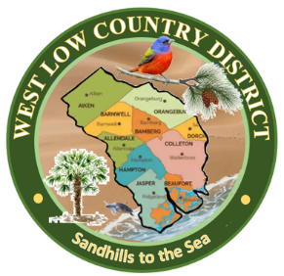
2024 West Low Country District Awards Application
(January 1-December 31, 2024) Due January 15, 2025

Submitted by: _________________________________________________________________
(Club Name and Club Number)
Number of Members in the Club: _______
Award #________ Award Name__________________________________________
Submitted Date: _________________________

- New Project: __________ or Continuing Project: ___________
- Beginning Date: __________________ Completion Date: __________________
- Brief Summary and objectives of project.
This section should explain the basic information about the program, including the purpose, what was done, how it was done, and what was accomplished.
- Involvement of club members, other organizations, etc.
This section should include members and other people involved in the program. Explain each person’s role and why they were participating.
- Project expenses and means of funding, continuing involvement, follow up maintenance.
List expenses and how the funds were raised. Describe any future involvement and possible maintenance the club members will need to continue.
- Pages 2-3: Photos and Evidence
Attach up to 2 pages of photos and other evidence, such as plant lists, receipts, brochures, flyers, etc.

Attach or insert photos, digital photos, and/or landscape plan (does not need to be professionally drawn).
You can start sending awards on September 1. Start your information with question #1. Number and answer all questions. You may remove the questions or reduce the font of this page to give you more space, if necessary. Use number only with answer. This page should only have answers for questions 1-5. Question #6 will be up to two pages of evidence, including photos.
Deadline for West Low Country District Awards is January 15, 2025 for projects completed from January 1 through December 31, 2024.
All Applications are limited to three (3) pages, with this form counting as the first page.
Submit electronically or mail hard copy to District Awards Chairman.
Christy Sloan
23 Emerald Drive
North Augusta, SC 29841
g.sloan21@comcast.net
(I really would love hard copies, but electronically, OK)

2024 West Low Country District Awards Application
(January 1-December 31, 2024) Due January 15, 2025

Submitted by: ___XYZ Garden Club - 952_WL________________
(Club Name and Club Number)

Number of Members in the Club: __11___

Award #_11_____ Award Name___Parking/Roadside Beautification Award________

Submitted Date: __September 30, 2024______

- New Project: __X_____ or Continuing Project: ___________
- Beginning Date: __2/20/2024____ Completion Date: ____2/20/24___
- XYZ Garden Club chose the entrance to the local fire department as a beautification project. This entrance was chosen because it is a focal point in our town and we felt that cleaning up and adding bushes and flowers would provide a welcoming feeling to visitors of our town. We also wanted to beautify the entrance so it would welcome the firefighters that work so hard to protect our town. Three boxwoods and 4 nandinas were planted on each side of the drive, along with flowering annuals to brighten up the entrance. Mulch was put down to deter weeds and finish off the flowerbeds.
- Six club members (list names) and 4 firefighters (list names) helped dig the holes and plants the flowers. They then mulched the beds and watered everything in.
- The community raised $200 through donations and XYZ Garden Club donated $200 to purchase the plants. Mulch was donated by the local nursery. The third Saturday of each month will be designated as a work day to weed and replace annuals. The fire department will also work several days a months when firefighters are on call.
- Attached are photos and a list of all the plants purchased.

**This is just a short example of how the form can be filled out. No need to reinvent the wheel. Just answer the questions and provide details. You will probably have much more description of what you completed than is above. If your explanation takes up more space, just continue on the next page. It can be printed front and back, so it is still one page.

Please contact me if you have any further questions.

Christy Sloan

GCSC Awards

GCSC Awards

State Awards Chairman: Sandie Duerksen
165 Double Eagle Court, Aiken, SC 29803
803-645-2871 (C) , sandieduerksen@gmail.com

SEPTEMBER 1:
- Awards 39 and 40, Send Yearbook to your District Director and to GCSC President, David Stoudenmire, president@gardenclubofsc.org David Stoudenmire, 3914 Bryant Street, Loris, SC 29569
OCTOBER 1:
- District Directors, Send 1st Place Yearbook Winners (in each category) to Sandie Duerksen,
Awards Chairman.
NOVEMBER 15:
- Award 38, Youth Award High School Essay Contest
Entries to High School Essay Chairman, Jacqueline Weinzierl, 8741 East Fairway Woods Circle, N Charleston, SC 29420 tomandjacqueline@msn.com

DECEMBER 10:
- Award 23, Landscape Design Awards to LDC President, Karen Prewitte kpadgett4c@gmail.com.
- Award 29, Publicity Press Books and all other GCSC Awards to GCSC State Awards chairman, Sandie Duerksen
- Awards 31 and 32, NGC FSAA/SSFS (Flower Show) Awards to Chairman Linda Howle, howlelinda@yahoo.com
- Awards 33-36 NAJCSC Awards to NAJCSC President, Linda Howle, 305 Cashua Street,, ., Darlington, SC 29532, howlelinda@yahoo.com
- Youth Awards 37. A-D to District Directors.
- SAR Special Project & NGC Plant America Applications to State Awards Chairman, Sandie Duerksen
FEBRUARY 1:
- President’s Report-Club and Council, to GCSC President, David Stoudenmire, president@gardenclubofsc.org, 3914 Bryant St. Loris, SC 29569 and your District Director.
- GCSC Scholarship Applications to Chairman Sandra Barker, sandrabarker13@yahoo.com
MARCH 1:
- Award 25 Juried Art/Photo Digital Submissions to Sherri Bardsley, firequeensherri@aol.com by March 1.

DEADLINE FOR ALL OTHER AWARDS: DECEMBER 10
(Scales of Points for Judging All Awards, Pages 8-13))

You may begin sending award applications September 1, to State Awards Chairman.

Send ALL applications in WORD document.
PLEASE REFER TO GCSC WEBSITE FOR UPDATES

GCSC SERVICE & RECOGNITION AWARDS
1. Presidential Service Citation
To an individual for outstanding contributions to the GCSC organization. No application required. Awarded by GCSC President.

2. The Garden Club of South Carolina Special Award
The highest award given to an individual for meritorious accomplishments, which exemplifies GCSC objectives. Certificate awarded.

3. State Certificate of Merit
To the club that has demonstrated GCSC objectives by contributing service of unusual merit to the community in which it is located. Service examples include birds; bees; butterfly gardens; historic preservation projects; conservation of our natural resources of air, water, forests, land, and wildlife; native plant projects; plant-specific projects, and other projects directly related to GCSC objectives. Provide complete documentation, detailing all phases of project. Certificate awarded. Each Membership Category 1st Place winner receives $25.

4. Sarah Porter Smith Boylston Memorial Garden Award
Given in honor of Sarah Porter Smith Boylston for her gift of the Memorial Garden. Project must describe Memorial Garden support through contributions and/or fund-raising projects. Certificate awarded.

NON-COMPETITIVE AWARDS
No Application necessary, determined by information from GCSC Computer Data Certificates.
5. National Life Membership
To the club that lists, on April 1, the highest percentage of new National Life Members.
6. State Life Membership Award
To the club that lists, on April 1, the highest percentage of new State Life Members.
7. Membership Award
To the club with the largest increase in membership from January 1- December 31. This figure is derived by computing the difference between members gained and lost in the calendar year from information from the Club President’s Report.
8. GCSC Garden Heroes
The Honoree receives a mailed certificate and is featured on the GCSC website and in The SC Gardener magazine. Minimum Donation of $100.00. See GCSC website for full details and application. Chair, Gina Ginther, theginthers@comporium.net

COMPETITIVE AWARDS:
First year of term: January-December 2023, Second year of term: January-December 2024
9. Pollinator Award
For the most exceptional project conserving and protecting pollinators by creating or maintaining pollinator habitats, pollinator sanctuaries and/or planting pollinator-friendly gardens. Each Membership Category 1st Place winner receives $25. (NGC EC1, SAR 3)

10. Legacy Gardening Award
For the most outstanding community project planned to feature past, present, and future garden design
Sponsored by the President’s Project 2023-2025 Each Membership Category 1st Place
winner receives $25.

11. Claudia Wright Lea Phelps Award
Given in honor of Claudia Wright Lea Phelps, Founder and First President of GCSC, for the most outstanding project involving members of the community; project must demonstrate GCSC and NGC objectives. Commercial projects are not eligible for this GCSC Award, but may be eligible for NGC Award. (NGC L4). Copy of landscape plan should be included. Each Membership Category 1st Place winner receives $25. (NGC CE-2; SAR 4)

12. Arbor Day Celebration Award
To a club with the most outstanding tree planting activity and/or promotion of Conservation of Native Trees and/or Arbor Day Activities. Each Membership Category 1st Place winner receives $25. (SAR -1)

13. Blue Star Byway/Memorial Marker Award *
To a club or group of clubs for the beautification and maintenance of a Blue Star Byway/Memorial Marker/s*. The project may be a replacement of a destroyed or long neglected marker. Each Membership Category 1st Place winner receives $25. (NGC CE7, SAR-14)* see Blue Star Marker Grant application on GCSC website.

14. Holiday Beautification Project of an Historic or Public Building Award
For the most outstanding holiday beautification project of historic or public building. Each Membership Category 1st Place winner receives $25. (NGC CE5)

15. Civic Achievement Award (NGC CE2; SAR 4)
For the most distinguished civic or conservation project making permanent improvement, and/or working with civic and other groups, making permanent improvement for public benefit: e.g. establishing sanctuaries, children’s gardens, municipal gardens, etc. No commercial projects are eligible. Each Membership Category 1st Place winner receives $25 Each category 1st Place winner receives $25.

16. Club Public Program Award:
For a garden club which presents the most outstanding program to the public and most outstanding effort to increase public visibility representing GCSC. and NGC objectives. Each Membership Category 1st Place winner receives $25. (NGC G4)

17. Therapeutic Garden Award
For the club which uses gardening projects as therapy to benefit the physically or learning challenged residents in nursing homes, schools, prisons, low-income housing, cancer centers, etc. Evidence must show recipients involved in the garden or project. Each Membership Category 1st Place winner receives $25 (NGC G-3 SAR 6,7)

18. Conservation of Natural Resources Award
For the most comprehensive project displaying conservation and protection of our natural
resources. Each Membership Category 1st Place winner receives $25. (NGC EC1 SAR 15)

19. Lucy B. Pomeroy Historic Preservation Award
For the completion of an historic preservation project such as restoration of a park, building, public garden, cemetery, or historical marker of importance to local, state, or national heritage. Include before and after pictures of the restoration. Each Membership Category 1st Place Winner receives $25. (NGC CE2, SAR 8)

20. National Garden Week Activities Award
For the club, group of clubs, or council for the best overall promotion of National Garden Week. The entry to show community awareness throughout the entire week and include local and/or state proclamations demonstrating GCSC goals and objectives. Each Membership Category 1st Place Winner receives $25. (NGC MAE5, SAR 10)

21. Backyard Wildlife Habitats Award
To a club who has the most National Wildlife Federation (NWF) certified backyard
habitats for pollinators and other wildlife. This can include club members’ yards, as well as yards in the garden club’s community, which the club has actively worked to include. Each Membership Category 1st Place Winner Receives $25. Each category winner receives $25.

22. Wildlife Gardening Award
To the garden club with the most notable project or projects educating the public on the benefits of gardening for wildlife. Each Membership category 1st place winner receives $25. (NGC G4)

23. Landscape Design Consultants Award
The following awards are to be given annually. Applications must be submitted by December 15 to the Landscape Design Consultants Council President: Karen Prewitt, 33
Hasell Street, Charleston, SC 29401 and a written report must accompany each entry. Funded by LDC. (NGC L5,L6, SAR 12)
i. $50 to a federated garden club for a small, landscaped area not to exceed 12ft x 12ft
ii. $50 to a federated garden club for a large, landscaped area exceeding 12ft x 12ft
iii. $50 to a federated council or group of federated clubs that sponsor a
landscaped area, other than public

24. Plant It Pink
This award will be given to the club for the most outstanding and innovative NEW project by a club or council emphasizing the use of pink cultivars (flowers, fruits, or foliage) to promote breast cancer awareness. Each Membership Category 1st Place Winner Receives $25. (SAR 13)

25. Juried Art/Photography
Theme: “Let’s Grow, South Carolina!”
See application and information on GCSC Website. Award of $200.
Digital Photos only to Sherri Bardsley, firequeensherri@aol.com by March 1.

26. Club Sponsored Youth Conservation and Natural Resources Award
To a federated club which sponsored a youth garden club that has completed the most outstanding work in conservation in the field of environmental concerns: e.g. horticulture, landscaping, restoration, conservation, and natural resources. Winner receives $25. [NGC YW9 , YW8, YW4- SAR Y 1]

27 . “Growing Youth” Gardeners Club Award
To the federated club which recruits and sponsors a NEW youth garden club with the largest number of members will be recognized at the SC Convention in 2022 and 2023. Award rules on the GCSC website. This Youth Club must be registered and complete the tasks of Youth Garden Club. The award requirement stipulates at least one student enters for competition in Youth Symposium Awards. Winner receives a certificate and $50. (NGC YR-1)
PUBLICITY & PROMOTION AWARDS
28. Publication Award
For an outstanding publication: newsletter, brochure; calendar; cookbook; history; manual by a club. Electronic submissions permitted. Each Membership Category 1st Place Winner Receives $25. (NGC MAE4 ,SAR 18)

29. Publicity Press Book Award (Scale of Points, page 9)
Certificate may be awarded to a winning Book of Evidence exhibiting quality, quantity, and diversity of coverage in the print media promoting garden clubs and NGC Objectives. Deadline: December 10, to State Awards Chairman, Sandie Duerksen

Complete an Application Form. Instead of answering the questions,
PREPARE a BOOK of EVIDENCE
1. Label on outside cover: number and name of award, name of club, city, and state.
2. Submit in folder; 8 1⁄2 x 11 or 9 x 12. No heavy scrapbooks or oversized portfolios.
There is no limit on the number of pages. Plastic page protectors may be used.
3. Material must consist of any of the following: Newspaper, magazine, newsletter, or flyers for one-time event, or any printed clippings (Ex: Your state official publication) with the name and date of publications over each article. Clear photocopies are permitted; reduced photocopies of large or lengthy article are permitted. Downloading of published newspaper articles from the Internet is permitted. Judges take into consideration the difficulty in securing newspaper publicity.
4. No page numbering or Table of Contents needed. Affix contents in chronological order January 1 through December 31.
5. Clippings evenly cut. No loose clippings permitted.
6. Each published item must contain the name of organization and/or individual/s identified as a member of the organization. Underline first use of name of organization and/or member in each article.
7. Articles should include who, what, when, where, etc. where applicable; publicity should relate.

30. Social Media/Website Award (Scale of Points, page 9)
For the most outstanding website or social media page promoting GCSC/NGC objectives. Please provide website address, site manager, update schedule and cost. Judging will include ease of navigation from the actual site .Note: There ae 4 catagories.to.choose from the following for your application …..30.A Website designed and managed by club members 30B Social media page designed and managed by club members 30C Website professionally designed 30D Social media page professionally designed….Each Membership Category 1st Place Winner $25. (NGC MAE2)

STANDARD FLOWER SHOW AWARDS
All Awards in this section will be funded and judged by The Nationally Accredited Judge’s Club of South Carolina Awards Year: January 1- December 31
Deadline: December 10

*Awards 31 and 32 are GCSC Awards
*Awards 33, 34, 35, and 36 are NAJCSC Awards
Year: January 1- December 31; Deadline to Chairman: December 10
AWARDS 31. & 32. Any Flower Show Schedule considered for this award must have prior approval by the NAJCSC Flower Show Awards/Schedules Chairman as having met the criteria for an NGC Flower Show as set forth in the 2017 NGC Handbook.
Send all applications to: Chairman Linda Howle, 305 Cashua Street, Darlington, SC 29532
(Scale of Points for all FS Awards can be found in the FS Handbook, 2017 Edition)

FOR AWARDS 31 & 32 are GCSC Awards. Send all applications to: FS Chairman Linda Howle, 305 Cashua Street, Darlington, SC 29532 howlelinda@yahoo.com

31. Standard Flower Show Achievement Award
Certificate Award for the following NGC Flower Show Achievement Awards: 5, 17, 18, 21, 22, 25, 30, 34, 35, 47, 57 (See NGC website, www.gardenclub.org for a complete description of criteria, application categories and any restrictions.)

32. Small Standard Flower Show Award
Certificate to the club with 25 or fewer members having a Small Standard Flower Show. One award per calendar year, must include schedule and photos.

AWARDS 33, 34, 35, and 36, send applications to Nationally Accredited Judge’s Club of SC President: Linda Howle, 305 Cashua Street, Darlington, SC 29532., Saluda, NC 28773,
howlelinda@yahoo.com
All Awards in this section will be funded and judged by The Nationally Accredited
Judge’s Club of South Carolina Awards Year: January 1- December, Deadline: December 10

33. Educational Exhibit Award
To a club member for an Educational Exhibit entered in a Small Standard or Standard Flower Show- Winner receives Nationally Accredited Judges Club of SC Certificate.

34. Standard Flower Show Schedule Award
i. Club $25
ii. Group of clubs or Council $25

35. SC Judges Club Ribbon Awards for CLUBS
Photocopies of signed and dated ribbons must accompany application. This includes more than one show as listed in the current NGC Handbook for Flower Show Judge’s. Winner based on a percentage of club members. Winners receive $25.
i. To the club whose collective members received the greatest number of blue ribbons in the Design Division of Standard Flower
ii. To the club receiving the greatest number of blue ribbons in the
Horticulture Division of Standard Flower Shows.

36. SC Judges Club Ribbon Awards for INDIVIDUALS
Photocopies of signed and dated ribbons won in a one award-year period and must
accompany application. Not offered to the same individual two consecutive years. Certificate awarded.
i. To the individual member winning the greatest number of blue ribbons for
the GREATEST VARIETY of designs in the Design Division of Standard
Flower Shows.
ii. To the individual member winning the highest number of blue ribbons for
the GREATEST VARIETY of Horticulture in the Horticulture Division of
Standard Flower Shows.

YOUTH AWARDS: Schedule of Awards/Deadlines

Awards 37 A-D, Send Youth Contest Awards to District Directors by December 10.
District Directors send 1st Place Contest Winners in each category to Youth Awards Chairman, Kathy Griffin, cgbeach@yahoo.com, by January 15. All entries must be sponsored by a Federated Garden Club. All First -Place winners receive a $20 gift card and are invited to attend the Youth Awards Celebration at Riverbanks Botanical Zoo.

37 A. Litter Control Award
Gift card $20 to the youth with the most successful and effective litter/environment/campaign.

37 B. GCSC Poetry Contest
Gift card $20 will be awarded to the first-place winners in grades K-9. Submit entries on 8.5 x 11 paper, place title, contact and sponsoring Garden Club information on back. (SAR Y 4)
2022-2023 "Seeds, Trees, and Bees.. Oh My Celebrating the Diversity of Nature"

37 C. GCSC Poster Contest:
Gift Card $20 to each first-place winner in each eligible grade 1-5
1. SMOKEY THE BEAR, must feature Smokey and include Smokey’s fire
prevention message. “Only You Can Prevent Wildfires!” and/or
2. WOODSY OWL, must feature Woodsy Owl and include Woodsy Owl’s
conservation message: “Lend a Hand, Care for the Land”

37 D. Recyclable Sculpture Contest
Gift card $20 will be awarded to the first-place winners in grades 4–8. Submit photos of entries with title of project, contact, and sponsoring Garden Club information on back by December 15 to your District Director. Use recycled or reused materials to create the sculpture. (SAR Y 5)

38. High School Essay Contest
Applicants in the 9th -12th grade, sponsored by a Federated Garden Club or Council, submit a 600 – 700 word essay by November 15 to Jacqueline Weinzierl, 8741 E Fairway Circle, , N Charleston, SC 29420, tomandjacqueline@msn.com. Winner is eligible for SAR and NGC contests. First-place winner receives $250. (SAR Y3)
2021-2022 Theme: “Adapting Our Actions to Protect our Natural Habitats”
Criteria and more information can be found at www.gardenclubofsc.org

39. Club Yearbook Award (Scale of Points pages, 11 - 13)
Yearbook deadline: September 1, mail to District Director and GCSC President, David Stoudenmire, president@gardenclubofsc.org
1st, 2nd, 3rd, and Honorable Mention certificates will be awarded if merited, in each of the following
membership categories based on number of members paying GCSC dues.
1. Club (under 20 members), 2. Club (20-29), 3. Club (30-44) 4. Club (45-69), 5. Club (70-99), 6. Club (100-299), 7. Club ( 300+)

40. Council Yearbook Award (Scale of Points, page 10-11)
Yearbook deadline: September 1, Yearbooks must be sent to District Director and GCSC President David Stoudenmire, presiden@gardenclubofsc.org.

41. Special Achievement
For a special civic or club project demonstrating GCSC and NGC objectives and not included in any other GCSC award category. Each Membership Category 1st Place Winner Receives $25.
(NGC CR2, SAR 19 ).

SCALE OF POINTS: ALL AWARDS Judged by the Following Scale of Points:
(EXCEPTIONS: Yearbook, Publications, Publicity, Press Book, Website, and Flower Show Achievement, which have their own Scale of Points.)
Presentation: Neat, concise, includes all required information on the Application Form (3 sheets allowed) or the Book of Evidence, if required. 15 pts.

Achievement: Scope of project, need and fulfillment, benefits, accomplishment, comprehensiveness of work, activities to attain goals, evaluation of goals reached, educational, prior planning, very brief history if continuing roject, financial report, other. 65 pts.
Participation: Size of club; involvement of members, community, government agencies,
professionals, youth, residents in facilities, others. Not all of these need to be involved. 15 pts.
Record or Documentation: Supporting data (as applicable), clear, well-labeled and neatly attached, before and after photographs if applicable, landscape plan (does not have to be professionally drawn), financial report, letters of appreciation, community awards, newspaper/magazine articles (if possible), radio or TV script (if possible), etc. Photocopies are permitted. 15 pts.
Total 100 pts.

Publicity Press Book Scale of Points, Award 29
NOTE: SAR states that a pressbook will be returned if you send a stamped, self-addressed envelope with your entry to State Chairman.
Presentation: Criteria: Entries must be submitted in a folder with holes to
firmly hold the pages (theme-style binder or file folder). No heavy scrapbooks or
ones larger than 8 ½ x11 or 9x12 will be judged.
Cover must have an affixed label stating the category(small, medium, large), name of
garden club, city, state, region, and name of person submitting. 30 pts.
Quality:
1.Materials must consist of only actual published articles with newspaper,
newsletter, etc. “clipping” with name and date over each article. No decorative
embellishments will affect judging. Affix contents in chronological order Jan1-Dec 31.
Pages must be numbered, and an index is required. Pressbooks will be returned if a
stamped, self-addressed envelope is included with entry.
2.Each published item must contain the name of the club, district, council and/or individual
identified as a federated garden club member. Underline the first use of the of the club’s
name, district, council/individual, in the article. 35 pts.
Quantity: Number of pages is unlimited. articles for each month (take in
consideration dark months) use of varied publications and media. 20 pts.
Diversity of Coverage: local, council, district, state, national, other. 15 pts.
Total 100 pts.

Social Media/Website Scale of Points, Award 30

Presentation: Design/Appearance: attractive, engaging, easy to view, layout 25 pts.
Navigation: Ease of navigation, navigation system, bar, map, logical flow of
pages, clear, page headers, links active 35 pts.
Achievement: Club/group information present/easy to find, educational 20 pts.
Promotion: Promotes GCSC and NGC objectives 10 pts.
Maintenance: Does it appear to be updated? 10 pts.
Total 100 pts.

NEW *Special Yearbook Requirements for 501(c)3 Clubs and Councils
In addition to the standard yearbook requirements, 501(c)3 Clubs and Councils must include the following items. These are not part of your Yearbook Judging but are submitted to the 501(c)3 Compliance Officer to prove annual Club/Council compliance with GCSC’s Group Exemption Letter requirements:
- GCSC Group Exemption Letter 5876 – This is the IRS # given to GCSC that enables GCSC to award 501(c)3 subordinate status to your club or council.
- Club/Council EIN # - This is your IRS registration number attached to all Club/Council banking and used to file annual 990 tax forms and provide donation receipts to donors.
- Constitution, Bylaws and Policies* – These must be made available to all members and to the public upon request. If not printed in the yearbook, please note in the yearbook where they be found. For example: For organizational documents, go to www.YOURCLUBWEBSITE.com/bylaws
- Proposed Budget and Annual Financial Reports – It is always good practice to publish your proposed budget and your end of year profit/loss statement in your yearbook. For 501(3)c Clubs and Councils, it is required.
- Programs and Projects – These MUST benefit the community at large in greater percentage than the membership. The majority of meetings, other than business meetings, must be open to the public or clubs must host regular public events and programs that benefit the greater good.
*Many clubs keep all of these documents in a permanent file that is only printed for members when updated. This saves printing costs and paper.

Council/Groups of Clubs Yearbook Scale of Points, Award 40
FORMAT – 15 POINTS (A through E = 15 points total)
A .BOOK STRUCTURE: ……… 3pts/ ___
  - Practical, convenient size for club membership, durable neat.
May be stapled, spiral or 3-ring binder (no clip-binders). If a 3-ring binder is used, substitute with paper cover and include required information listed above and so note.
  - Ample margins, and font size readable for membership.
B. FRONT COVER ………. 3pts/_____
  - Name of Club, your federated club number in state, town, GCSC as state organization and
federated state number (# 5129), year federated, year.
  - Appealing design.
C. TITLE PAGE ……… 2pts/_____
  - Name of group ,include your federated GCSC state club number.
  - Town, state organization (i.e.: name of your town).
  - Year
  - Number of clubs involved,
  - Affiliated organizations including NGC (district, state, region, NGC, other). Include name of NGC President, Regional Director, State President with each affiliation.
D. TABLE OF CONTENT: …………………………………………………………………………………..……….… 2pts/_____
Number the yearbook pages and list topics with respective page number.
E .SUBSEQUENT PAGES: In any order most useful to members and best fit for page placement.
F. Organizational Information…………………………………………………………………..……………… 10 pts/_____
List organizational officers and committee chairmen. Include mailing address telephone numbers, e-mail address and club affiliation for each. Include mailing addresses, telephone numbers, e-mail addresses and club affiliation for each.
G. Calendar of Events……………………………………………………………………………………………….. 10 pts/_____
List meeting dates for your organization, including date, time and place of meeting as well. as schools, symposiums, and special events. This will help avoid conflicting dates.
H. Bylaws, policies, and objectives:
Bylaws are not required unless the group is a 501c3. A Dissolution Clause is required
in all. Bylaws. 10 Pts._____
I. Programs …………………………………………………………………............. 20 pts._____
List meeting topics, include dates, time, and place(address). Give name of speaker. Indicate if program is a presentation, tour, workshop, sharing activity, etc.
J. Projects…………………………………………………………………….............. 20 pts._____
1. List projects as continuing or new, including the name of chairman and website, region website and NGC website.
location/description of project; state if project is fundraiser
K. Member Club Identification…………………………………………………… 20 pts/_____
List of member clubs, including club presidents, names and meeting dates; list total number of dues paying members.

Total Possible Points 100/ Actual Score/_____

Club Yearbook Scale of Points, Award 39
FORMAT – 15 POINTS (A through E = 15 points total)
A…BOOK STRUCTURE: 2 pts/ ___
  - Practical, convenient size for club membership, durable neat.
May be stapled, spiral or 3-ring binder (no clip-binders). If a 3-ring binder is used, substitute with paper cover and include required information listed above and so note.
  - Ample margins, and font size readable for membership.
FRONT COVER ……………2 pts/_____
  - Name of Club, your federated club number in state, town, GCSC as state organization and
federated state number (# 5129), year federated, year.
  - Appealing design.
TITLE PAGE:…………………………………………….. …………… 2 pts/ _____
  - Name of club include your federated GCSC state club number.
  - Town, state organization (i.e.: name of your town).
  - Year
  - Number of dues paying members (if club pays for membership of associate, inactive or honorary
members, they are counted in total membership).
  - Affiliated organizations (district, state, region, NGC, other).
- TABLE OF CONTENTS: 1 pt./ _____
  - Number the yearbook pages and list titles on Table of Contents page.
- SUBSEQUENT PAGES: In any order most useful to members and best fit for page placement.
Information in a club yearbook should be in a logical order.
National and state information does not have to be in front.
List of Club Officers and Committee Chairmen 2 pts/ ____
Membership Roster: 2 pts/ ____
Complete mailing addresses, telephone numbers, and e-mails (if applicable). Do not crowd the listing.
You may inset the following to save space:
“All area codes are ______ and postal zip codes are______ unless otherwise noted”
Name of NGC President with state of residence, theme, and projects: 1 pt./ _____
(Locate this information at www.gardenclub.org)
Name, address, phone number, and e-mail address of State President, SAR Regional Director,
State District Director, Council President (if applicable) 1 pt./ _____
List themes for State President and Regional Director (GCSC website www.gardenclubofsc.org and
SAR website www.southatlanticregionofgardenclubs.org).
Calendar of Events: 2 pts/ _____
List dates and locations for district/state/region/national meetings and events to encourage members to attend and eliminate setting of conflict dates.

F. PROGRAMS – 50 POINTS
Topics should cover a variety of GCSC/ NGC Goals & Objectives such as Birds, Blue Star Memorials, Butterflies, Floral Design, Conservation and Environment, Therapy, NGC and State Presidents Projects. (Indicate if special interest club such as: Design only, Horticulture only, etc.).
Meets Minimum number of meetings required by state (seven) 3 pts/ _____

List date and time of meetings, location, and address 3 pts/ _____

List speakers, qualifications (brief), program title 4 pts/ _____

Variety of program topics (theme not required) 14 pts/ _____

Variety of styles of programs (lectures, PPT, tours) 12 pts/ _____

Variety of speakers (specialists, members, panel, etc.) 14 pts/ _____
G. PROJECTS – 35 POINTS
Involves actual membership participation to benefit the community and further NGC Goals and Objectives. Some fundraisers may help benefit & beautify the community as well as produce revenue for the clubs and some help promote NGC Member Services as well as publicize our organization and goals. Certain social activities may lead to membership increase. State each in description.
List of continuing and new projects 15 pts/ _____
A club is not required to have new projects.

Give a brief description of projects 20 pts/ _____
Include location, name of chairman, how members participate. list of donations (if applicable), in-kind
donations (if applicable), plans for maintenance if applies.

Example: Establish a Teaching Garden at Adkins Elementary School-after school program with planned
curriculum, 4 days a week from 3:30-5:45pm. Laurie Benson, Chairman.

OPTIONAL (no points given)
To fill extra space you can include bylaws, budget, fundraising, roll call, and/or former presidents.
Reminder: All Bylaws are required to have a Dissolution Statement.* please see following page
CLUB THEME
If a club theme is used, it should be evident throughout the book. Themes may be interpreted
with monthly program topics and/or titles/graphics/quotes. Projects do not need to be limited to theme.

Total Possible Points 100 pts/Actual Score _____



2023-2025 GCSC AWARD APPLICATION
GCSC Award #:____ Award Title:________________________________Date Submitted:__________

Applicant Club or Individual name:________________________________________________________
If individual award, also enter person’s name as it should appear on the award.

Number of Members in Club/Council:___________ Your club number in the State:_________________

Contact name, address, email and phone number:_____________________________________________
________________________________________________________________________________________

Name of State Garden Club: The Garden Club of South Carolina, Inc., # in State Club-5129
State Awards Chairman, Address, Phone, Email: Sandie Duerksen, 165 Double Eagle Court, Aiken, SC 29803 803-645-2871 © sandieduerksen@gmail.com

Instructions: Answer questions #1-6. Delete these instructions from your application
- Application form is limited to the fronts only of no more than three pages
Do not put photos on page 1. You do not have to use all three pages. No report covers, binders or plastic sheets allowed.

For electronic submission, fill in this form, save it and then attach to an email.

- Application will not be returned: Print a finished copy for your files.
[exceptions: publications, books, cookbooks, etc. & DVD/CD’s]

Absolute Deadline: December 10, 2024. GCSC Awards Chair must forward entries to NGC by Jan. 15
and to SAR Regional Director to be received by January 25.

Your application will be judged on your answers to the below required criteria. You must answer all.

Use this application form as your first page. Complete each topic using the below numbering system.
1. New Project: Yes_____ No_____ Beginning date: Completion date:
2. Provide a brief summary of your project and your objectives.
3. Describe the involvement of both your club members and other organizations, groups, etc.
4. How was your project funded and what were your expenses?
5. Describe your club’s continuing involvement in the project, or follow up work, on-going maintenance.
6. Attach documentation, digital photos, or copies of letters of appreciation, newspaper or magazine articles
and/or landscape plan or drawings [does not need to be professionally drawn]

2022-23 GCSC AWARD APPLICATION (SAMPLE)
GCSC Award # 43 Award Title: Special Achievement Date Submitted: Dec 9, 2022
Submitting club: Gardening on the Cay
Number of Members in Club: 43 Your club number in the State: 636EP
Contact name, address, email and phone number: Tara Ranson 818 Ryans Place Fort Mill, SC 29715 TDRanson@yahoo.com 803-487-3236 _____________________________________________________________________________________
New Project: Yes_____ No__X___ Beginning date: 2012 End date: ongoing
Brief summary and objective of projects:
Gardening on the Cay works to combine our love for gardening and the objectives of GCSC with lots of “hands on” volunteer work to give back to our community. To that end, we partner with other non-profits and civic groups whenever possible to design club projects that best use the talents of our busy members since many in our club are still working. There are several projects (described below) that our club participates in that may not fit into an Award offered this term, so “Special Achievement” is the best category for some of our club’s strongest work.
Gardening on the Cay supports the Fort Mill Care Center (FMCC) year-round through food bank donations, special projects and by maintaining their 120 ft stone flower bed. The Fort Mill Care Center is a non- profit organization that provides food assistance to families in the Fort Mill and Tega Cay communities. At our monthly meetings, Gardening on the Cay collects items for the food pantry and makes monetary donations. In 2022 this committee led the club effort to donate a total of 527 pounds of food and $750 for the FMCC. That included hundreds of pounds of fresh vegetables we harvested from our own Tiny Sprouts Youth Garden Club raised beds late this summer. Our club participation is 100%!
For a December project, Gardening on the Cay partnered with a group of volunteers from The Humane Society of York
County on Nov 30 to fill 375 Christmas stockings and 75 gift coffee mugs for five local charities. This is our “PROJECT JOY”. All the stockings and items were donated by the two groups. Each stocking contained a book, an ornament, a toy, a stuffie, a knitted hat, some candy, and a candy cane. Twelve club members plus 7 other volunteers helped to fill the stockings and mugs. It took about 90 hours of work on this one Christmas project. These will be delivered in mid-December. The committee also maintains 150 ft stone garden planters and decorates the front of the Center seasonally
Our involvement with Habitat for Humanity of York County continued this year with our signature project, “Habitat
Porch Warmings” for the two new homes built in our county. This is our 10th year partnering with Habitat, and over the years we have “warmed” and helped dedicate 24 porches. Gardening on the Cay purchased and placed two rocking chairs and pillows on each front porch, plus a seasonal wreath and planter were created by club members just for these homes. This project happens seamlessly because a committee of four purchases and stores the chairs each summer and delivers everything for the home dedications when they are scheduled later in the year. Ben Gair, Community Development Director for Habitat of York County, calls our club project “The Icing on the Cake!” and uses it for photo ops.
Involvement of club members and other organizations:
Our commitment to the FMCC requires 100% participation from our club members. We harvested fresh vegetables all summer, donated canned goods at every meeting as well as worked on the 375 Christmas stockings and 75 mugs. Our partnership with Habitat for Humanity is ongoing and averages 2-3 homes per year.
Project expenses and means of funding: Canned goods and all the elements for the Stockings for FMCC are donated by club members. Additional plants and mulch needed for the stone planters are debited from the club treasury, and the committee budget for this is $100. For the Habitat for Humanity Porch Warmings, our club budgets the purchase of 4 rocking chairs, 2 pillows, 2 seasonal porch planters and we make front door wreaths.
That committee budget is $300 Continuing involvement in the project, follow up, or maintenance: These projects are an ongoing JOY to participate in. They are year-round commitments, and both agencies count on our help.

Photos attached:

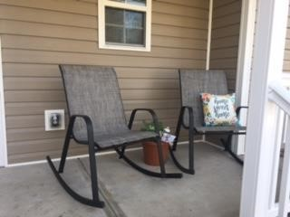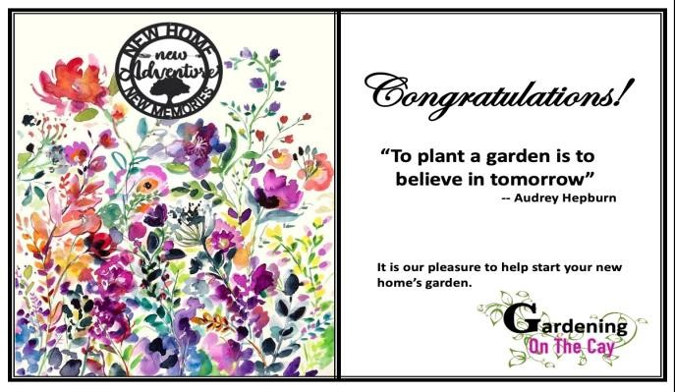

Habitat For Humanity “Porch Warming” Summer 2022. Our “calling card” for each Habitat dedication

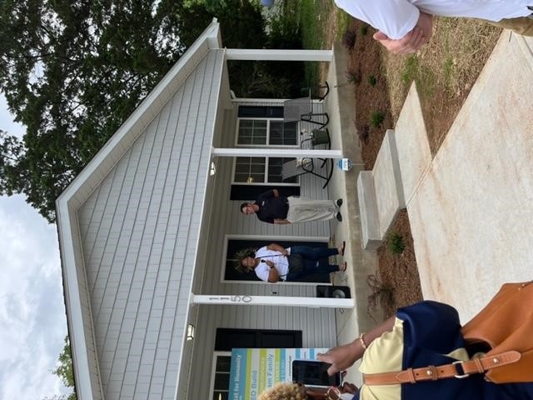

The Fall dedication of one Habitat house with our” Porch Warming” serving as a backdrop.



Club members met Nov 30 to build 375 Christmas stockings for local charities.

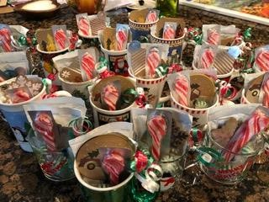

(left) 375 Christmas stockings thrifted, filled, and packed by 12 club members - ready to be delivered in mid-December to various children’s charities.
(right) 75 Christmas mugs for homeless and marginalized adults, filled with coffees, cocoas, teas, and candy.

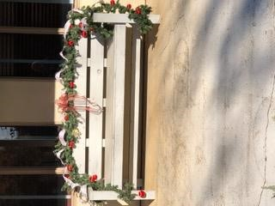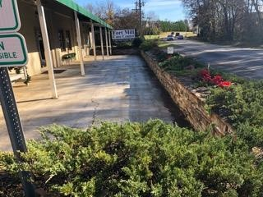

Year round, a small committee in our club maintains the 150 ft stone planter garden in front of the Fort Mill Care Center. The front bench is where the food bank clients wait to pick up their groceries. We decorate the bench seasonally to provide a cheery greeting.

GCSC
Youth Awards
&
Scholarships



Garden Club of South Carolina, Inc
2024-2025 Scholarships

The Garden Club of South Carolina, Inc. offers many scholarship opportunities for students throughout the state. The scholarships are open to high school seniors and any full-time student with a minimum of 12 graded hours of classes as an undergraduate and 9 graded hours of classes as a graduate student. Each applicant must be sponsored by a federated garden club, group of clubs or council. Additional requirements are listed inside the student packet. Please encourage students to read the qualifications and requirements carefully to ensure they submit complete applications. Applications are accepted via email only.

As a federated garden club, YOUR GARDEN CLUB NAME HERE has created student information packets for the GCSC Scholarships, including a list of available scholarships, application forms, eligibility and requirements, and a checklist to assist them in completing the application. Included on the checklist is the contact information for our club president, who will provide a one-page letter of recommendation to submit with the student application. If students need assistance or have questions about the application process, please contact the Youth Awards Chair listed at the bottom of this letter.

Digital copies of this paperwork can be found at The Garden Club of SC, Inc. website at this address: https://gardenclubofsc.org/Scholarships. The link is titled “Scholarship Information Kit” and will open a Word document with the necessary paperwork.

SUBMIT COMPLETE APPLICATIONS VIA EMAIL ONLY TO:
GCSC Scholarship Chairman Sandra Barker
sandrabarker13@yahoo.com
BY FEBRUARY 1, 2025. NO LATE SUBMISSIONS WILL BE ACCEPTED.

If you have any questions about this program or need additional paperwork, please contact the Youth Awards Chair at: ENTER YOUR NAME AND CONTACT INFO HERE


THE GARDEN CLUB OF SOUTH CAROLINA, INC.
SCHOLARSHIPS

HESSIE MORRAH HORTICULTURE SCHOLARSHIP
- An endowed $2000 award
- Offered to all tech/junior/4 year undergraduates and graduate students enrolled in accredited institutions .
- May apply as high school senior.
- Encourages the study of agriculture, agronomy, botany, city planningfloriculture, land managements, landscape architecture, plant pathology, historic preservation or related majors.
BABS BARNETTE ENVIRONMENTAL SCHOLARSHIP
- An endowed $500 award
- Offered to rising junior or senior undergraduatesand graduate students.
- May apply as college sophomore
- Encourages the study of environmental control issues and allied courses.
GCSC DISTRICT SCHOLARSHIPS
- A $500 award
- Offered to all tech/junior/4 year undergraduate and graduate students whose permanent address is located within one of seven GCSC Districts.
- May apply as a high school senior
- Granted only when specific funds are available.
GCSC PRESIDENTIAL SCHOLARSHIP
- A $2000 award
- A special award to an outstanding applicant whose record celebrates academic excellence while demonstrating maturity,focus, and a passion for obtaining their long term goal of scholarly achievement.
- Granted only when specific funds are available.
PEARL FRYAR HORTICULTURAL SCHOLARSHIP
- A $1000 award
- GPA for this Award ONLY is a cumulative 2.5 on a 4.0 Scale
- Available to students pursuing horticulture degrees through SC high schools, trade schools, community colleges, junior colleges,and universities.
- Granted only when specific funds are available.
SAR SCHOLARSHIP
- A $2000 award granted to only 1 candidate that best meets SAR criteria.
- See www.southatlanticregiongardenclubs.org. for specific details.
NGC SCHOLARSHIP
- A $4000 award granted by National Garden Club, Inc. .
- See www.gardenclub..org Scholarship.

THE GARDEN CLUB OF SOUTH CAROLINA, INC.
APPLICANT ELIGIBILITY
Applicants must meet ALL of the following criteria:
- Must be a U S citizen and and meet requirements as a South Carolina resident.
- International, foreign exchange, and doctoral program students are not eligible.
- Must be enrolled as a full time student with a minimum of 12 graded hours of classes as
an undergraduate and 9 graded hours of classes as a graduate student.
- Must have a cumulative GPA of at least 3.0 on a 4.0 scale.
(Exception Pearl Fryer Award GPA is 2.5 on a 4 point scale}
SELECTION CRITERIA
- All applications received by GCSC Chairman will be judged by that chairman and a committee of 8 in order to choose the winning applications.
- After judging is complete at the state level the SAR and NGC Scholarship Chairmen will receive their application by March 1 for judging.
- The following Sample Scale of Points may be used for evaluation of each application.
Academic Record 40%
Applicant’s Essay 25%
List of Honors/ Extracurricular Activities/ Work 13%
Financial Need 15%
Recommendations 5%
Conformance 2%
- GCSC will notify all applicants in writing of the committee’s decisions on or before March 15. Winners will be honored at the April GCSC State Meeting.
- Applicants who continue to maintain a 3.0 average are encouraged to apply next year.
DESCRIPTION OF FUNDS
- Checks for the winning applicants will be mailed in mid July to the
- Financial Aid Office of the institution at which the student is enrolloed. No funds will be sent directly to the student.
- All funds will be distributed by the Financial Aid Office according to the particular school’s term system, unless the student has only one term remaining before completion of the program.
- In the event a student withdraws or transfers from their orignal school, the balance of the funds must be returned to GCSC. No funds will be distributed to another university, until the balance remaining has been received .
APPLICATION DETAILS
- All fields must be completed…email deadline(see below) FEBRUARY 1
- Essay limit is 1 page. Include applicant signature.
- List of activities is 1 page. Includes only items for the last 3 years.
- Each of 3 letters of recommendation is 1 page.
- Transcripts are sent directly from school to scholarship chairman.
- All documents must be in a folder and submitted to GCSC Scholarship Chairman,
SUBMIT COMPLETE APPLICATIONS VIA EMAILTO GCSC SCHOLARSHIP CHAIRMAN,

Sandra Barker (910-641-7328) sandrabarker13@yahoo.com
POSTMARK DEADLINE DATE: February 1

The Garden Club of South Carolina, Inc

YOUR SCHOLARSHIP CHECKLIST…….
_______ Cover page
________ Completed GCSC application form ( all questions answered)
________ Personal essay describing goals, background , reason for choosing
stated field of study,financial concerns ,and interests. (1 page)
(w/signature)
________ List of extracurricular activities, honors, recognitions received with
in the last 3 years. ( 1 page)
________ Completed official transcript mailed from school to chairman
________ Wallet size photo of applicant.

Inclusion of a photograph of the student is encouraged. Submission of an essay assumes permission to print the winning essay and permission to display a photograph of the student.

________ 3 single page letters of recommendation from :
1. Federated Garden Club President reference /Name & Address
___Your Garden Club President, Email & Phone Number______________
2. School official reference/ Name & Position
________________________________________________________________
3. Character Reference/Name & Relation to applicant
________________________________________________________________

The Garden Club of South Carolina, Inc.

Your Scholarship Options Cover Page 2024-2025

Name________________________________________________________________
Please mark your choice/choices for scholarship consideration for school year of
2024-2025. Deadline date for all GCSC and SAR applications is February 1
GCSC criteria and application found at www.gardenclubofsc.org.
GCSC SCHOLARSHIPS
___________ Hessie T. Morrah Horticulture Scholarship: $2000.
___________ Babs Barnette Environmental Scholarship: $500

___________ GCSC District Scholarship: $500.
___________ GCSC Presidential Scholarship: $2000

___________ Pearl Fryar Horticulture Scholarship: $1000

SAR SCHOLARSHIP
___________ Corrie Whitlock Memorial Scholarship: $1000
Only one applicant best meeting SAR criteria to be forwarded to South Atlantic Region competition. Must be a rising college junior, senior, grad student. Criteria and application found at www.southatlanticregiongardenclubs.org/ scholarship tab.
NGC SCHOLARSHIP
___________ National Garden Club Inc. Scholarship: $4000
Only one SC applicant best meeting criteria may be forwarded to National competition. Must be a rising college Junior, Senior, or Grad student. Deadline March 1, 2025. Criteria and application found at www.gardenclub.org/ Scholarship
IMPORTANT: All applications must be submitted VIA EMAIL to GCSC Scholarship Chairman:.
Sandra Barker sandrabarker13@yahoo.com (910-641-7328)

Deadline: February 1

THE GARDEN CLUB OF SOUTH CAROLINA, INC.
SCHOLARSHIP APPLICATION

Full Name of Applicant:_________________________________________________

Date of Birth:___________________College ID#_________________________________________

Permanent Mailing Address:__________________________________________________________

Email Address:____________________________________________________________________

Applicant Phone Number:____________________________________________________________

Parent/ Guardian Name:_____________________________________________________________

Address:_________________________________________________________________________

Email Address:____________________________________________________________________

Parent/ Guardian Phone Number:_____________________________________________________

For academic year 2024-2025 applicant will be: (circle one)

Freshman, Sophomore, Junior, Senior, Graduate Student

Tech/ College/ University ___________________________________________________________

Financial Aid Office & Address_______________________________________________________

Financial Aid Office Phone Number: __________________________________________________

Major:___________________________________________________________________________

Current HS/ College, if different from one to be attended in 2024-2025

_____________________________Address:____________________________________________

The Garden Club of South Carolina, Inc.
2024-2025 High School Essay Contest
“IS RECYCLING PLASTICS THE ANSWER TO OUR
PLASTIC DISPOSAL PROBLEM?”

The High School Essay Contest, also listed as GCSC Award #38, is open to any South Carolina High School Student (grades 9-12) sponsored by a federated garden club, group of clubs or council. For 2024-2025, the theme is “IS RECYCLING PLASTICS THE ANSWER TO OUR PLASTIC DISPOSAL PROBLEM?” The student will have to be creative as the theme should be incorporated in the title, but not used as the title. All entries become the property of the GCSC, Inc., and a certificate and the new cash award of $500.00 will be presented to the winner of the GCSC High School Essay Contest at the annual meeting in 2025. This year’s winning GCSC essay will also be forwarded to the South Atlantic Region (SAR) of the National Garden Club.

As a federated garden club, YOUR GARDEN CLUB NAME HERE has created information packets about the HS Essay Contest, including entry forms, rules, and a publication permission form. Documents with an asterisk (*) must be returned with the completed contest entry. An entry without a Publication Permission Form will not be judged. Also, it is important to follow the attached instructions regarding the student’s information and to include the name of the sponsoring garden club, which is: (____________________________________)

High School Essay Contest – (grades 9-12)
- High School Essay Information Flyer (for display)
- Essay Contest Rules
- Essay Contest Information and Signature Page *
- Publication Release Form *

DEADLINE: ALL ENTRIES MUST BE MAILED OR EMAILED TO THE GCSC HIGH SCHOOL ESSAY CHAIRMAN BY NOVEMBER 15, 2024.

High School Essay Chair: JACQUELINE WEINZIERL
8741 EAST FAIRWAY WOODS CIRCLE
CHARLESTON, SC 29420
tomandjacqueline@msn.com

If you have any questions about this program or need additional paperwork, please contact: ENTER YOUR NAME AND CONTACT INFO HERE

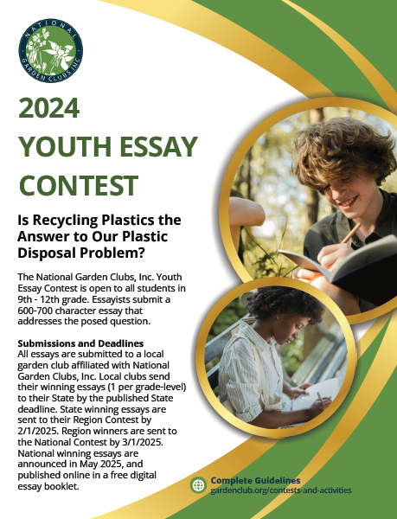



ESSAY CONTEST RULES

The length of the essay must be between 600-700 words. All entries must be typed or computer-generated with the current theme, “IS RECYCLING PLASTICS THE ANSWER TO OUR PLASTIC DISPOSAL PROBLEM?” Again, the theme cannot be used as the title. Essays must be typed in Microsoft Word, using font no smaller than 11 point. Essays must be in a format suitable for printing in The South Carolina Gardener. Include a page listing the name, address, phone number, email address, school attending, grade level, and a list of activities. The submission must include the name of the sponsoring federated club(s) or council. Essayist’s family does not have to be a member of the local sponsoring garden club. Inclusion of a photograph is optional. The photo must not show faces of anyone included, and the essayist must attest they have the rights to the photo (or that the photo is free and open source.) For further information and judging criteria, please refer to the GCSC website. Essays must be the original created work of the participant student. The GCSC is not responsible for the content of essay material. Essays found to contain AI (Artificial Intelligence) will be disqualified. You may use these formats: APA or MLA. You may cite sources at the end of the essay.
SCALE OF POINTS
20%--Originality
20%--Central idea of essay is clear and addresses the theme question.
20%--Organization of ideas uses a logical structure, clear paragraphs, and appropriate transitions.
20%--Vocabulary, grammar and mechanics effectively communicate meaning.
10%--Creative title.
10%--Conformance to length.
Include student name, address, phone number, email, school attending, grade level, list of activities of student, name of sponsoring garden club(s); photo optional.

DEADLINE: ALL ENTRIES MUST BE MAILED OR EMAILED TO THE GCSC HIGH SCHOOL ESSAY CHAIRMAN BY NOVEMBER 15, 2024.
JACQUELINE WEINZIERL
8741 EAST FAIRWAY WOODS CIRCLE
CHARLESTON, SC 29420 tomandjacqueline@msn.com

The State winning essay will be sent to their Region Contest by 2/1/2025.

The Region winner will be sent to the National Contest by 3/1/2025.

National winning essays are announced in May 2025, and published online in a free digital essay booklet.

THE GARDEN CLUB OF SOUTH CAROLINA
2024-2025 HIGH SCHOOL ESSAY CONTEST
“IS RECYCLING PLASTICS THE ANSWER TO OUR PLASTIC DISPOSAL PROBLEM?”
INFORMATION AND SIGNATURE PAGE

PLEASE FILL IN THE INFORMATION BELOW AND SUBMIT WITH ESSAY:

NAME:___________________________________________________
MAILING ADDRESS:_________________________________________
PHONE NUMBER:___________________________________________
EMAIL ADDRESS OF STUDENT:_________________________________
HIGH SCHOOL ATTENDING:____________________________________
HIGH SCHOOL’S MAILING ADDRESS AND PHONE NUMBER:____________
__________________________________________________________
CURRENT GRADE:____________________________________________
LIST OF ACTIVITIES IN WHICH YOU PARTICIPATE:___________________

NAME OF SPONSORING FEDERATED GARDEN CLUB, COUNCIL, DISTRICT, OR STATE (GCSC):____Your Garden Club Name, West Low Country District___
INCLUDE A PHOTO OF YOURSELF, BUT IT IS NOT MANDATORY

THE GARDEN CLUB OF SOUTH CAROLINA, INC. IS NOT RESPONSIBLE FOR THE CONTENT OF ESSAY MATERIAL. BELOW, PLEASE SIGN ACKNOWLEDGING YOU HAVE READ AND WILL ABIDE BY THE RULES OF THE ESSAY CONTEST AND THAT THE ESSAY YOU ARE SUBMITTING IS YOUR ORIGINAL WORK AND IS NOT THE PRODUCT OF AI (ARTIFICIAL INTELLIGENCE).

_____________________________ _______________________________
PRINT NAME OF STUDENT SIGNATURE OF STUDENT

DATE: ______________

Garden Club of South Carolina
Youth Contests

GCSC partners with the U.S. Department of Agriculture, Forest Service and the National Garden Clubs, Inc. to sponsor three youth contests each fall. The Smokey Bear & Woodsy Owl Poster Contest, Youth Poetry Contest, and Youth Sculpture Contest are several ways children can embrace their creativity while learning ways to keep our planet green and care for the environment.
Our garden club has created information packets about each of the contests, including entry forms, rules, and a publication permission form. Below is a list of the documents for each contest. Documents with an asterisk (*) must be returned with the completed contest entry. An entry without a Publication Permission Form will not be judged.
- Smokey Bear & Woodsy Owl Poster Contest – (grades 1-5)
- Poster Contest Information
- Poster Contest Announcement
- Poster Contest Rules
- Poster Sticker *
- Publication Release Form *

- Youth Poetry Contest – (grades K-9)
- Poetry Information
- Poetry Entry Form *
- Publication Release Form *

- Youth Sculpture Contest – (grades 4-8)
- Sculpture Information and Rules
- Sculpture Entry Form *
- Publication Permission Form *
Smokey Bear and Woodsy Owl must be presented in their correct colors. Please refer to this website to show an example of the correct colors for each icon. https://gardenclub.org/sites/default/files/2024-01/smokey-woodsy-certificate.pdf
Please contact me when your entries are ready to be collected. All contest entries and paperwork will be picked up by Dec. 1, 2024.
Thank you for participating in these GCSC contests. We hope this information is helpful. For additional information, please contact:
(ENTER YOUR GARDEN CLUB YOUTH CHAIR CONTACT INFO HERE)





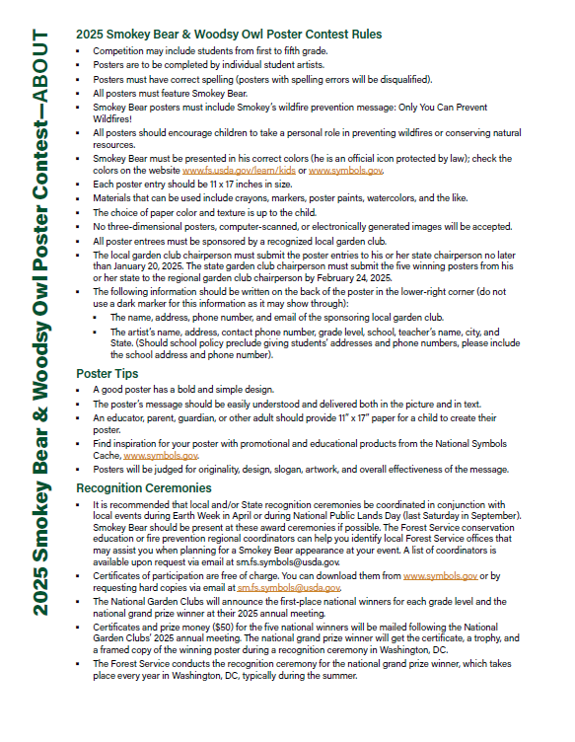

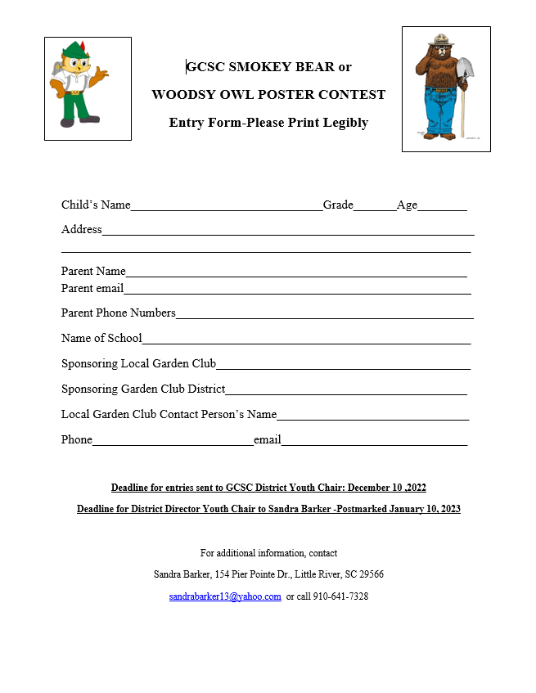



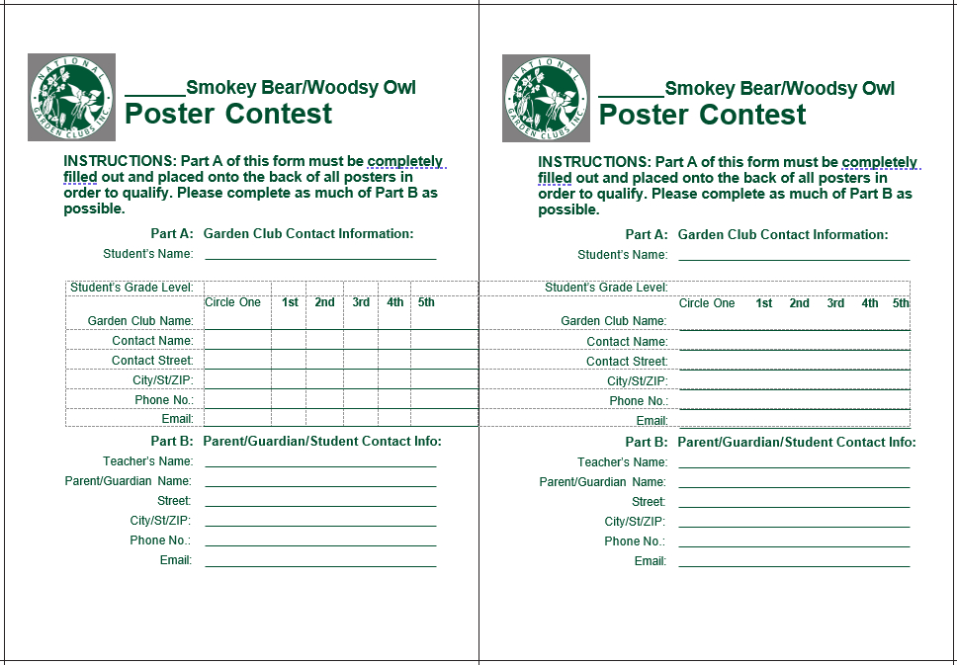
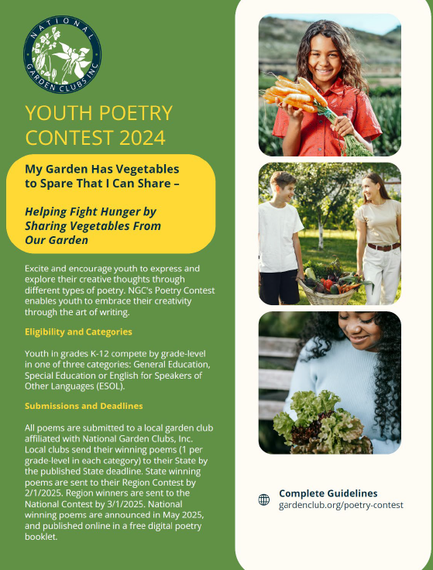

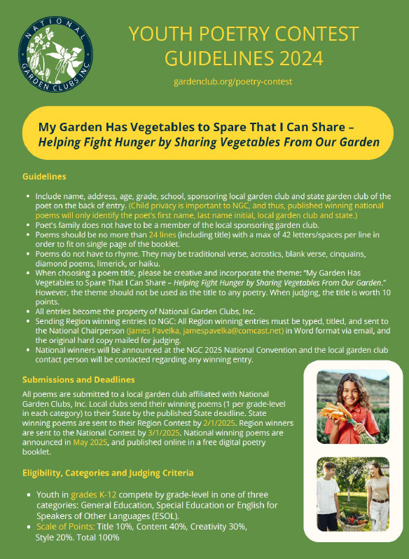

GCSC GARDEN POETRY CONTEST

2024-2025 Theme
"My Garden has Vegetables to Spare That I Can Share- - Helping Fight Hunger by Sharing Vegetables from Our Garden "
Excite and encourage our Youth to express and explore their creative thoughts through different types of poetry. NGC's Poetry Contest enables our Youth to embrace their creativity through the art of writing. Be imaginative and join the winners to see your poetry in a booklet.

Only regional winners are considered in the judging for national winners. Contest winners will not be allowed to win two consecutive years. All winning entries will be compiled into a booklet, which will be made available to the winners.
Eligibility:
Special Education: Kindergarten through Ninth Grade.
English as a second language: Kindergarten through Ninth Grade.
General Education: Kindergarten through Ninth Grade.
Dates for Submission:
All entries must be collected from schools by Dec. 1 for submission to District Youth Chair by Dec. 10.
Guidelines
All entries must be typed and titled
Include name, address, age, grade, and school of participant on the back of entry.
Sponsoring garden club and state garden club name must also be identified.
Sponsoring garden club may be that of a grandparent.
All entries become the property of National Garden Clubs, Inc.
Poems do not have to rhyme.
Poems may be traditional verse, acrostics, blank verse, cinquains, diamond poems, limerick, or Haiku. The theme should not be used as the title to any poetry. When judging, the title is worth 10 points.
Entries will be collected from schools by Dec. 1, 2024
Scale of Points:
Title: 10%
Content: 40%
Creativity: 30%
Style: 20%
Total: 100%
Contest Submission are Due by December 10, to District Youth Chairs
Winners from District level must be Postmarked by January 10, to Ann Crider
For additional information, contact
Ann Crider, anncrider@bellsouth.net, 864-360-9071
3 Montclair Ave, Greenville, SC 29609

GCSC GARDEN POETRY CONTEST
Entry Form-Please Print Legibly

Child’s Name_______________________________________Grade_______Age________
Address___________________________________________________________________
___________________________________________________________________
Parent Name_______________________________________________________________
Parent email_______________________________________________________________
Parent Phone Numbers_______________________________________________________
Name of School____________________________________________________________
Sponsoring Local Garden Club___Your Garden Club Name Here_____________________
Sponsoring Garden Club District____West Low Country District_____________________
Local Garden Club Contact Person’s Name___Your Garden Club Youth Chair___
Phone__Your Phone Number__email___Your Email Address____

For additional information, contact
Ann Crider, anncrider@bellsouth.net, 864-360-9071
3 Montclair Ave, Greenville, SC 29609

The Garden Club of South Carolina, Inc.
Youth Sculpture Contest

The purpose of this contest is to encourage youth to keep our planet green and to get involved with saving our environment.
Contest Rules:
- Children in grades 4 through 8 are eligible to enter.
- Sculptures must consist of recyclable, reused and/or reduced materials.
- Width and depth of sculpture can be no more than 8 ½ x 11 inches.
- Height should be proportional to width.
- The entry formed found on the GCSC website should be used.
- Entries should include at least two photos (4x6 inches recommended) attached to the
back of the Entry Form.
- Club entries must be sent to District Youth Chairman by December 10.
- Scale of Points:
- Creative use of materials/self-expression – 60 points
- Description of sculpture and materials – 30 points
- Craftsmanship and technique – 10 points

Deadline for entries sent to GCSC District Youth Chair: December 10, 2024
Deadline for District Director Youth Chair to Ann Crider -Postmarked January 10, 2025

For additional information, contact
Ann Crider, anncrider@bellsouth.net, 864-360-9071
3 Montclair Ave, Greenville, SC 29609

GCSC YOUTH SCULPTURE CONTEST
Entry Form-Please Print Legibly
Child’s Name_______________________________Grade_______Age________
Address______________________________________________________________
________________________________________________________________
Parent Name_______________________________________________________
Parent email________________________________________________________
Parent Phone Numbers________________________________________________
Name of School_____________________________________________________
Sponsoring Local Garden Club_________________________________________
Sponsoring Garden Club District_______________________________________
Local Garden Club Contact Person’s Name_______________________________
Phone__________________________email______________________________
List Materials Used in Your Sculpture:

Describe Your Sculpture in 3 to 5 Sentences:

Attach at least two (4 x 6 inch recommended) photos of your sculpture to the back of this sheet.
Deadline for entries sent to GCSC District Youth Chair: December 10,2024
Deadline for District Director Youth Chair to Ann Crider -Postmarked January 10, 2025
For additional information, contact
Ann Crider, anncrider@bellsouth.net, 864-360-9071
3 Montclair Ave, Greenville, SC 29609

Camp Wildwood – JUNE 15-21, 2025
REGISTRATION FORM AVAILABLE SOON

Camp Wildwood will take place June 15-21, 2025. Garden club-sponsored campers may register October 1 - 31, using the application link found in the Members section of the Garden Club of South Carolina website. The link will go live the morning of October 1.
Club members working with prospective first-year campers can log onto the GCSC Members section, copy the link, then forward it to the camper's parent or guardian. A parent or guardian is required to fill out the application, signing permissions, submitting proof of health insurance, and providing the sponsoring garden club's name.
Again this year, the fee is $250 for each first-year camper. Clubs wishing to sponsor a camper should select a first-year camp prospect who will have completed the ninth grade by mid-June 2024.
Each year, federated GCSC garden clubs are challenged and invited to find the brightest conservation-minded students to attend Camp Wildwood.
This highly-regarded Leadership and Environmental Camp provides an opportunity to rising high school sophomores to study wildlife and outdoor skills that are not taught elsewhere.
Together, The SC Department of Natural Resources, The SC Wildlife Federation, The Harry Hampton Memorial Wildlife Fund and The Garden Club of South Carolina, Inc. ensure the continued success of this camp.

Camp Wildwood 2025 Applications
Important Dates
October 1-31: Applications accepted from candidates proposed by GCSC-affiliated garden clubs
November 1: Applications open to the public
Frequently Asked Questions
1. Each garden club can sponsor one or more first-year campers. Make sure that parents or guardians know the name of the sponsoring club, which is needed to complete the application.
2. The fee is $250 for a first-year camper.
3. Online applications only. There are no paper forms.
4. Applications must be filled out by the applicant's parent or legal guardian.
5. Campers must have completed 9th grade by June 2025.
6. No cell phones or other electronic devices are permitted at camp--experience has shown that most everyone will be too busy making friends and having fun to notice. Staff will be available to arrange phone calls to and from campers in case of emergency.
7. For a more in-depth look at the program, check out the Camp Wildwood website at campwildwoodsc.com
How to Apply
1. Starting October 1, GCSC clubs wishing to nominate a camper can log into the GCSC website's Members section.
2. Copy the Camp Wildwood application link, then forward it to the camper's parent or other legal guardian. That person must know the sponsoring club's name to complete the application process.
3. Only the camper's parent/legal guardian may fill in the application, which includes signing permission forms and submitting proof of health insurance.
Questions? Need more information? Contact Susan Hite at hite.susan@gmail.com.



National Garden Clubs, Inc.
RELEASE FOR PUBLICATION AND WEBSITE

NATIONAL GARDEN CLUBS, INC.

and

GARDEN CLUB OF SOUTH CAROLINA, INC.

__YOUR GARDEN CLUB NAME HERE___
Local Garden Club

Before sharing a name, information and/or photograph in one of our publications or on our websites, the above-listed organizations require a signed release form from all adults and from the parent or legal guardian of any youth under 18. Please complete both sides of the release form below.

ADULT:

I, ____________________________________________________ (print name),

being over 18 years of age, hereby grant the above-listed organizations, the right to use the name, photograph, biography, city, state, country and article information, without compensation, on our websites and in any publication or written material. Please print below as you wish your name to appear.

DATE: ___________________

Print Name: ___________________________________________

Signature: _____________________________________________

Address and phone number: _________________________________________
__________________________________________________________________
__________________________________________________________________
(Email optional)
______________________________ __________________________________________

MINOR YOUTH SECTION: YOUTH UNDER 18 YEARS OF AGE

PLEASE INITIAL BESIDE INFORMATION YOU AS PARENT/LEGAL GUARDIAN RELEASE FOR USE BY NATIONAL GARDEN CLUBS, INC.

______ my child’s name. Please print below, as you wish the name to appear:

_______________________________________________________________________

______my child’s photograph

______my child’s biography

______my child’s work or contest entry submitted to the above organizations

______other:__________________________________________________________________

______my child’s city, state and country (specific addresses never used)

I UNDERSTAND THAT THE ABOVE-LISTED ORGANIZATIONS WILL USE MY OR
MY CHILD’S INFORMATION, MY OR MY CHILD’S SUBMITTED TEXT, AND MY
OR MY CHILD’S LIKENESS ONLY FOR EDUCATIONAL, INFORMATIONAL
AND/OR PROMOTIONAL PURPOSES. I HEREBY AGREE TO HOLD THE ABOVE-
LISTED ORGANIZATIONS, THEIR LICENSEES AND AFFILIATES HARMLESS
FROM ANY LIABILITY RESULTING FROM MY OR MY CHILD’S STATEMENTS AND ACTION DEPICTED OR DESCRIBED IN THE INFORMATION, TEXT AND GRAPHIC REPRESENTATIONS.

DATE: ___________________

Printed Name of Parent/Legal Guardian: _____________________________

Signature of Parent/Legal Guardian: __________________________________

Address and phone number: _________________________________________
__________________________________________________________________
__________________________________________________________________

(email optional) __________________________________________________

WAYS TO ATTRACT NEW MEMBERS TO YOUR GARDEN CLUB – courtesy of Sandie Duerksen
- Word of mouth.
- Personal invitations to neighbors, friends, family.
- Newspaper articles regarding your club and its activities.
- Invite “Garden of the Month” winners.
- Create displays at libraries and other civic buildings during National Garden Week.
- Give presentations to other clubs and invite them to one of your meetings.
- Provide workshops for members and friends – teach simple flower design with each making one.
- Have a special coffee or tea with each member bringing a guest.
- Referrals from other members.
- Smile – show you are having fun at workshop and project sites.
- Provide a greeter at the entrance to your meeting who welcomes each member.
- Invite a friend to your club holiday party.
- Hold meetings at public places, area civic centers, libraries.
- Offer 1st year dues free.
- Advertise.
- Have an active membership committee.
- Leave fliers at public places with contact info.
- Hold open house displaying awards, scrapbooks, flower designs, good food, and smiles.
- Have couples’ clubs.
- Hold a tour of homes.
- Leave invitations at restaurants.
- Encourage youth clubs at schools.
- Invite prospects 5-7 times per year.
- Have a membership goal for the year.
- Build a club website.
- Use social media.
- Follow up with online requests.
- Have good programs.
- Follow up with every guest.
- Be seen… have members give talks at community meetings.
- Advertise at sport events, concerts, plays.
- Design a club logo.
- Design a club brochure.
- Make your meetings fun.
- Develop a letter from the president to each new member.
- Feature a new member at each meeting … a spotlight person.
- Hold joint meetings with other clubs.
- If a club is ready to fold, invite the remaining members to yours.
- Tap the talent of your membership.
- Last but not least, have fun! Guests will want to return.

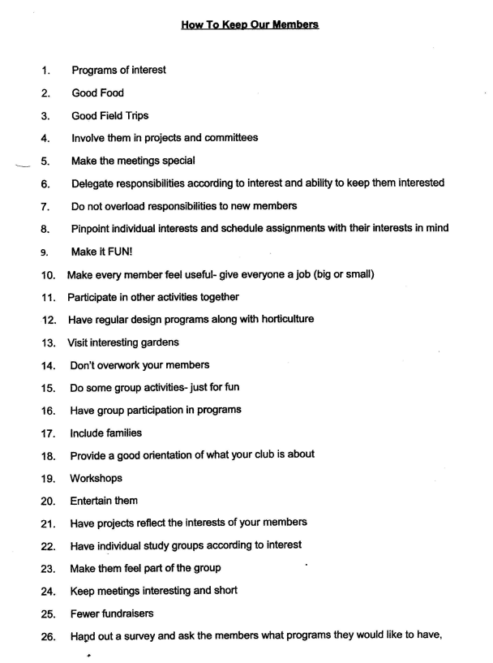

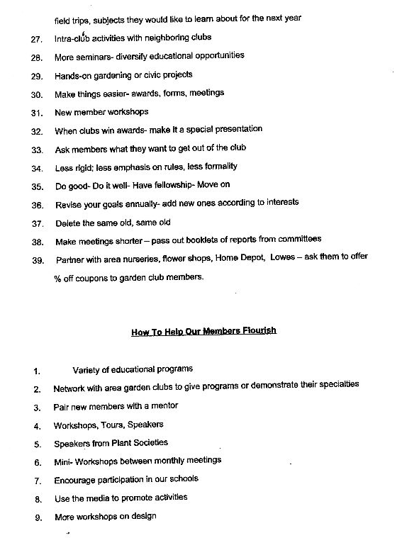

Club Dues
Info
and President Reports

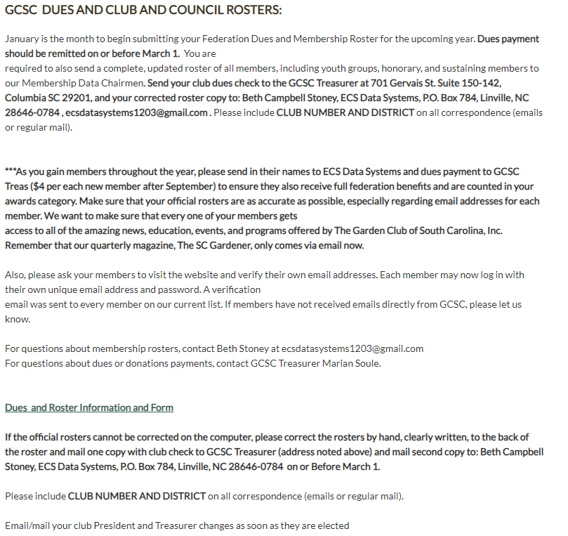



THE GARDEN CLUB OF SOUTH CAROLINA, INC.
ANNUAL REPORT OF GARDEN CLUB PRESIDENTS

Report Due FEBRUARY 1

The Garden Club of South Carolina, Inc. sincerely appreciates your hard work,
dedication, contributions, participation, and enthusiasm throughout the state to increase
our visibility and promote the opportunities GCSC offers to benefit others.

Please report your Garden Club activity from January 1 – December 31
Do not send photos
Make three (3) copies and submit via mail/email to:
GCSC President
Your District Director
Your Garden Club files

Name of Garden Club ___________________________________________________________

GCSC Garden Club # _______________ City ______________________________________

District __________________________________ Number of DUES paying members _______

Year Organized ____________________ Year of GCSC Federation _____________

CURRENT Garden Club Information:

President ______________________________________________________________________

Address ______________________________________________________________________

Phone number _____________________ Email ____________________________________

INCOMING Garden Club Information:

President ______________________________________________________________________

Address ______________________________________________________________________

Phone number _____________________ Email ____________________________________

LENGTH of President’s Term _________ Installation date (month/year) _________________

Sent Club Roster and dues check to GCSC Treasurer treas.gcsc@gmail.com Y/N _____

Members gained this year # _______________ Members lost # _______________

List names of deceased club members during the last year:

List number of club members attending the following:
 | Spring District Meeting |  | GCSC State Meeting |  | SAR Convention
 | District Presidents’ Conference |  | GCSC Convention |  | NGC Convention

Do you visit the GCSC Website: Often ________ Occasionally ________ Never ________

Is the Website easy to navigate: Yes _____ No _____

Comments ____________________________________________________________________

______________________________________________________________________________

Check the following that your Garden Club used for meetings/projects/events:
 | Arbor Day/Trees |  | Conservation |  | Litter Control/Recycling
 | Backyard Wildlife Habitat |  | Design |  | Memorial Garden
 | Birds |  | Flower Show |  | National Garden Week
 | Bees/Butterflies |  | Garden Therapy |  | Native Plants
 | Blue Star Memorial |  | Girl Scouts |  | Plant It Pink
 | Camp Wildwood |  | Historic Preservation |  | Roadside Beautification
 | Civic Development |  | Horticulture |  | Youth Activities
 | Other:

Number of Garden Club members having or participating in the following:
 | Backyard Wildlife Habitats |  | Landscape Design Sch. |  | GCSC Logo Sales
 | Environmental Studies Sch. |  | GCSC Life Membership |  | GCSC Awards
 | Flower Show School |  | SAR Life Membership |  | GCSC Board of Directors
 | Judges Club |  | NGC Life Membership |  | GCSC Tours
 | Gardening School |  | NGC Calendars |  | Grants

Does your Garden Club donate to the following:
 | Camp Wildwood |  | State Scholarships |  | Five Star Honor Clubs*
 | Memorial Garden |  | District Scholarships |  | State Christmas Tree
 | President’s Projects Fundraising |  | GCSC Charitable Giving/Bequests
*Five Star Honor Clubs Project supports the following GCSC programs and projects:
- Camp Wildwood/Youth Symposium
- Blue Star Memorial
- GCSC Headquarters
- SC State Christmas Tree
- Memorial Garden
GCSC distinguishes Clubs or Councils that donate a minimum of $200 to the Five Star Honor Clubs Project with their
name placed on the Five Star Plaque displayed at State Meeting and Convention and listed in the SC Gardener.

Please respond to the following questions on the back or separate page:
1. Provide CONTACT information ONLY for BEST PROGRAM -list one or more
2. Describe your Garden Club’s MOST OUTSTANDING PROJECT (One page or less)
3. Identify any way to improve GCSC.

THE GARDEN CLUB OF SOUTH CAROLINA, INC.
ANNUAL REPORT OF GARDEN COUNCIL PRESIDENTS

Report Due FEBRUARY 1

The Garden Club of South Carolina, Inc. sincerely appreciates your hard work,
dedication, contributions, participation, and enthusiasm throughout the state to increase
our visibility and promote the opportunities GCSC offers to benefit others.

Please report your Garden Council activity from January 1 – December 31
Do not send photos
Make three (3) copies and submit via mail/email to:
GCSC President
Your District Director
Your Garden Council files

Name of Garden Council ___________________________________________________

GCSC Garden Council # __________ City ________________________________

District ______________________________________ Number of Clubs ______

Year Organized __________ Year of GCSC Federation __________

CURRENT Garden Council Information:

President ______________________________________________________________________

Address ______________________________________________________________________

Phone number ____________________ Email ____________________________________

INCOMING Garden Council Information:

President ______________________________________________________________________

Address ______________________________________________________________________

Phone number ___ Email ____________________________________

LENGTH of President’s Term _________ Installation date (month/year) ___________

Sent Council Roster and dues check to GCSC Treasurer treas.gcsc@gmail.com Y/N ______

Clubs gained this year # ______________ Clubs lost this year # __________________

Do you visit the GCSC Website: Often ________ Occasionally ________ Never _______

Is the Website easy to navigate: Yes ________ No ________

Comments: ____________________________________________________________________

______________________________________________________________________________

______________________________________________________________________________
Check the following that your Garden Council used for meetings/projects/events:
 | Arbor Day/Trees |  | Conservation |  | Litter Control/Recycling
 | Backyard Wildlife Habitat |  | Design |  | Memorial Garden
 | Birds |  | Flower Show |  | National Garden Week
 | Bees/Butterflies |  | Garden Therapy |  | Native Plants
 | Blue Star Memorial |  | Girl Scouts |  | Plant It Pink
 | Camp Wildwood |  | Historic Preservation |  | Roadside Beautification
 | Civic Development |  | Horticulture |  | Youth Activities
 | Other:

Does your Garden Council donate to the following:
 | Camp Wildwood |  | State Scholarships |  | Five Star Honor Clubs*
 | Memorial Garden |  | District Scholarships |  | State Christmas Tree
 | President’s Projects Fundraising |  | GCSC Charitable Giving/Bequests

*Five Star Honor Clubs Project supports the following GCSC programs and projects:

- Camp Wildwood/Youth Symposium
- Blue Star Memorial
- GCSC Headquarters
- SC State Christmas Tree
- Memorial Garden

GCSC distinguishes Garden Clubs or Councils that donate a minimum of $200 to the Five Star Honor Clubs Project with their
name placed on the Five Star Plaque displayed at the State Meeting and Convention and listed in the SC Gardener.

Please respond to the following questions on the back or separate page:
1. Provide CONTACT information ONLY for BEST PROGRAM – list one or more
2. Describe your Garden Council’s MOST OUTSTANDING PROJECT (One page or less)
3. Identify ways to improve GCSC.


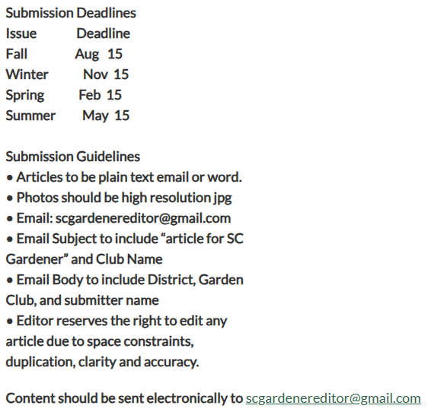
Special Requests: Your help is needed to off-set the rising costs of printing and mailing the SC Gardener magazine. If you would prefer to read the complete issue online and don’t wish to receive a printed copy, please “opt-out” by emailing Laurie Churchill, Editor, at: scgardenereditor@gmail.com.
Also, please ask your members to visit the website and verify their email addresses. Each member may now log in with their own unique email address and password. A verification email was sent to every member on our current list. If members have not received emails directly from GCSC, please let us know.

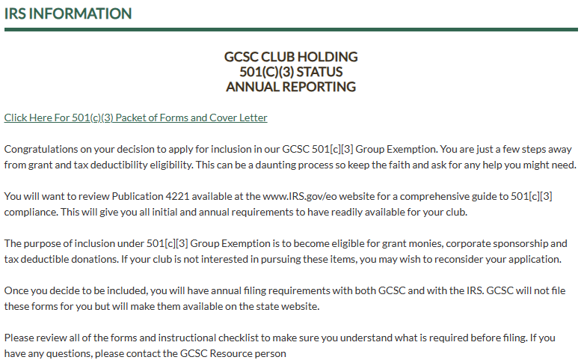






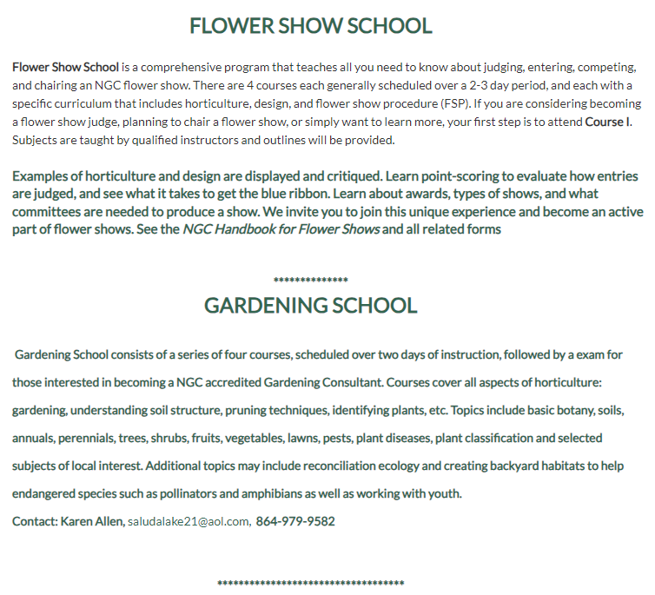


The Garden Club of South Carolina, Inc.
Personnel Form
Instructions: Complete form and mail or email (Attach additional pages if needed; let us know your talents!)
ONE (1) copy to 1st Vice President – Betty Jackson
1247 Augusta Rd., Trenton, South Carolina 29847
803-275-2664, bettywisejackson@gmail.com
TWO (2) copies to your District Director
Forms are DUE by June 30

Name: Address: City, State & Zip:

Email address:

Phone:

Are you currently serving as a GCSC Board Member?

(yes) (no)

(if answered yes what is your position): ______________________________________
Would you like to continue to serve on the GCSC BOD in your current position? ____(yes) ____(no)
If no, what position/office are you interested in?_____________________________________
FOR NEW BOD APPLICANTS ONLY: PLEASE COMPLETE THE REMAINING QUESTIONS
What position(s) on the Board have you held in the past ?

What positions have you held at the District level? ______

All Board of Directors members must read the GCSC Bylaws and Standing Rules documents to understand GCSC’s mission and understand the guidelines for service. Please note required attendance at GCSC Board meetings, donations to support awards, and filing reports.

On a scale of 0-5 (5 is highest), please provide your level of proficiency with computer usage (0-5)_____
level 0= Don’t use computer
level 1= READ only - Email, search web only
level 2= BASIC READ/WRITE – open/create WORD documents, Use Facebook, share photos
level 3= PROFICIENT – Open/create basic MS Office files (WORD/EXCEL/PowerPoint) attach documents to emails, manage Facebook pages, edit photos, convert to PDF, etc.
level 4= ADVANCED - #3+ Desktop publishing skills, proficient in social media. level 5= PRO - #4 + ADVANCED Social media skills on several platforms.

Position (s) you seek on GCSC Board of Directors:

Your garden club (Name, Town & District):

Educational/Professional Background:

Skills/line of work/occupation:

Garden club positions held (Local Garden Club)

Activities and/or membership in other organizations (horticulture, civic, church, other):

Areas of special garden club interest (i.e., historic preservation; youth; horticulture; publicity; environment; other):

Identify particular areas of expertise:

Briefly describe your experience, expertise and interests you bring to GCSC that will enable you to be a team player and promote the best interests of this volunteer organization:

Signature: Date:

West Low Country District
Personnel Form
Instructions: Complete and mail or email (Attach additional pages if needed; let us know your talents!)
Email to Kathy New at knknew@comcast.net or
Mail two (2) copies to 222 Patricia Drive, North Augusta, SC 29841

Name: ____________________________________________________________________________
Address: __________________________________________________________________________
City, State, and Zip: __________________________________________________________________
Email address: __________________________________________ Phone: _____________________
Are you currently serving as a WLC Chairperson? ____________ (Yes) ______________ (No)
If answered yes, what is your current position? _________________________________________
Would you like to continue to serve WLC in your current position? ________ (Yes) ______ (No)
If no, what position/office are you interested in? ________________________________________
FOR NEW WLC POSITIONS ONLY: PLEASE COMPLETE THE REMAINING QUESTIONS
What position(s) in WLC have you held in the past? ________________________________________
__________________________________________________________________________________
What position(s) have you held in your garden club? _______________________________________
__________________________________________________________________________________
-------------------------------------------------------------------------------------------------------------------------------------
On a scale of 0-5 (5 is highest), please provide your level of proficiency with computer usage (0-5) _________
Level 0 = Don’t use computer
Level 1 = READ only – Email, search web only
Level 2 = BASIC READ/WRITE – Open/create WORD documents, use Facebook, share photos
Level 3 = PROFICIENT – Open/create basic MS Office files (WORD/EXCEL/POWERPOINT), attach documents to emails, manage Facebook pages, edit photos, convert to PDF, etc.
Level 4 = ADVANCED - #3 + Desktop publishing skills, proficient in social media
Level 5 = PRO - #4 + ADVANCED social media skills on several platforms

Position(s) you seek with West Low Country: ____________________________________________________
Your garden club (Name, Town, & District): _____________________________________________________
_________________________________________________________________________________________
Educational/Professional Background:
Skills/Line of Work/Occupation: _______________________________________________________________
_________________________________________________________________________________________
Garden Club positions held (Local Garden Club): __________________________________________________
_________________________________________________________________________________________
Activities and/or membership in other organizations (horticulture, civic, church, other): __________________
_________________________________________________________________________________________
_________________________________________________________________________________________
Areas of special garden club interest (historic preservation; youth; horticulture; publicity; environment; other):
_________________________________________________________________________________________
_________________________________________________________________________________________
_________________________________________________________________________________________
Identify particular areas of expertise: __________________________________________________________
_________________________________________________________________________________________
_________________________________________________________________________________________
Briefly describe your experience, expertise and interests you bring to West Low Country that will enable you to be a team player and promote the best interests of this volunteer organization: ________________________
_________________________________________________________________________________________
_________________________________________________________________________________________
_________________________________________________________________________________________
_________________________________________________________________________________________
_________________________________________________________________________________________
All chairmen must read the GCSC Bylaws and Standing Rules to understand GCSC’s mission and understand the guidelines for service.

Signature: ____________________________________________________ Date: _______________________

GARDEN CLUB/COUNCIL LEADERSHIP GUIDE
View the:
Garden Club/Council Leadership Guide
Leadership Guide Cover
“Did you know that as a garden club member you are part of the largest volunteer organization in the nation? There are approximately 180,000 garden club members of National Garden Clubs, Inc. (NGC) and approximately 5000 members of the Garden Club of South Carolina, Inc. (GCSC). Individually and collectively, we make an important difference in our communities, state and nation!

The Garden Club of South Carolina, Inc., a nonprofit 501(c)(3) charitable organization, is a force for good that promotes all aspects of gardening, focusing on preservation and restoration of historic gardens, conservation and environmental protection of natural resources, education of members and youth, organizations, civic beautification, horticulture, and floral design.”

“This booklet was originally published by GCSC, Inc. in June 2011 as the Garden Club/Council Offices’ Manual. It was updated and revised in June 2015 as the Garden Club/Council Leadership Guide by Yvonne Morris, Former GCSC President(2015-2017) and Karen Oliver, 2009-11 Officers’ Manual Committee Chairman/Former West Low Country Director and Current GCSC Birds Committee Chairman.

The Garden Club
of
South Carolina, Inc.
Garden Club/Council
Leadership Guide

Member of
National Garden Clubs, Inc.
And
South Atlantic Region

This booklet was originally published by GCSC, Inc. in June 2011 as the Garden Club/Council Offices’ Manual. It was updated and revised in June 2015 as the Garden Club/Council Leadership Guide by Yvonne Morris, Current GCSC President; Karen Oliver, 2009-11 Officers’ Manual Committee Chairman/Former West Low Country Director and Current GCSC Butterflies and Bees Committee Chairman; and Dee LeMay, GCSC Corresponding Secretary.
This guide will be presented by Karen Oliver at the July 2015 Summer Expo, an informational meeting for all Garden Club of South Carolina Club/Council Presidents and any club members who attend. This guide will be posted on the GCSC website: www.gardenclubofsc.org

Table of Contents
Introduction and Welcome........................................................... 1
Organizational Structure .............................................................. 2
Resources and Communication .................................................... 3
Hints for Effective Leadership ..................................................... 6
Successful Meeting Tips .............................................................. 7
Suggested Order of Business ....................................................... 7
Officers’ Roles and Responsibilities ........................................... 8
President ...................................................................................... 8
Vice President(s) ......................................................................... 9
Recording Secretary .................................................................... 9
Corresponding Secretary ........................................................... 10
Treasurer .................................................................................... 10
Membership Strategies .............................................................. 12
Awards = Recognition and Publicity ......................................... 13
References .................................................................................. 13

INTRODUCTION AND WELCOME
Did you know that as a garden club member you are part of the largest volunteer organization in the nation? There are approximately 180,000 garden club members of National Garden Clubs, Inc. (NGC) and slightly more than 5,100 members of the Garden Club of South Carolina, Inc. (GCSC). Individually and collectively, we make an important difference in our communities, state and nation!
The Garden Club of South Carolina, Inc., a nonprofit 501(c)(3) charitable organization, is a force for good that promotes all aspects of gardening, focusing on preservation and restoration of historic gardens, conservation and environmental protection of natural resources, education of members and youth, organizations, civic beautification, horticulture, and floral design.”
A complete list of the NGC and GCSC Objectives can be found at our website www.gardenclubofsc.org

ORGANIZATIONAL STRUCTURE
You belong to your local garden club
which may be part of a Garden Council
that belongs to one of Seven Districts:

Coastal ~ East Low Country
West Low Country ~ East Piedmont
West Piedmont ~ East Sandhills ~ West Sandhills
Presiding Officer: District Director

Then, Districts belong to:
The Garden Club of South Carolina, Inc. (GCSC)
Organized April 22, 1930
Presiding Officer: State President

The 50 State Garden Clubs are divided into Eight Regions:
New England ~ Central Atlantic ~ Deep South
South Atlantic ~ Central ~ South Central
Rocky Mountain ~ Pacific
Presiding Officer: Regional Director

GCSC is a member of the South Atlantic Region (SAR)

All Eight Regions belong to:
National Garden Clubs, Inc. (NGC)
A national organization whose mission
provides education, resources, and national networking opportunities to promote the love of gardening, floral design, and civic and environmental responsibility.
Founded in 1929
Presiding Officer: NGC President

RESOURCES AND COMMUNICATION
All officers and chairmen in NGC, SAR and GCSC serve for a two-year term, beginning and ending in odd-numbered years. Nominating takes place in even-numbered years. Clubs/councils are encouraged to follow this administrative term to facilitate recordkeeping and mailing of various publications.
Email and web access have become the prevailing methods of communication, especially filtering down from the national level to state level to districts/councils/clubs. If the club/council president is not proficient at the computer, then it is advisable to designate someone in the club to receive all email communications and pass them on. Email is undoubtedly the most efficient and rapid method of communication, but it is not failsafe. Computers crash and email messages can inadvertently be diverted to spam or junk mail. Remember to follow up with phone calls or letters, as necessary.
National Garden Clubs, Inc. (NGC)
NGC Headquarters is located in St. Louis, Missouri. Mem-bers may contact headquarters by phone: 314-776-7574 ext. 15 or visit the website: www.gardenclub.org for gardening tips, special projects, schools, designs, forms and sales items. All council/club presidents receive The National Gardener, a quarterly magazine, for their terms of office as do National Life members and current subscribers. Also, NGC Flower Show Judges, Landscape Design Consultants, Garden Study Consultants and Environmental Study Consultants must sub-scribe to maintain their credentials. The National Gardener contains information on education programs, schools and symposiums throughout the United States. It has articles re-lated to horticulture and floral design, as well as official Flower Show information and rule changes. It is essential that all judges and members planning Flower Shows make these written corrections in the Handbook for Flower Shows when they are published in The National Gardener, spring and summer issues. Council/Club presidents should advise members of these changes.
NGC also has online shopping service for books, flower show supplies, official jewelry, pins and education program tools. The website contains a wealth of information and several free publications, as well as all NGC-related forms.
The annual National Convention rotates among states. National Conventions are very enjoyable, informative and educational. Vendors from across the country provide wonderful shopping opportunities for design and horticulture supplies.
As part of its mission, NGC offers educational opportunities for members and non-members. Flower Show Schools are a series of courses to train NGC members to become Accredited Flower Show Judges. Landscape Design Study Courses offer a series of four 10-hour courses which cover the history of landscape design and offer instruction from landscape architects in a variety of design techniques used in home and municipal settings. Environmental Study Schools are a series of four courses in environmental studies. Students completing the courses may become NGC Environmental Consultants. Gardening Study Courses fo-cus on helping members become accomplished horticulturists. Courses cover all aspects of growing, from understand-ing soil structure to pruning techniques, plant identification, etc. All courses may be sponsored by member clubs, groups of clubs, districts or state garden clubs and are open to gar-den club members and nonmembers. Credentials/course credits earned in one state are recognized in all states.

South Atlantic Region (SAR)
SAR is composed of five states: Kentucky, North Carolina, South Carolina, Virginia and West Virginia. The South Atlantic Region Director sends correspondence to each state president regarding Regional Projects. Conventions are held annually and rotate among the member states.
Garden Club of South Carolina, Inc. (GCSC)
GCSC provides three methods of communicating with members:
- The South Carolina Gardener is a quarterly mag-azine which contains timely information about state, district and club activities. It contains time-ly information about state, district and club activities. It is sent to every dues-paying member of GCSC.

- The Garden Club of South Carolina, Inc. Handbook is published every two years with each new administration. It contains contact information for state officers, district directors, chair-men, and Flower Show judges, and consultants for Landscape Design. It also lists a calendar of events and awards due dates, all awards information, and GCSC history, Bylaws and Policy and Procedure. It is printed for GCSC Board members and is available on the GCSC website.

- www.gardenclubofsc.org lists valuable information and provides timely reminders and forms. Bookmark it on your “favorites” site on your search engine to keep up with the news.

Every club receives an annual roster in early spring, which includes the club’s identification number. Since many clubs have identical names, it is essential that you place your correct number on all checks for the payment of state dues. It is most important that each council/club president and treasurer review the roster, make corrections and return the corrected roster with member dues payment to the GCSC Treasurer by March 31 of each year.
Each Club and Council President is responsible for completing an annual “President’s Report” and mailing it to the State President and the District Director by February 1. By re-viewing the president’s report at the beginning of each monthly meeting and recording members’ activities that ap-ply, recordkeeping is much more accurate.
GCSC holds an educational and informational event each summer in Columbia. This meeting is open to all members with special emphasis on club/council officers. The State President conducts the meeting and will introduce State Officers, District Directors, and will present projects and programs applicable to this two year administration. State Chairmen provide exhibits and workshops to help districts, councils and clubs explain and promote NGC, SAR and state projects.
GCSC holds a spring State Convention in odd numbered years, rotating host responsibilities among the seven districts. New GCSC Officers and District Directors are installed at this time. State conventions are fun and exciting to attend and are wonderful opportunities to meet stimulating members from all over the state who have varied goals and interests. (Hint! Sit at a table with strangers. You may have some new best friends by the end of the meal!)
GCSC hosts a one-day spring State Meeting in Columbia in even numbered years, to have a special guest speaker, pre-sent awards and conduct business. Members always look forward with special interest as they hear reports about other garden clubs from the District Directors. What a great way to get more program ideas! An entertaining and informative speaker then rounds out the day’s activities. The numerous projects that receive awards offer ideas and inspiration for ways to serve communities throughout the state.

Districts/Councils/Clubs

Each District holds an official annual meeting in March. The GCSC State President and many state board members attend to share ideas, while interesting speakers and vendors make a district meeting well-worth attending. District awards high-light these district meetings.
Your District Director and Co-director are always glad to answer questions and share information to help you be a more effective officer. The areas and towns in each district and the district directors and co-directors are listed on the website. Do not hesitate to call or email your director or co-director for assistance.
Councils of Garden Clubs are found usually in larger com-munities, where clubs join to share ideas, information and resources. A council serves as a resource to clubs and coordinates garden club activities that contribute to the community.
Your club is the most vital link in the whole federated organization! As officers, you hold the key to the vitality of your group.

The knowledge, attention, energy and enthusiasm of the president directly affects the club’s growth and performance and the members’ satisfaction.
HINTS FOR EFFECTIVE LEADERSHIP
“It is a fine thing to have ability, but the ability to discover ability in others is the true test.”¹

Leadership Is A Set of Functions:

A leader guides the club with sensitivity and consideration for members. Always remember that new members (and even some more experienced members) of your club may not be familiar with the projects, programs, terminology or activities that are discussed and may be hesitant to ask questions.
A successful leader trains others to lead, giving them a chance to share talents and responsibility. Take interest in others and encourage them. Always welcome constructive criticism.
An officer delegates authority; then truly expects that person to fulfill their job. This encourages members to feel responsible for the club’s success.
Know your organization. If you don’t, admit it and find out the answers! Read the bylaws; update them carefully as needed. Keep up with information coming from NGC, GCSC, SAR and your district.
Computer skills have become essential for officers. GCSC can offer guidance on the use of the state website and may conduct workshops to assist members.
Above all, remember that we are all volunteers, and that volunteers need encouragement. Lavishly give recognition to those who deserve it.

Successful Meeting Tips
- A positive attitude is highly contagious! Spread it liberally!

- Time is our most valuable commodity. No one wants to attend meetings that are a waste of time.

- Always start and end your meetings on time.

- All officers and committee chairmen must know and understand their responsibilities.

Suggested Order of Business

Call to Order
Welcome by the President
Invocation
Roll Call of Members
Introduction of Guests
Approval of the Minutes
Correspondence
Treasurer’s Report
Officers’ Reports, Beginning with the President
Reports of Standing Committee Chairmen
Reports of Special Committee Chairmen
Unfinished Business
New Business
Announcements
Program
Adjournment
OFFICERS’ ROLES AND RESPONSIBILITIES
President
When you accept the nomination for president, realize your responsibility for guiding these hard-working volunteers. You must review your council/club’s rules and bylaws, up-date them if needed, and be prepared to enforce them with dignity and tact. Preside with courtesy and poise, according to parliamentary procedure. Give serious thought to assignment of the committee chairmanships.

1. Either just before or after installation, hold a preliminary board meeting to set goals and make plans for this administration. Review National, Regional, State and District projects to decide which to incorporate. Review officers’ responsibilities and state your expectations. (E.g., every officer and committee chair-man is expected to attend all executive board and governing board meetings. If you cannot attend, then make sure your report is provided in your absence, or let the president know there is no report.)

2. Once club activities have been decided, then prepare a budget to facilitate them. Present the proposed budget to the general membership. You must be fiscally responsible and assure that enough money is left for business to continue when you leave the presidency.

3. Prepare a written agenda for each meeting and dis-tribute it to all attending to keep the meeting focused on the issues and time. Members will know exactly when they are to report. The agenda can be as de-tailed as you want, or it can be merely an outline.

4. Keep the club’s stated goals and objectives before the club members throughout the year.

5. Each officer and chairman should make scheduled reports for meetings and an annual written report.

6. At the end of the fiscal period, it is an excellent idea to have a review of the financial records by a committee other than the treasurer, with her assistance. It is very sound fiscal advice to revise your bylaws if they fail to address this.

7. Be on time and call all meetings to order promptly. Keep the proceedings moving according to the agenda.

8. It is the president’s responsibility to accurately complete the annual President’s Report due to the District Director and State president by February 1st. It can be found on the GCSC website.

9. The projects listed on the President’s Report can help clubs decide which projects to pursue for that year. RECOMMENDATION: Review the President’s Report at the first meeting of the year, and update at every meeting. This is much easier than trying to re-construct it much later.

Vice President(s)
The presiding officer is usually the president, but the vice president may have to fill in at times. In case the president is not able to fulfill her term, the first vice president usually is called on to complete it. Refer to the club bylaws for specific responsibilities. Good communication is vital between all officers. “Cross-training” is not only a valuable tool in the workplace, but also in volunteer organizations. Location of and access to club possessions (stationery, Flower Show properties, financial documents and institutions) should be general knowledge. Specific job responsibilities will vary according to your bylaws, so review them carefully. With regard to the regular task of creating the council/club year-book, a very astute East Low Country member recommends saving it in your documents and also backing it up on a DVD or CD. Not only is the data protected in case of a hard drive crash, but also compiling the next yearbook will then be much easier by simply editing the existing yearbook. The CD or DVD can be given to the subsequent yearbook editor.

Recording Secretary
It is highly desirable that the recording secretary be proficient in a word processing program and have the physical capability to take and transcribe minutes. If the president fol-lows the same order of business on her written agenda each meeting, it is much easier to set up the format in the computer. If it is saved (e.g., “Iris Garden Club Minutes, Sept, 10), then for the next meeting, you can use that file, change the information and then use the “SAVE AS” feature to save both your original folder and the new set of minutes.
The minutes should reflect a record of what is DONE not what is SAID. Minutes are the legal record of the business of your club. The opening paragraph includes the Call to Order (name of club, date, time, place and type of meeting) and the approval of the previous minutes, either “approved as read” or “approved as corrected”. Initial all corrections.
The body of the minutes includes the reports of officers and committees, unfinished business, new business, results of votes and the program and announcements. (The program and announcements are grouped in a separate paragraph at the end of the minutes and included only the speaker name and title of program. Then announcements.) Make no effort to summarize points given by the speaker. A handy reference for all clubs to is Robert’s Rules of Order, Newly Revised 11th Edition.
What every recording secretary should know:
1. Arrive at the meeting on time and be prepared to record the proceedings.

2. Have on hand a copy of the club bylaws and standing rules, the club’s authority on Parliamentary procedure, and the minutes of the previous meetings. Stand up and read the minutes, simply and distinctly. Minutes are a report and a history. The minutes are the LEGAL record of the club and should never reflect the secretary’s opinion.

3. If a motion is complicated, the secretary may ask to have it presented in writing, for accuracy.

4. The president will ask if there are any corrections to the minutes. They are then approved either “as read” or “as corrected”.

5. Make the treasurer’s report a part of the minutes. Be sure to get a copy of all financial documents.
Corresponding Secretary
1. The corresponding secretary is responsible for reading and reporting on all correspondence received on behalf of the club, and for outgoing communications as directed by the president.

2. When reporting to the club, read the communications received and condense long letters, if desired.

3. Give the correspondence requiring action to the president to be acted upon under “New Business”. In some clubs, the corresponding secretary notifies members of upcoming events and may be asked to develop a “list server” for group communications of upcoming meetings for the club/council. She may have the responsibility of compiling and distributing the club/council newsletter.

Read the bylaws for specific responsibilities in your organization. Smaller clubs might combine the duties of recording secretary and corresponding secretary.

Most people will accept leadership jobs if they are given specific assignments and if they believe they have the skills to do the job.

Treasurer
The treasurer is the custodian of the money of the club; collects, deposits and disburses funds; must have authority (by-laws or by a vote) for all expenditures; and keeps a record of dues paid and pays all line items in the budget on time. Some larger clubs, councils and districts may use a computer ac-counting program. It would be highly advantageous if all state/districts, councils/clubs of GCSC used the same pro-gram. This would facilitate reconciliation of all financial re-porting, and also provide cross-training.
1. The treasurer should assure that another member, preferably the president, knows the location of the checkbook and financial records and has access to them in the event of an emergency.
2. For the bank account in the club’s name, the new treasurer should make certain that the bank signature card is properly signed by the new treasurer and the new president.

3. According to the bylaws, (s) he works with the president and the finance committee in the development of the next budget.

4. The treasurer’s report does not require a vote for approval by the members. However, the president should always ask “Are there any questions concerning items in the financial report?” It is then “attached to the minutes.”

5. The president and recording secretary each should receive a copy of the treasurer’s report. The treasurer should possess mathematical and computer skills to carry out the financial business of the club/council. (E.g., more councils and districts are using financial bookkeeping programs.) If a bookkeeping program is used, the prospective treasurer needs to be literate in these programs. It is a good idea to have an assistant treasurer, who can train in these programs and then move up to treasurer.

6. The financial statement should contain: the balance on hand at the beginning of the period; receipts (money received); disbursements (money paid out) and the balance on hand at the close of the period.

7. The treasurer receives the computer roster from GCSC in early spring and is responsible for correct-ing the roster and payment of the state dues of $6.00 per member by March 31 to the GCSC treasurer.

8. The treasurer will assure the club/council computer number is written on all state correspondence.

Remember, we get out of an experience what we put into it. Involvement is the key to a rich, rewarding life of garden club activities.

MEMBERSHIP STRATEGIES
Regardless of how important the work of your garden club is, no matter how vital the services your club performs or how great the potential for fun and fellowship, none of your club’s strengths can be exercised without active membership. ACTIVE MEMBERSHIP is the key! Active, involved and interested members will unlock the doors of success and growth for your club.

Membership involves leadership in two ways:
1. We must recruit new members and help them become active.

2. We must stimulate active participation on the part of existing members.

Ideas to Stimulate Membership
- Be inviting!
- Have interesting programs and projects.
- Invite fellow club members to ride with you to club, council, district, and state meetings.
- Develop a website and keep it updated.
- Develop a club information brochure for distribution.
- Work with a scout troop, with homeschooled children, or at a school to establish youth garden clubs.
- Work with schools to promote recycling and plant workshops.
- Be creative with meeting times, for example, “after work” or evening meetings. Host an informal supper meeting. Form “couples” clubs. These have been successful in many com-munities. Hold “Home Flower Arranging Workshops” or a basic design course, not to be judged.
- Invite potential members (men and women) to your meetings and encourage them to join.
- Hold a new members’ installation ceremony.
- Distribute club brochure and/or membership information at flower shows, garden tours, and education programs.
- Invite prospects to join or to form a new club. Have membership information at the local Chamber of Commerce, neighborhood get-togethers, newcomer groups, and Master Gardner programs. Master Gardeners can be highly energetic garden club members.

AWARDS = RECOGNITION AND PUBLICITY
Awards are the means by which we receive recognition for the work we do. GCSC offers award workshops at the annual summer information meeting and upon request to facilitate applications. Awards rules and due dates are on the GCSC website. Find someone in the club/council who has an aptitude for documenting events. Review the NGC, SAR, GCSC and District projects for awards that fit your club’s activities or interest. State awards applications are made through the GCSC Award Chairman (2nd Vice President) and first place winners that qualify are forwarded to SAR and NGC to compete with other states.
There is a benefit to informing the public of our tremendous activities. Some uninformed people think we just sit around and sip tea! Develop a relationship with someone at your local newspaper and send photos and written facts about your projects. Prepare! Research! Organize! Remember to KISS: “Keep it Simple, Sweetie”.

REFERENCES

“How to Be an Effective President of a Federated Garden Club.” GCG, Dogwood District, 2003.
“Officer Handout.” Augusta Council of Garden Clubs.
Henry M. Robert III and others, Robert's Rules of Order Newly Revised, 11th ed. (Da Capo Press, 2011).
The Garden Club of South Carolina, Inc. Handbook, 2015-17.
“The GCG Presents Stepping Stones for Success.” The Garden Club of Georgia.

