GCSC Memorial Garden
1919 Lincoln St.
Columbia, SC
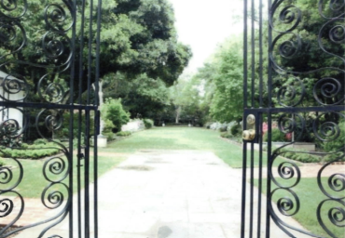
Are you looking for a permanent, heartfelt way to memorialize or honor someone who served or is presently serving in the armed forces? Tribute brick pavers not only serve as a celebration of friends and family, but also provide building blocks for our future, helping to ensure that GCSC Memorial Garden will continue to provide a place of dignity and serenity for the citizens of South Carolina, our community, and all who enter its gates.
Please donate an engraved brick paver in honor or memory of a family member or loved one. Your donation will become a part of the Memorial Garden’s history for years to come. The Garden Club of South Carolina, Inc. is a 501(c)(3) non-profit corporation; therefore, all donations are tax deductible.
Thank you, in advance, for your contribution!
TO RENT THE MEMORIAL GARDEN FOR YOUR EVENT,
CALL 803-737-2235 or email venuesatarsenalhill.com
It’s a great day trip for your club to plan a visit!

Nancy Bunch, Trustees Chairman
