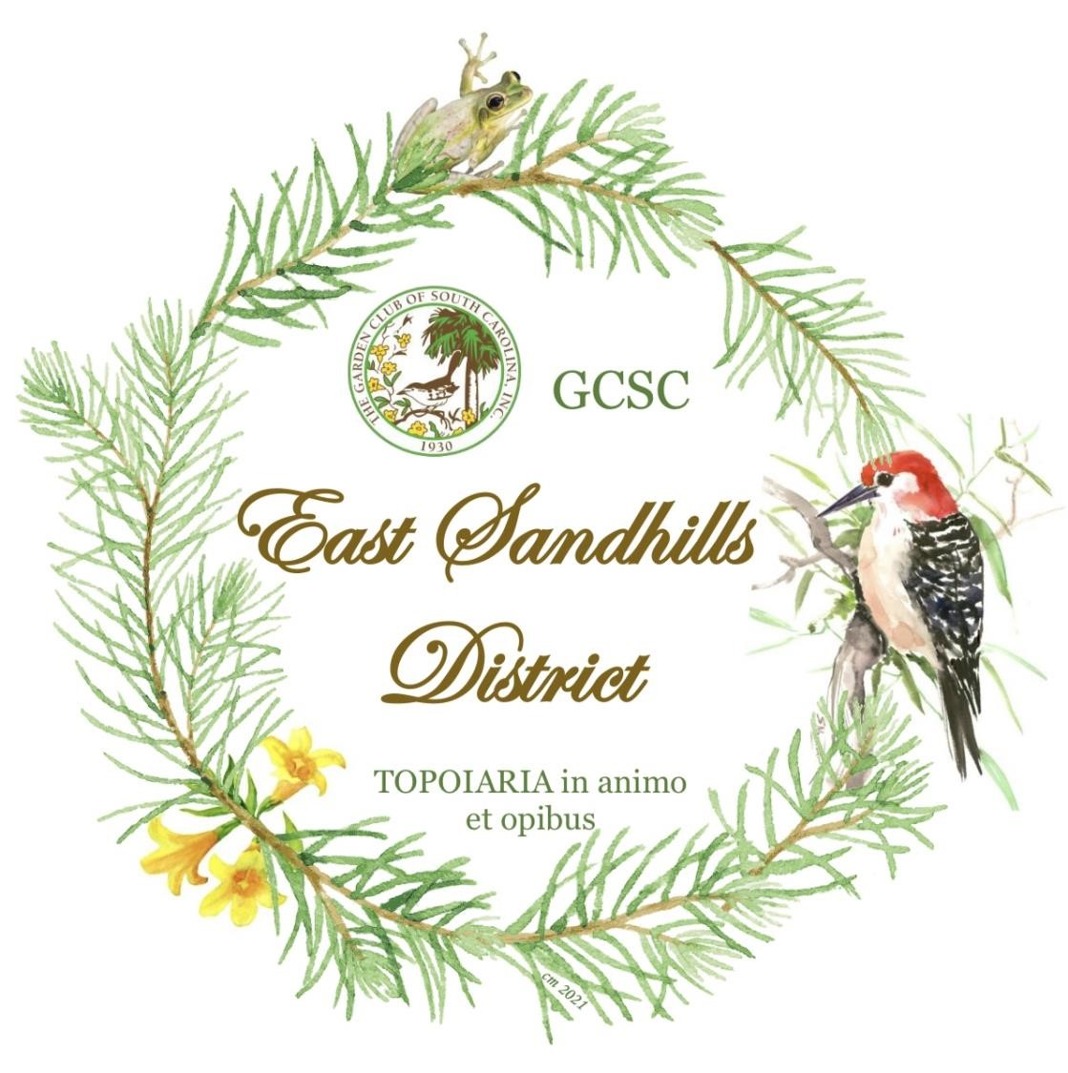

East Sandhills District

Handbook

2025

- 2027 2025

““
Butterflies… “Come learn with me”

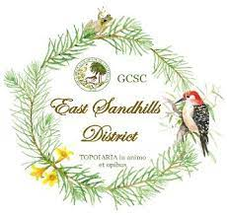

History of the East Sandhills District Crest

The crest was approved and accepted by GCSC President – Linda Howle, April 2021.

Graphicly designed and given as a gift to the new District Director of East Sandhills by Courtney Mozingo of Wildwood Garden Club.

After researching the Sandhills of South Carolina, the artist design depicts a circle of pines that are Long-leaf pines that grow all throughout the Sandhills district. There is a Red-cockaded woodpecker and a Pine Barrens tree frog added within the pines, which are endangered wildlife species in the Sandhills area of South Carolina. The yellow jasmine, also know as the state flower, is to add color for the wild flowers that grow not only throughout the Sandhills area, but all over South Carolina. At the bottom of the crest is Latin “TOPIARIA in animo et opibus”, which translates “Gardening in mind and resources”.

TABLE OF CONTENTS

This Photo by Unknown Author is licensed under CC BY-NC-ND
East Sandhills District Director’s Message…………………………………2

East Sandhills District Director and Co-Director Bio’s……………………3-4

The Garden Club of SC, Inc. Mission, Objectives, Pledge to GC Flag…...5-6

Leaders and Themes for 2025-2027………………………………………...7-9

East Sandhills District Clubs and Councils……………………………….10-11

Calendar of Events for 2025-2027………………………………………….12-13

East Sandhills District Awards……………………………………………..14-15

The Garden Club of South Carolina Awards……………………………..16-28

The Garden Club of South Carolina Scholarships……………………….29-33

Garden Club Program Ideas ……………………………………………….34

Membership …………………………………………………………………35-37

Sample GCSC Award Application - Attachment

Please enroll as a member at the Garden Club of South Carolina, Inc. website: www.gardenclubofsc.org,
Go to the members’ area and sign in. There are directions if you have never signed it. It is a secure website for members. You will have to scroll down to the bottom of the page to insert your username, which will be your email address.
EAST SANDHILLS DISTRICT DIRECTOR’S MESSAGE
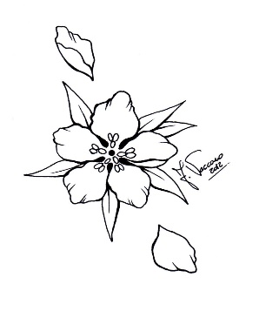 Butterflies… “Come learn with me”

It is an honor to serve as your Garden Club of South Carolina East Sandhills District Director for 2025-2027. Your trust in my abilities to lead this district is greatly appreciated. Over the past two years, I have met many of you and I am inspired and grateful for all the effort, work, and talent that is given by the clubs to their community and surrounding communities. However, we can continue to build on what has been done and continue the successes. With that in mind, the following are the objectives that both myself and the Assistant Director, Terri Brown, have set for the East Sandhills District:

- Improve the submission of yearbooks by reviewing the evaluation form as to how points are used to determine the score.

- Increase garden club/council participation in submitting applications for state awards. It is important for the clubs to be recognized for the work they are doing in their communities.

- Develop a better understanding of the difference between District awards and State awards and the procedures involved in their awarding.

- Create a plan to garner support for submission of state scholarship applications from the East Sandhills District as well as submission of essays for the State Essay contest.

- Continue to focus on communicating with the clubs either by email, text, phone, as well as visiting each of the clubs for one of their meetings. It is so important for the club members to put a face with both the District Director and Assistant Director.

- Increase the awareness of the Club and Council Presidents about the wealth of information contained on the GCSC website and their ability to access and navigate the website.

- Encourage the District Clubs and Councils to embrace the GCSC President’s theme Butterfliers… “Come Flutter with Me!”

- Ensure that club and council Presidents know that we are readily accessible to help them with projects, programs, information, and any other undertakings to make their terms successful.

- Try to increase the membership of the garden clubs. As an agenda item at the Summer Workshop, ideas will be shared on how membership can be increased.

- As a District Director, it is important to include the Assistant Director in all decisions and activities so they are being groomed to accept the responsibilities and role of District Director.

EAST SANDHILLS DISTRICT DIRECTOR BIO


Growing up in a farm family in Orangeburg, SC, I have always had a love for agriculture, the environment, and teaching. When I was in high school, I knew I wanted to teach, but just didn’t know what I could teach. As a high school freshman, I took my first Agri-Science class, and I was hooked. When I was a senior in high school, my FFA Advisor and Agriculture Educator encouraged me to combine my passions and become an Agriculture Educator. I attended Clemson University where I received a Bachelor of Science in Agriculture Education with an inference in Animal Science and then followed up with a Master’s Degree in Agriculture Education with an inference in Food Science and Food Safety and Special Education. I began my teaching journey at Chesterfield High School where I taught Animal Science classes. After three years, I was called to teach at the Lee County Career and Technology Center which only had a Horticulture Program. I didn’t know much about Horticulture, but I was up for the challenge. Within my first-year teaching in Lee County, I was invited to my first Bishopville Garden Club Meeting. The Ladies were welcoming and had a wealth of gardening knowledge that they were willing to share. Together we have grown as gardeners and community members.
At the Lee County Career and Technology Center, I teach two pathways Horticulture and Plant and Animal Systems. We have a garden area, greenhouse, pasture area, equipment area, and shop/lab area. For the animal side, the students and I care for 9 goats, 20 chickens, 3 rabbits, and 2 dogs. Our greenhouse grows fall and spring plants for sale as well as houses student research projects. The students and I grow fall and spring vegetables to share with members of our community and are working toward our GAP certification. We are also in the process of adding fruit and nut trees to help educate the community and provide access to healthy food products. Together we are working to improve our gardening skills, improve our community, and grow as future leaders.
Most of this would not be possible without the support of my husband. He is always willing to lend a hand with any crazy ideas that I have. His passion for agriculture, horticulture, and agriculture education is stronger than mine some days. He loves serving our community at the Bishopville Water Department by making sure we have safe clean water for our city.
Through the Bishopville Garden Club, I have grown from being a Chapter Chaplin to serving as the East Sandhills District Scholarship Committee Chairman, East Sandhills District Youth Committee Chairman, and the East Sandhills Horticulture Committee Chairman. Currently, I serve as the President of the Bishopville Garden Club and I am looking forward to serving as the East Sandhills Assistant Director. I hope that with the help of my fellow garden club members we can make a positive difference in our home, community, region, and state. The love of gardening has brought us together and together we can make a difference.

EAST SANDHILLS DISTRICT ASSISTANT DIRECTOR BIO

Driven by a passion for horticulture and a desire to enhance our communities, I am thrilled to embark on this journey as the garden club assistant director for East Sandhills District. I live in Florence, South Carolina also known as the “Magic City”. The city of Florence received this name by the turn of the century due to its prospering growth. Through the years I have enjoyed volunteering for numerous non-profit organizations in my community.

My love for gardening was instilled at an early age by my Grandparents. My Grandfather worked in the gold mines in Alaska during the great depression. In doing so he was able to send my Grandmother $2000.00 dollars. My Grandmother was supposed to buy tickets for herself and her three daughters to Alaska but instead my Grandmother took the money and bought 350 acres of timber and farmland in southern Georgia. My Grandmother said she would rather be warm and starve than cold and starve. My Grandfather came back to Georgia where they worked and made a beautiful farm. I learned lots of skills from them both that I still use today.

I retired from the mortgage banking industry 10 years ago and helped my husband Mike start a Heating, Air, and Electrical company. A few years ago, we retired from the business and just enjoy spending time with our Children and Grandchildren. We also both loves gardening together.

I look forward to the next few years with enthusiasm. I know there is lots of knowledge we all can share. I look forward to learning about the projects and programs from each of the clubs. Always remember your dedication and hard work makes your clubs thrive, and your contributions to the communities are invaluable.



THE GARDEN CLUB OF SOUTH CAROLINA, INC.



MISSION: The Garden Club of South Carolina, Inc., a non-profit organization, is a force for good that promotes all aspects of gardening, focusing on preservation and restoration of historic garden, conservation and environmental protection of natural resources, education of members and youth organizations, civic beautification, horticulture, and floral design.

PLEDGE OF ALLEGIANCE TO THE FLAG OF THE GARDEN CLUB OF SOUTH CAROLINA:

I Pledge allegiance to the Flag of the Garden Club of South Carolina for the love of gardening for which it stands, for the promotion and protection of our environmental concerns, and for achievement in beautification and conservation in all phases of Garden Club service. Written by Emily Floyd Stephens, President 1999-2001.

QUICK FACTS:

- We have 4,150 members.
- We have 175 clubs.
- We have 18 Governing Councils.
- We are a member of the National Garden Clubs, Inc. and the South Atlantic Region.
- We were first organized on April 22, 1930 and Federated with the National Garden Clubs, Inc. April 22, 1934.
- We are proud to have these Affiliate Members:
  - Moore Farms Botanical Garden
  - Riverbanks Zoo and Botanical Garden
  - South Carolina Botanical Garden at Clemson
  - Piedmont Physic Garden
  - South Carolina Wildlife Federation

  - South Carolina Native Plant Society
  - South Carolina Blue Bird Society

OBJECTIVES:

- To encourage civic planting and beautification and the establishment and maintenance of roadside parks
- To promote the protection and conservation of our natural resources
- To maintain the Memorial Garden and establish roadside memorials on designated Blue Star Highways honoring our war dead and living veterans
- To further horticultural education, conservation, and landscape design through scholarships
- To advance the arts of gardening, landscape design, flower arranging, and horticulture through schools, symposiums and non-commercial flower shows
- To coordinate the interest and activities of this organization and to cooperate with other organizations in the furtherance of the aforementioned objectives in such activities as may be determined by the Board of Directors
- To give awards for achievement in beautification, conservation, and horticulture
- To encourage the love of all phases of garden club work among youth

SEVEN DISTRICTS:
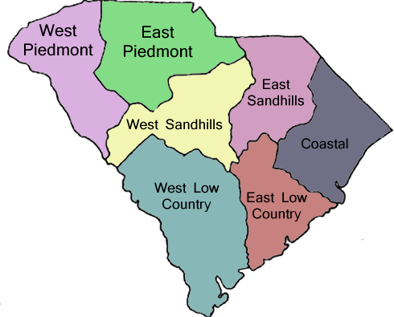
- West Piedmont
- East Piedmont
- West Sandhills
- East Sandhills
- Coastal
- West Low Country
- East Low Country

LEADERS AND THEMES


NATIONAL GARDEN CLUB, INC.
2025-2027 President, Donna M. Donnelly
“Plant America for the next 100 years!”
dmdonnelly@gardenclub.org


SOUTH ATLANTIC REGIONAL GARDEN CLUB
2025-2027 Regional Director, Linda Howle
“South Atlantic Region-Watch Us Grow!”
howlelinda@yahoo.com


THE GARDEN CLUB OF SOUTH CAROLINA, INC.
2025-2027 President, Betty Jackson
Butterflies… “Come Flutter with Me!”
bettywisejackson@gmail.com

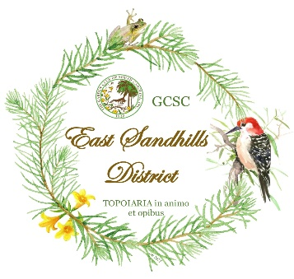
THE GARDEN CLUB OF SOUTH CAROLINA, INC.
EAST SANDHILLS DISTRICT
2025-2027 District Director, Elizabeth Tolson
Butterflies “Come learn with me”
617 Bethune Highway
Bishopville, SC 29010
jtolson617@ftc-i.net or tolsone@lee.k12.sc.us
803-229-2845 (cell)

2025-2027 Assistant Director, Teri Brown
459 Edenderry Drive
Florence, SC 29501
Terea.s.brown@gmail.com
843-601-1721 (cell)

THE GARDEN CLUB OF SOUTH CAROLINA, INC. EXECUTIVE BOARD 2023-2025

Betty Jackson – President
Jan Burch – First Vice President/Finance Chairmen
Peggy Benton – Second Vice President/ Events Chairman
Michelene Sheehy – Third Vice President/Awards Chairman
Dot Closs – Recording Secretary
Kim Rossi – Corresponding Secretary
Marian Soule – Treasurer
Linda Howle - Parliamentarian
Becky Crow – Historian
Coastal District Director – Graceann Phillips
East Low Country District Director– Joan McDonald
West Low Country District Director – Christy T Sloan
East Sandhills District Director – Elizabeth Tolson
West Sandhill District Director– Margaret Axson
East Piedmont District Director– Denie Crowder
West Piedmont District Director – Phyllis Roth

Other Chairmen:

Margaret Graham – Webmaster, Registrar, and Star Chapter
843-222-2548 jpgmcg69@gmail.com

Tara Ranson – Membership
803-487-3236 tdranson@yahoo.com

THE GARDEN CLUB OF SOUTH CAROLINA, INC.
PRESIDENT, Betty Jackson 2025-2027
Butterflies… “Come Flutter with Me!”

Butterfly Kits

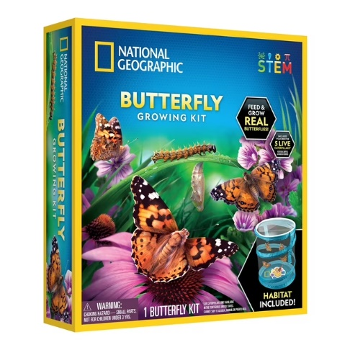

National Geographic Butterfly Growing Kit for Child 4 Years and up
$13.56 at Walmart

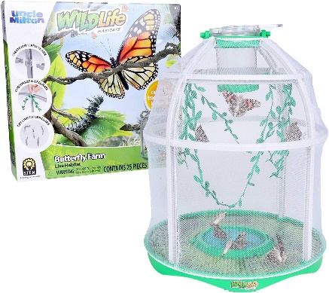

Uncle Milton Butterfly Farm Live Habitat - Observe Caterpillars Transform Into Butterflies, STEM Toy, Great Gifts for Boys & Girls Ages 6+
$19.99 at Amazon

Purchase a Butterfly kit and share the experience with a group of students.


Ea0st Sandhills District
Garden Club/Council
Presidents and Co-Presidents
a
as of June 9, 2025
1. Azalea Garden Club Meet: 1st Thursday @ 6:00 p.m.
Grace Prescott
2395 Watersong Run 803-607-9274 (H)
Sumter, SC 29150 803-968-5694 (C)

- Azalea Home and Garden Club Meet: 2nd Monday @ 6:00 p.m.
Geneva H. Brown Jenny229L@gmail.com
229 Lester Avenue 843-799-4589 (H)
Florence, SC 29501 843-621-0312 ©

3. Bishopville Garden Club Meet: 1st Monday @ 7:00 p.m.
Beth Tolson jtolson617@ftc-i.net or tolsone@lee.k12.sc.us
617 Bethune Hwy. 803-428-2080 (H)
Bishopville, SC 29010 803-229-2845 (C)

- Council of Garden Clubs of Sumter Meet: 1st Wednesday @ 10:00 a.m.
Patricia Hamilton Fernandez mplwfernandez@aol.com
417 West Calhoun St. 610-291-3886 ©
Sumter, SC 29150

- Darlington Garden Club Meet: 3rd Tuesday @ 6:00 p.m.
Debbie Spinazzola debbie.spinazzola@gmail.com
438 Bubbly Brook Drive 252-532-5074 ©
Darlington, SC 29532

- Florence Council of Garden Clubs Meet: 2nd Monday @ 10:00 a.m.
Terri Brown teresa.s.brown@gmail.com
459 Edenderry Drive 843-601-1721
Florence, SC 29501

- Forget-Me-Not Garden Club Meet: 3rd Thursday @ 9:30 a.m.
Elise Walker ewalker1@sc.rr.com
2122 Tudor Lane 843-229-1699
Florence, SC 29505

8. Four O’clock Garden Club Meet: 2nd Thursday @ 4:00
Kathy Stedman kstedman5593@gmail.com
825 Abbington Hall 843-260-4489
Florence, SC 29501

9. Lee Gardeners Garden Club Meet:
Angela Pate angela.pate@gmail.com
4989 Elliott Highway 803-968-2426
Lynchburg, SC 29080 803-453-5080

10. Pageland Garden Club Meet: 2nd Thursday @ 7:00 p.m.
Catherine Williams davisg@shtc.net
997 Griggs Street Computer Communication send to Lane Wallace
Pageland, SC 29728 lanedwallace@gmail.com

11. Pine Haven Garden Club Meet: 2nd Friday @ 10:00 a.m.
Elizabeth Herdt missperky53@yahoo.com
1314 W. Brookwood Dr. 843-617-3882
Florence, SC 29501

12. Poinsett-Bland Garden Club Meet: 2nd Thursday @ 3:00 p.m.
Gay Nelson gsn76usc@gmail.com
2198 Avalon Drive. 803-481-2282
Sumter, SC 29154

- Quinby Garden Club Meet: 1st Monday @ 6:30 p.m.
Karen Belissary kbelissary@newgenerationshhc.com
3719 West Gentry Drive 843-230-8879
Florence, SC 29501

- Sunflower Garden Club Meet: 1st Thursday @ 5:00 p.m.
Vanessa Prince vanessaprince1@att.net
111 Court Street 843-544-7638
Bennettsville, SC 29512

- Wildwood Garden Club Meet: 2nd Wednesday @ 5:00 p.m.
Folly Carter wallacehouse@fmarion.edu
4822 East Palmetto Street 843—230-2259 ©
Florence, SC 29506

The Garden Club of South Carolina
2025 – 2026
Calendar (as of July 1, 2025)

2025

May 1 | NAJCSC Meeting, Columbia
May 15 | Gardener, Summer Edition Deadline
May 18 – 23 | National Garden Club Convention, North Charleston, SC  Installation of Donna Donnelly as NGC President
May 30 | GCSC Memorial Day Service
June 1 - 7 | National Garden Week
June 11 – 12 | Gardening Study School, Course 3 – Series 1, Spartanburg, SC
June 15 - 21 | Camp Wildwood 2025
June 17 | GCSC Finance Committee Meeting - Virtual
June 19 | GCSC Board of Directors Meeting - Columbia
June 25 | West Sandhills District Summer Presidents’ Mtg - Columbia
June 26 | East Sandhills District Summer Presidents’ Mtg - Bishopville
June 27 | East Piedmont District Summer Presidents Mtg - Greenville
July 17 | West Low Country District Summer Presidents’ Mtg –  Graniteville
August 5 | East Low Country District Summer Presidents’ Mtg - Charleston
August 13 | Coastal District Summer Presidents’ Mtg – Little River  (Wampee)
August 15 | Gardener, Fall Edition Deadline
August 19 | West Piedmont District Summer President’s Mtg - McCormick
September 1 | Yearbooks due to GCSC President and District Directors  Begin sending GCSC state award applications
September 17 | GCSC Finance Committee Meeting - Virtual
September 18 | NGC Board Meeting - Virtual
September 25 | GCSC Board of Directors Meeting, Columbia
October 1 | District Yearbook First Place Winners due to GCSC  Third Vice President Awards Chairman
October 2 | NAJCSC Meeting, Columbia
November 7 | Memorial Garden Veterans’ Event, Columbia
November 11 - 12 | Landscape Design School - Charleston
November 15 | Gardener, Winter Edition Deadline
November 15 | High School Essays Due to Jacqueline Weinzierl
November TBD | Decorate South Carolina State Christmas Tree, Columbia
November TBD | South Carolina Carolighting Ceremony, Columbia
December 5 | Arbor Day, South Carolina
December 10 | GCSC Award Applications Due to Third Vice President/Awards  Chaiman
2026

Ongoing throughout the year | Ames Grant Deadline - NGC
Ongoing throughout the year | Native Plant and Wildflower Grant Deadline - NGC
Ongoing throughout the year | Natural Disasters Grant Deadline - NGC
Ongoing throughout the year | Youth Grant Deadline - NGC
January 10 | District Youth Awards to Alecia Elrod
January 15 | Roster and Dues Letter sent to GCSC clubs
January 15 | GCSC Finance Committee Meeting - Virtual
January 21 | WEM NGC Meeting - Virtual
January 22 | GCSC Board of Directors Meeting - Columbia
February 1 | GCSC Presidents’ Reports Due to GCSC President and District  Director
February 1 | Scholarship Application Deadline, Electronically to  Sandra Barker
February 15 | Gardener, Spring Edition Deadline
March 1 | GCSC Club rosters and dues submission deadline
March 1 | Juried Art Digital Entries due to Sherri Bardsley
March 3 | East Sandhills District Meeting, Florence
March 4 | West Sandhills District Meeting, Irmo
March 5 | NAJCSC Meeting, Columbia
March 10 | West Low Country District Meeting, Hampton
March 11 | East Low Country District Meeting, Mt. Pleasant/Charleston
March 12 | Coastal District Meeting, Dillon
March 19 – 22 | SAR Convention, Parkersburg, WVA
March 24 | West Piedmont District Meeting, Anderson
March 25 | East Piedmont District Meeting, Woodruff
March 28 or April 18 | Youth Awards Celebration - TBD
April 15 | GCSC Finance Committee Meeting
April 22 – 23 | GCSC State Meeting - TBD
May 7 | NAJCSC Meeting, Columbia
May TBD | NGC Convention, St. Louis, MO
June 10 – 11 | Gardening Studies School Course IV, TBD
June 7 - 16 | National Garden Week

GARDEN CLUB OF SOUTH CAROLINA, INC
EAST SANDSHILLS DISTRICT
AWARDS LIST FOR CALENDAR YEAR 2025 thru 2027
AWARDED AT DISTRICT MEETING TUESDAY, MARCH 3, 2026
AND DISTRICT MEETING MARCH 2027

The following awards will cover garden club activities during the period January 1, 2025 thru December 31, 2025 and January 1, 2026 thru December 31, 2026. Please use this list as a guide when planning your activities for the coming year. Awards for first place will carry a monetary award. The President’s report will be used to determine the award recipients except for the club yearbook award.

Note: Small Clubs are 1-20 members, Medium Clubs are 21-50 members, and Council. Membership Categories used for Yearbooks and President’s Report: under 20 members; 20-29; 30-44; 45-69; 70-99; 100-299; 300+. The awards are as following:

CLUB YEARBOOK AWARD:
Under 20: 20 - 29:
First Place - $10.00 First Place - $10.00
Second Place Second Place
Third Place Third Place

30-44: Council:
First Place -$10.00 First Place $10.00
Second Place Second Place
Third Place Third Place

PRESIDENT’S REPORT AWARD:
Under 20: 20 - 29:
First Place - $10.00 First Place - $10.00
Second Place Second Place
Third Place Third Place

30-44: Council:
First Place -$10.00 First Place $10.00
Second Place Second Place
Third Place Third Place

ARBOR DAY:
Small Club: Medium Club:
First Place - $10.00 First Place - $10.00
Second Place Second Place

DISTRICT MEETING ATTENDANCE:
Small Club: Medium Club:
First Place - $10.00 First Place - $10.00
Second Place Second Place

MEMBERSHIP INCREASE:
Small Club: Medium Club:
First Place - $10.00 First Place - $10.00
Second Place Second Place

PLANT IT PINK:
Small Club: Medium Club:
First Place - $10.00 First Place - $10.00
Second Place Second Place

BEST CLUB PROJECT:
Small Club: Medium Club: Council:
First Place - $10.00 First Place - $10.00 First Place $10.00
Second Place Second Place Second Place

BEST CLUB PROGRAM:
Small Club: Medium Club: Council:
First Place - $10.00 First Place - $10.00 First Place $10.00
Second Place Second Place Second Place

POLLINATOR AWARD:
Small Club: Medium Club:
First Place - $10.00 First Place - $10.00
Second Place Second Place

CIVIC ACHIEVEMENT AWARD:
Small Club: Medium Club:
First Place - $10.00 First Place - $10.00
Second Place Second Place

The Garden Club of South Carolina, Inc.
STATE AWARDS 2025-2027

State Awards Chairman: Michelene Sheehy,
2535 West Edgefield Road, Florence, SC 29501
michelene.sheehy@yahoo.com (703)587-4322 ©
SEPTEMBER 1:
- Awards 39 and 40, Send Yearbook to your District Director and to GCSC President, Betty Wise Jackson, 1247 Augusta Road, Trenton, SC 29847, bettywisejackson@gmail.com, 803-275-2664
OCTOBER 1:
- District Directors, Send 1st Place Yearbook Winners (in each category) to Michelene Sheehy,
Awards Chairman.
NOVEMBER 15:
- Award 38, Youth Award High School Essay Contest
Entries to High School Essay Chairman, Jacqueline Weinzierl, 8741 East Fairway Woods Circle, N. Charleston, SC 29420, tomandjacqueline@msn.com

DECEMBER 10:
- Award 23, Landscape Design Awards to LDC President,Karen Prewitte kpadgett4c@gmail.com, and a copy to the State Awards Chairman, Michelene Sheehy.
- Award 29, Publicity Press Books and all other GCSC Awards to GCSC State Awards chairman, Michelene Sheehy
- FSAA/SSFS (Flower Show) Awards to President, Karen Galloway, 430 Dean Hall Lane, Columbia, SC 29209, karengalloway68@gmail.com
- Awards 33-36 NAJCSC Awards to NAJCSC President, Karen Galloway, 430 Dean Hall Lane, Columbia, SC 29209, karengalloway68@gmail.com
- Youth Awards 37. A-D to District Directors.
- SAR Special Project & NGC Plant America Applications to State Awards Chairman, Michelene Sheehy
FEBRUARY 1:
- President’s Report-Club and Council to GCSC President, Betty Wise Jackson, 1247 Augusta Road, Trenton, SC 29847, bettywisejackson@gmail.com and your District Director.
- GCSC Scholarship Applications to Chairman Sandra Barker, sandrabarker13@yahoo.com
MARCH 1:

- Award 25 Juried Art/Photo Digital Submissions to Sherri Bardsley, firequeensherri@aol.com by March 1.

DEADLINE FOR ALL OTHER AWARDS: DECEMBER 10
(Scales of Points for Judging Awards, Pages 9-13))

You may begin sending award applications September 1, to State Awards Chairman.
Send ALL applications in WORD document.
PLEASE REFER TO GCSC WEBSITE FOR UPDATES
SERVICE & RECOGNITION AWARDS
1. Presidential Service Citation
To an individual for outstanding contributions to the GCSC organization. No application required. Awarded by GCSC President.

2. The Garden Club of South Carolina Special Award
The highest award given to an individual for meritorious accomplishments, which exemplifies GCSC objectives. Certificate awarded.

3. State Certificate of Merit
To the club that has demonstrated GCSC objectives by contributing service of unusual merit to the community in which it is located. Service examples include birds; bees; butterfly gardens; historic preservation projects; conservation of our natural resources of air, water, forests, land, and wildlife; native plant projects; plant-specific projects, and other projects directly related to GCSC objectives. Provide complete documentation, detailing all phases of project. Certificate awarded. Each Membership Category 1st Place winner receives $25.

4. Sarah Porter Smith Boylston Memorial Garden Award
Given in honor of Sarah Porter Smith Boylston for her gift of the Memorial Garden. Project must describe Memorial Garden support through contributions and/or fund-raising projects. Certificate awarded.

NON-COMPETITIVE AWARDS
No Application necessary, determined by information from GCSC Computer Data Certificates.

5. National Life Membership
To the club that lists, on April 1, the highest percentage of new National Life Members.

6. State Life Membership Award
To the club that lists, on April 1, the highest percentage of new State Life Members.

7. Membership Award
To the club with the largest increase in membership from January 1- December 31. This figure is derived by computing the difference between members gained and lost in the calendar year from information from the Club President’s Report.

8. GCSC Garden Heroes
The Honoree receives a mailed certificate and is featured on the GCSC website and in The SC Gardener magazine. Minimum Donation of $100.00. See GCSC website for full details and application. Chair, Gina Ginther, theginthers@comporium.net
COMPETITIVE AWARDS:
First year of term: January-December 2025, Second year of term: January-December 2026

SCALE OF POINTS: ALL AWARDS Judged by the Following Scale of Points:
(EXCEPTIONS: Yearbook, Publications, Publicity, Press Book, Website, and Flower Show Achievement, which have their own Scale of Points.)
Presentation: Neat, concise, includes all required information on the Application Form
(3 sheets allowed) or the Book of Evidence, if required. 5 pts.
Achievement: Scope of project, need and fulfillment, benefits, accomplishment,
comprehensiveness of work, activities to attain goals, evaluation of goals reached,
educational, prior planning, very brief history if continuing project, financial report, other. 65 pts. Participation: Size of club; involvement of members, community, government agencies,
professionals, youth, residents in facilities, others. Not all of these need to be involved. 15 pts.
Record or Documentation: Supporting data (as applicable), clear, well-labeled and neatly attached, before and after photographs if applicable, landscape plan (does not have to be professionally drawn), financial report, letters of appreciation, community awards, newspaper/magazine articles (if possible), radio or TV script (if possible), etc. Photocopies are permitted. 15 pts. Total 100 pts.

9. Pollinator Award
For the most exceptional project conserving and protecting pollinators by creating or maintaining pollinator habitats, pollinator sanctuaries and/or planting pollinator-friendly gardens. Each Membership Category 1st Place winner receives $25. (NGC EC1, SAR 3)

10. Presidential Initiatives Award
The following four awards will be awarded to clubs only and will be sponsored by the President’s Project 2025-2027. In support of the 2025-2027 President’s theme - Butterflies …“Come Flutter with Me!
” four award categories have been identified. Each first-place membership category winner for each award will receive $25.00.
10 i. Creating a new Butterfly Garden
This award is given to a club that is starting a butterfly garden. The club must identify a specific area, create a planting design, which includes native caterpillar food plants and three different native butterfly nectar sources. Include names of the plants, cost, funding source, involvement of club members, (the number of members participating), and any community assistance. The project must be started and completed by the end of the current calendar year.
10 ii. Refurbishing an existing Butterfly Garden
This award is given to a club which has an existing butterfly garden and needs upgrading and replacement of butterfly attracting plants. Please provide a design which shows the replacement plants, identify the names of the new plants, cost, and funding source. Also, include any outside involvement with the project. Include the number of members involved with the project. The refurbishment needs to occur by the end of the current calendar year
10 iii. Best Butterfly Garden Club Program
This award will be made to the club that has the best butterfly garden program. Include the presenter’s name, qualifications, number of attendees, and synopsis of presentation. Include any steps taken after the presentation either by the club or its membership as it relates to the program.
10 iv. Best Youth Education Program about Butterflies
This award can involve students in public or private schools, youth garden clubs, or any student group. Please include the objectives of the program, synopsis of the presentation, hands-on activities, age range of the students, number of club members and number of students involved in the education program, and any follow-up.
11. Claudia Wright Lea Phelps Award
Given in honor of Claudia Wright Lea Phelps, Founder and First President of GCSC, for the most outstanding project involving members of the community; project must demonstrate GCSC and NGC objectives. Commercial projects are not eligible for this GCSC Award, but may be eligible for NGC Award. (NGC L4). Copy of landscape plan should be included. Each Membership Category 1st Place winner receives $25. (NGC CE-2; SAR 4)

12. Arbor Day Celebration Award
To a club with the most outstanding tree planting activity and/or promotion of Conservation of Native Trees and/or Arbor Day Activities. Each Membership Category 1st Place winner receives $25.
(SAR -1)

13. Blue Star Byway/Memorial Marker Award *
To a club or group of clubs for the beautification and maintenance of a Blue Star Byway/Memorial Marker/s*. The project may be a replacement of a destroyed or long neglected marker. Each Membership Category 1st Place winner receives $25. (NGC CE7, SAR-14)* see Blue Star Marker Grant application on GCSC website.

14. Holiday Beautification Project of an Historic or Public Building Award
For the most outstanding holiday beautification project of historic or public building. Each Membership Category 1st Place winner receives $25. (NGC CE5)

15. Civic Achievement Award
For the most distinguished civic or conservation project making permanent improvement, and/or working with civic and other groups, making permanent improvement for public benefit: e.g. establishing sanctuaries, children’s gardens, municipal gardens, etc. No commercial projects are eligible. Each Membership Category 1st Place winner receives $25 Each category 1st Place winner receives $25. (NGC CE2; SAR 4)

16. Club Public Program Award: For a garden club which presents the most outstanding program to the public and most outstanding effort to increase public visibility representing GCSC. and NGC objectives. Each Membership Category 1st Place winner receives $25. (NGC G4)

17. Therapeutic Garden Award
For the club which uses gardening projects as therapy to benefit the physically or learning challenged residents in nursing homes, schools, prisons, low-income housing, cancer centers, etc. Evidence must show recipients involved in the garden or project. Each Membership Category 1st Place winner receives $25 (NGC G-3 SAR 6,7)

18. Conservation of Natural Resources Award
For the most comprehensive project displaying conservation and protection of our natural
resources. Each Membership Category 1st Place winner receives $25. (NGC EC1 SAR 15)

19. Lucy B. Pomeroy Historic Preservation Award
For the completion of an historic preservation project such as restoration of a park, building, public garden, cemetery, or historical marker of importance to local, state, or national heritage. Include before and after pictures of the restoration. Each Membership Category 1st Place Winner receives $25.
(NGC CE2, SAR 8)

20. National Garden Week Activities Award
For the club, group of clubs, or council for the best overall promotion of National Garden Week. The entry to show community awareness throughout the entire week and include local and/or state proclamations demonstrating GCSC goals and objectives. Each Membership Category 1st Place Winner receives $25. (NGC MAE5, SAR 10)

21. Not available

22. Wildlife Gardening Award
To the garden club with the most notable project or projects educating the public on the benefits of gardening for wildlife. Each Membership category 1st place winner receives $25. (NGC G4)

23. Landscape Design Consultants Award
The following awards are to be given annually. Applications must be submitted by December 15 to the Landscape Design Consultants Council President: Karen Prewitt, 33 Hasell Street, Charleston, SC 29401, one copy to the State Awards Chairman, and a written report must accompany each entry. Funded by LDC. (NGC L5, L6, SAR 12)
i. $50 to a federated garden club for a small, landscaped area not to exceed 12ft x 12ft
ii. $50 to a federated garden club for a large, landscaped area exceeding 12ft x 12ft
iii. $50 to a federated council or group of federated clubs that sponsor a
landscaped area, other than public

24. Plant It Pink
This award will be given to the club for the most outstanding and innovative NEW project by a club or council emphasizing the use of pink cultivars (flowers, fruits, or foliage) to promote breast cancer awareness. Each Membership Category 1st Place Winner Receives $25. (SAR 13)

25. Juried Art/Photography
Theme: Butterflies…”Come Flutter with Me!”
See application and information on GCSC Website. Award of $100 shared by artist and club for Best in Show and $25.00 award for first place in the four juried art categories.
Send Digital Photos Only to Sherri Bardsley, firequeensherri@aol.com by March 1.
Co- Chairman, Darla Oathout

26. Club Sponsored Youth Conservation and Natural Resources Award
To a federated club which sponsored a youth garden club that has completed the most outstanding work in conservation in the field of environmental concerns: e.g. horticulture, landscaping, restoration, conservation, and natural resources. Winner receives $25.
[NGC YW9 , YW8, YW4- SAR Y 1]

27. “Growing Youth” Gardeners Club Award
To the federated club which recruits and sponsors a NEW youth garden club with the largest number of members will be recognized at the SC annual meeting and convention. Award rules on the GCSC website. This Youth Club must be registered and complete the tasks of Youth Garden Club. The award requirement stipulates at least one student enters for competition in Youth Symposium Awards.
Winner receives a certificate and $50.
(NGC YW-1)

PUBLICITY & PROMOTION AWARDS
28. Publication Award
For an outstanding publication: newsletter, brochure; calendar; cookbook; history; manual by a club. Electronic submissions permitted. Each Membership Category 1st Place Winner Receives $25.
(NGC MAE4 ,SAR 18)

29. Publicity Press Book Award (Scale of Points, page 9)
Certificate may be awarded to a winning Book of Evidence exhibiting quality, quantity, and diversity of coverage in the print media promoting garden clubs and NGC Objectives. Deadline: December 10, to State Awards Chairman, Michelene Sheehy. (SAR 23)
Complete an Application Form. Instead of answering the questions,
PREPARE a BOOK of EVIDENCE
1. Label on outside cover: number and name of award, name of club, city, and state.
2. Submit in folder; 8 1⁄2 x 11 or 9 x 12. No heavy scrapbooks or oversized portfolios.
There is no limit on the number of pages. Plastic page protectors may be used.
3. Material must consist of any of the following: Newspaper, magazine, newsletter, or flyers for one-time event, or any printed clippings (Ex: Your state official publication) with the name and date of publications over each article. Clear photocopies are permitted; reduced photocopies of large or lengthy article are permitted. Downloading of published newspaper articles from the Internet is permitted. Judges take into consideration the difficulty in securing newspaper publicity.
4. No page numbering or Table of Contents needed. Affix contents in chronological order January 1 through December 31.
5. Clippings evenly cut. No loose clippings permitted.
6. Each published item must contain the name of organization and/or individual/s identified as a member of the organization. Underline first use of name of organization and/or member in each article.
7. Articles should include who, what, when, where, etc. where applicable; publicity should relate.

30. Social Media/Website Award (Scale of Points, page 9)
For the most outstanding website or social media page promoting GCSC/NGC objectives. Please provide website address, site manager, update schedule and cost. Judging will include ease of navigation from the actual site. Note:
There are four categories.to.choose from the following for your application: 30.A Website designed and managed by club members 30B Social media page designed and managed by club members 30C Website professionally designed 30D Social media page professionally designed. Each Membership Category 1st Place Winner $25. (NGC MAE2)

STANDARD FLOWER SHOW AWARDS
All Awards in this section will be funded and judged by The Nationally Accredited Judge’s Council of South Carolina Awards Year: January 1- December 31
Deadline: December 10

*Awards 31 and 32 are GCSC Awards
*Awards 33, 34, 35, and 36 are NAJCSC Awards
Year: January 1- December 31; Deadline to Chairman: December 10

AWARDS 31. & 32. Any Flower Show Schedule considered for this award must have prior approval by the NAJCSC Flower Show Awards/Schedules Chairman as having met the criteria for an NGC Flower Show as set forth in the 2017 NGC Handbook.
Send all applications to: President, Karen Galloway, 430 Dean Hall Lane, Columbia, SC 29209, karengalloway68@gmail.com
(Scale of Points for all FS Awards can be found in the FS Handbook, 2017 Edition)

31. Standard Flower Show Achievement Award
Certificate Award for the following NGC Flower Show Achievement Awards: 5, 17, 18,
21, 22, 25, 30, 34, 35, 47, 57 (See NGC website, www.gardenclub.org for a complete description of criteria, application categories and any restrictions.)

32. Small Standard Flower Show Award
Certificate to the club with 25 or fewer members having a Small Standard Flower Show. One award per calendar year, must include schedule and photos.

AWARDS 33, 34, 35, and 36, send applications to Nationally Accredited Judge’s Council of SC President: Karen Galloway, 430 Dean Hall Lane, Columbia, SC 29209, karengalloway68@gmail.com
All Awards in this section will be funded and judged by The Nationally Accredited
Judge’s Council of South Carolina Awards Year: January 1- December, Deadline: December 10

33. Educational Exhibit Award
To a club member for an Educational Exhibit entered in a Small Standard or Standard Flower Show- Winner receives Nationally Accredited Judges Council of SC Certificate.

34. Standard Flower Show Schedule Award
i. Club $25
ii. Group of clubs or Council $25

35. SC Judge’s Council Ribbon Awards for CLUBS
Photocopies of signed and dated ribbons must accompany application. This includes more than one show as listed in the current NGC Handbook for Flower Show Judge’s. Winner based on a percentage of club members. Winners receive $25.
i. To the club whose collective members received the greatest number of blue ribbons in the Design Division of Standard Flower
ii. To the club receiving the greatest number of blue ribbons in the
Horticulture Division of Standard Flower Shows.

36. SC Judge’s Council Ribbon Awards for INDIVIDUALS
Photocopies of signed and dated ribbons won in a one award-year period and must
accompany application. Not offered to the same individual two consecutive years. Certificate awarded.
i. To the individual member winning the greatest number of blue ribbons for
the GREATEST VARIETY of designs in the Design Division of Standard
Flower Shows.
ii. To the individual member winning the highest number of blue ribbons for
the GREATEST VARIETY of Horticulture in the Horticulture Division of
Standard Flower Shows.

YOUTH AWARDS: Schedule of Awards/Deadlines

Awards 37 A-D, Send Youth Contest Awards to District Directors by December 10.
District Directors send 1st Place Contest Winners in each category to Youth Awards Chairman, (Alecia Elrod, 18 W. Seven Oaks, Dr., Greenville, SC 29605, aleciaelrod@charter.net) by January 15. All entries must be sponsored by a Federated Garden Club. All First -Place winners receive a $20 gift card and are invited to attend the Youth Awards Celebration.

37 A. Litter Control Award
Gift card $20 to the youth with the most successful and effective litter/environment/campaign.

37 B. GCSC Poetry Contest
Gift card $20 will be awarded to the first-place winners in grades K-9. Submit entries on 8.5 x 11 paper, place title, contact and sponsoring Garden Club information on back. (SAR Y 4)
Plant America for the Next 100 Years

37 C. GCSC Poster Contest:
Gift Card $20 to each first-place winner in each eligible grade 1-5
1. SMOKEY THE BEAR, must feature Smokey with blue jeans, hat, and belt and include Smokey’s fire prevention message. “Only You Can Prevent Wildfires!” and/or
2. WOODSY OWL, must feature Woodsy Owl and include Woodsy Owl’s
conservation message: “Lend a Hand, Care for the Land”

37 D. Recyclable Sculpture Contest
Gift card $20 will be awarded to the first-place winners in grades 4–8. Submit photos of entries with title of project, contact, and sponsoring Garden Club information on back by December 15 to your District Director. Use recycled or reused materials to create the sculpture. (SAR Y 5)

38. High School Essay Contest
Applicants in the 9th -12th grade, sponsored by a Federated Garden Club or Council, submit a 600 – 700 word essay by November 15 to Jacqueline Weinzierl, 8741 E Fairway Circle, , N Charleston, SC 29420, tomandjacqueline@msn.com. Winner is eligible for SAR and NGC contests. First-place winner receives $500. (SAR Y3)
2025 - 2026 Theme: “How Can We Use Native Plants for Climate Adaptation”
Criteria and more information can be found at www.gardenclubofsc.org

39. Club Yearbook Award (Scale of Points pages, 11 - 13)
Yearbook deadline: September 1, mail to District Director and GCSC President, Betty Wise Jackson
1st, 2nd, 3rd, and Honorable Mention certificates will be awarded if merited, in each of the following
membership categories based on number of members paying GCSC dues.
1. Club (under 20 members), 2. Club (20-29), 3. Club (30-44) 4. Club (45-69), 5. Club (70-99), 6. Club (100-299), 7. Club ( 300+)

40. Council Yearbook Award (Scale of Points, page 10-11)
Yearbook deadline: September 1, Yearbooks must be sent to District Director and GCSC President, Betty Wise Jackson.

41. Special Achievement
For a special civic or club project demonstrating GCSC and NGC objectives and not included in any other GCSC award category. Each Membership Category 1st Place Winner Receives $25.
( SAR 19 ).

Publicity Press Book Scale of Points, Award 29
NOTE: SAR states that a pressbook will be returned if you send a stamped, self-addressed envelope with your entry to State Awards Chairman.
Presentation: Criteria: Entries must be submitted in a folder with holes to
firmly hold the pages (theme-style binder or file folder). No heavy scrapbooks or
ones larger than 8 ½ x11 or 9x12 will be judged.
Cover must have an affixed label stating the category(small, medium, large), name of
garden club, city, state, region, and name of person submitting. 30 pts.
Quality:
1.Materials must consist of only actual published articles with newspaper,
newsletter, etc. “clipping” with name and date over each article. No decorative
embellishments will affect judging. Affix contents in chronological order Jan1-Dec 31.
Pages must be numbered, and an index is required. Pressbooks will be returned if a
stamped, self-addressed envelope is included with entry.
2.Each published item must contain the name of the club, district, council and/or individual
identified as a federated garden club member. Underline the first use of the of the club’s
name, district, council/individual, in the article. 35 pts.
Quantity: Number of pages is unlimited. articles for each month (take in
consideration dark months) use of varied publications and media. 20 pts.
Diversity of Coverage: local, council, district, state, national, other. 15 pts.
Total 100pts.

Social Media/Website Scale of Points, Award 30

Presentation: Design/Appearance: attractive, engaging, easy to view, layout 25 pts.
Navigation: Ease of navigation, navigation system, bar, map, logical flow of
pages, clear, page headers, links active 35 pts.
Achievement: Club/group information present/easy to find, educational 20 pts.
Promotion: Promotes GCSC and NGC objectives 10 pts.
Maintenance: Does it appear to be updated? 10 pts.
Total 100 pts.
__________________________________________________________________________________

NEW *Special Yearbook Requirements for 501(c)3 Clubs and Councils
In addition to the standard yearbook requirements, 501(c)3 Clubs and Councils must include the following items. These are not part of your Yearbook Judging but are submitted to the 501(c)3 Compliance Officer to prove annual Club/Council compliance with GCSC’s Group Exemption Letter requirements:
- GCSC Group Exemption Letter 5876 – This is the IRS # given to GCSC that enables GCSC to award 501(c)3 subordinate status to your club or council.
- Club/Council EIN # - This is your IRS registration number attached to all Club/Council banking and used to file annual 990 tax forms and provide donation receipts to donors.
- Constitution, Bylaws and Policies* – These must be made available to all members and to the public upon request. If not printed in the yearbook, please note in the yearbook where they be found. For example: For organizational documents, go to www.YOURCLUBWEBSITE.com/bylaws
- Proposed Budget and Annual Financial Reports – It is always good practice to publish your proposed budget and your end of year profit/loss statement in your yearbook. For 501(3)c Clubs and Councils, it is required.
- Programs and Projects – These MUST benefit the community at large in greater percentage than the membership. The majority of meetings, other than business meetings must be open to the public or clubs must host regular public events and programs that benefit the greater good.
*Many clubs keep all of these documents in a permanent file that is only printed for members when updated. This saves printing costs and paper.

Council/Groups of Clubs Yearbook Scale of Points, Award 40
FORMAT – 15 POINTS (A through E = 15 points total)
A .BOOK STRUCTURE: 3pts/ ___
  - Practical, convenient size for club membership, durable neat.
May be stapled, spiral or 3-ring binder (no clip-binders). If a 3-ring binder is used, substitute with paper cover and include required information listed above and so note.
  - Ample margins, and font size readable for membership.
B. FRONT COVER 3pts/_____
  - Name of Club, your federated club number in state, town, GCSC as state organization and
federated state number (# 5129), year federated, year.
  - Appealing design.
C. TITLE PAGE 2pts/_____
  - Name of group ,include your federated GCSC state club number.
  - Town, state organization (i.e.: name of your town).
  - Year
  - Number of clubs involved,
  - Affiliated organizations including NGC (district, state, region, NGC, other). Include ONLY name, email address, and city of NGC President, Regional Director, State President with each affiliation.
D. TABLE OF CONTENT: ……………………………………………………….… 2pts/_____
Number the yearbook pages and list topics with respective page number.
E .SUBSEQUENT PAGES: In any order most useful to members and best fit for page placement.
F. Organizational Information……………………………………………………… 10 pts/_____
List organizational officers and committee chairmen. Include mailing address telephone numbers, e-mail address and club affiliation for each.
G. Calendar of Events……………………………………………………………….. 10 pts/_____
List meeting dates for your organization, including date, time and place of meeting as well. as schools, symposiums, and special events.
This will help avoid conflicting dates.
H. Bylaws, policies, and objectives:
Bylaws are not required unless the group is a 501c3. A Dissolution Clause is required
in all. Bylaws. 10 Pts._____
I. Programs …………………………………………………………………............. 20 pts._____
List meeting topics, include dates, time, and place(address). Give name of speaker. Indicate if program is a presentation, tour, workshop,
sharing activity, etc.
J. Projects…………………………………………………………………….............. 20 pts._____
1. List projects as continuing or new, including the name of chairman and website, region website and NGC website.
location/description of project; state if project is fundraiser
D. Member Club Identification…………………………………………………… 20 pts/_____
List of member clubs, including club presidents, names and meeting dates; list total number of dues paying members. ………………….………..
Total Possible Points 100/ Actual Score/_____

Club Yearbook Scale of Points, Award 39
FORMAT – 15 POINTS (A through E = 15 points total)
A…BOOK STRUCTURE: 2 pts/ ___
  - Practical, convenient size for club membership, durable neat.
May be stapled, spiral or 3-ring binder (no clip-binders). If a 3-ring binder is used, substitute with paper cover and include required information listed above and so note.
  - Ample margins, and font size readable for membership.
- FRONT COVER 2 pts/_____
  - Name of Club, your federated club number in state, town, GCSC as state organization and
federated state number (# 5129), year federated, year.
  - Appealing design.
- TITLE PAGE: 2 pts/ _____
  - Name of club include your federated GCSC state club number.
  - Town, state organization (i.e.: name of your town).
  - Year
  - Number of dues paying members (if club pays for membership of associate, inactive or honorary
members, they are counted in total membership).
  - Affiliated organizations (district, state, region, NGC, other).

- TABLE OF CONTENTS: 1 pt./ _____
  - Number the yearbook pages and list titles on Table of Contents page.
- SUBSEQUENT PAGES: In any order most useful to members and best fit for page placement.
Information in a club yearbook should be in a logical order.
National and state information does not have to be in front.
List of Club Officers and Committee Chairmen 2 pts/ ____
Membership Roster: 2 pts/ ____
Complete mailing addresses, telephone numbers, and e-mails (if applicable). Do not crowd the listing.
You may inset the following to save space:
“All area codes are ______ and postal zip codes are______ unless otherwise noted”
Name of NGC President with state of residence, theme, and projects: 1 pt./ _____
(Locate this information at www.gardenclub.org)
Name, city of residence, and e-mail address of State President, SAR Regional Director,
State District Director, Council President (if applicable) 1 pt./ _____
List themes for State President and Regional Director (GCSC website www.gardenclubofsc.org and
SAR website www.southatlanticregionofgardenclubs.org).
Calendar of Events: 2 pts/ _____
List dates and locations for district/state/region/national meetings and events to encourage members to attend and eliminate setting of conflict dates.
F.PROGRAMS – 50 POINTS
Topics should cover a variety of GCSC/ NGC Goals & Objectives such as Birds, Blue Star Memorials, Butterflies, Floral Design, Conservation and Environment, Therapy, NGC and State Presidents Projects. (Indicate if special interest club such as: Design only, Horticulture only, etc.).
Meets Minimum number of meetings required by state (seven) 3 pts/ _____

List date and time of meetings, location, and address 3 pts/ _____

List speakers, qualifications (brief), program title 4 pts/ _____

Variety of program topics (theme not required) 14 pts/ _____

Variety of styles of programs (lectures, PPT, tours) 12 pts/ _____

Variety of speakers (specialists, members, panel, etc.) 14 pts/ _____
G. PROJECTS – 35 POINTS
Involves actual membership participation to benefit the community and further NGC Goals and Objectives. Some fundraisers may help benefit & beautify the community as well as produce revenue for the clubs and some help promote NGC Member Services as well as publicize our organization and goals. Certain social activities may lead to membership increase. State each in description.
List of continuing and new projects 15 pts/ _____
A club is not required to have new projects.

Give a brief description of projects 20 pts/ _____
Include location, name of chairman, how members participate. list of donations (if applicable), in-kind
donations (if applicable), plans for maintenance if applies.

Example: Establish a Teaching Garden at Adkins Elementary School-after school program with planned
curriculum, 4 days a week from 3:30-5:45pm. Laurie Benson, Chairman.

NOTE: Yearbooks are judged by different categories than other awards. Categories are under20; 20-29;30-44;45-69;70-99;100-299;300 and more.
Optional info:To fill extra space you can include bylaws, budget, fundraising, roll call, and/or former presidents.
Reminder: All Bylaws are required to have a Dissolution Statement.* please see following page
CLUB THEME
If a club theme is used, it should be evident throughout the book. Themes may be interpreted
with monthly program topics and/or titles/graphics/quotes. Projects do not need to be limited to theme.
Total Possible Points 100 pts/Actual Score _____

THE GARDEN CLUB OF SOUTH CAROLINA, INC.
SCHOLARSHIPS
HESSIE MORRAH HORTICULTURE SCHOLARSHIP
- An endowed $2000 award
- Offered to all tech/junior/4 year undergraduates and graduate students enrolled in accredited institutions .
- May apply as high school senior.
- Encourages the study of agriculture, agronomy, botany, city planningfloriculture, land managements, landscape architecture, plant pathology, historic preservation or related majors.
BABS BARNETTE ENVIRONMENTAL SCHOLARSHIP
- An endowed $500 award
- Offered to rising junior or senior undergraduatesand graduate students.
- May apply as college sophomore
- Encourages the study of environmental control issues and allied courses.
GCSC DISTRICT SCHOLARSHIPS
- A $500 award
- Offered to all tech/junior/4 year undergraduate and graduate students whose permanent address is located within one of seven GCSC Districts.
- May apply as a high school senior
- Granted only when specific funds are available.
GCSC PRESIDENTIAL SCHOLARSHIP
- A $2000 award
- A special award to an outstanding applicant whose record celebrates academic excellence while demonstrating maturity,focus, and a passion for obtaining their long term goal of scholarly achievement.
- Granted only when specific funds are available.
PEARL FRYAR HORTICULTURAL SCHOLARSHIP
. A $1000 award
GPA for this Award ONLY is a cumulative 2.5 on a 4.0 Scale
. Available to students pursuing horticulture degrees through SC high schools, trade schools,
community colleges, junior colleges,and universities.
- Granted only when specific funds are available.
SAR SCHOLARSHIP
- A $2000 award granted to only 1 candidate that best meets SAR criteria.
- See www.southatlanticregiongardenclubs.org. for specific details.
NGC SCHOLARSHIP
- A $4000 award granted by National Garden Club, Inc. .
- See www.gardenclub..org Scholarship.

The Garden Club of South Carolina, Inc.

THE GARDEN CLUB OF SOUTH CAROLINA, INC.
APPLICANT ELIGIBILITY
Applicants must meet ALL of the following criteria:
- Must be a U S citizen and and meet requirements as a South Carolina resident.
- International, foreign exchange, and doctoral program students are not eligible.
- Must be a graduating High School Senior or must be enrolled in college as a minimum of 12 graded hours of classes as an undergraduate and 9 graded hours of classes as a graduate student.
- Must have a cumulative GPA of at least 3.0 on a 4.0 scale.
(Exception Pearl Fryer Award GPA is 2.5 on a 4 point scale}
SELECTION CRITERIA
- All applications received by GCSC Chairman will be judged by that chairman and a committee of 8 in order to choose the winning applications.
- After judging is complete at the state level the SAR and NGC Scholarship Chairmen will receive their application by March 1 for judging.
- The following Sample Scale of Points may be used for evaluation of each application.
Academic Record 40%
Applicant’s Essay 25%
List of Honors/ Extracurricular Activities/ Work 13%
Financial Need 15%
Recommendations 5%
Conformance 2%
- GCSC will notify all applicants in writing of the committee’s decisions on or before March 15. Winners will be honored at the April GCSC State Meeting.
- Applicants who continue to maintain a 3.0 average are encouraged to apply next year.
DESCRIPTION OF FUNDS
- Checks for the winning applicants will be mailed in mid July to the
- Financial Aid Office of the institution at which the student is enrolloed. No funds will be sent directly to the student.
- All funds will be distributed by the Financial Aid Office according to the particular school’s term system, unless the student has only one term remaining before completion of the program.
- In the event a student withdraws or transfers from their orignal school, the balance of the funds must be returned to GCSC. No funds will be distributed to another university, until the balance remaining has been received .
APPLICATION DETAILS
- All fields must be completed…email deadline(see below) FEBRUARY 1
- Essay limit is 1 page. Include applicant signature.
- List of activities is 1 page. Includes only items for the last 3 years.
- Each of 3 letters of recommendation is 1 page.
- Transcripts are sent directly from school to scholarship chairman.
- All documents must be in a folder and submitted to GCSC Scholarship Chairman,
SUBMIT COMPLETE APPLICATIONS VIA EMAILTO GCSC SCHOLARSHIP CHAIRMAN,

Sandra Barker (910-641-7328) sandrabarker13@yahoo.com
POSTMARK DEADLINE DATE: February 1,2025
The Garden Club of South Carolina, Inc

YOUR SCHOLARSHIP CHECKLIST…….
_______ Cover page
________ Completed GCSC application form ( all questions answered)
________ Personal essay describing goals, background , reason for choosing
stated field of study,financial concerns ,and interests. (1 page)
(w/signature)
________ List of extracurricular activities, honors, recognitions received with
in the last 3 years. ( 1 page)
________ Completed official transcript mailed from school to chairman
________ Wallet size photo of applicant.
Inclusion of a photograph of the student is encouraged. Submission of an essay assumes permission to print the winning essay and permission to display a photograph of the student.
________ 3 single page letters of recommendation from :
1. Federated Garden Club President reference /Name & Address
________________________________________________________________
2. School official reference/ Name & Position
________________________________________________________________
3. Character Reference/Name & Relation to applicant
________________________________________________________________

The Garden Club of South Carolina, Inc.

Your Scholarship Options Cover Page 2025-2026

Name________________________________________________________________
Please mark your choice/choices for scholarship consideration for school year of 2025-2026. Deadline date for all GCSC and SAR applications is February 1
GCSC criteria and application found at www.gardenclubofsc.org.
GCSC SCHOLARSHIPS
___________ Hessie T. Morrah Horticulture Scholarship: $2000.
___________ Babs Barnette Environmental Scholarship: $500

___________ GCSC District Scholarship: $500.
___________ GCSC Presidential Scholarship: $2000

___________ Pearl Fryar Horticulture Scholarship: $1000

SAR SCHOLARSHIP
___________ Corrie Whitlock Memorial Scholarship: $1000
Only one applicant best meeting SAR criteria to be forwarded to South Atlantic Region competition. Must be a rising college junior, senior, grad student. Criteria and application found at www.southatlanticregiongardenclubs.org/ scholarship tab.
NGC SCHOLARSHIP
___________ National Garden Club Inc. Scholarship: $4000
Only one SC applicant best meeting criteria may be forwarded to National competition. Must be a rising college Junior, Senior, or Grad student. Deadline March 1, 2025. Criteria and application found at www.gardenclub.org/ Scholarship
IMPORTANT: All applications must be submitted VIA EMAIL to GCSC Scholarship Chairman:.
Sandra Barker sandrabarker13@yahoo.com (910-641-7328)
Deadline: February 1,2025

THE GARDEN CLUB OF SOUTH CAROLINA, INC.
SCHOLARSHIP APPLICATION

Full Name of Applicant:_________________________________________

Date of Birth:___________________College ID#______________If Applicable

Permanent Mailing Address:_____________________________________

Email Address:________________________________________________

Applicant Phone Number:_______________________________________

Parent/ Guardian Name:_________________________________________

Address:_____________________________________________________

Email Address:________________________________________________

Parent/ Guardian Phone Number:_________________________________

For academic year 2025-2026 applicant will be: (circle one)
Freshman, Sophomore, Junior, Senior, Graduate Student

Tech/ College/ University _______________________________________

Financial Aid Office & Address___________________________________

Financial Aid Office Phone Number: _______________________________

Major:________________________________________________________

Current HS/ College, if different from one to be attended in 2025-2026

_____________________________Address:_________________________

East Sandhills District Garden Club/Council Program Ideas

Making Fall or Christmas wreaths
Learning how to make various bows
Making gingerbread ornaments from cinnamon and applesauce
Making ornaments from bird seed to hang on the trees
Learning about bees and their pollination

Leaning about Butterflies. Contact

WILDLIFE HABITAT Chair for GCSC
Kelly Long
Camellia Garden Club of Greer
1101 Greer, SC 29651
Phone: 864-350-4254
Email: longfamily22@charter.net
Container gardening
Visit the Florence District 1 Schools “The Farm” – Jeff Murrie (843)669-8169 jmurrie@fsd1.org
Clemson Extension Speaker – Carmen Ketron (843)944-8586 cketron@clemson.edu
City Planning Overview – Alane Zlotnicki, Senior Planner ((843)665-2047 x. 110
Flower Arranging – Consider the Lilies – Contact Lisa King or Angela Pecca (owner) (843)472-5202 – will come to meeting or meeting can go to the store in Florence
Erica Goza – Branching Out, Mayesville, SC (864)934-2875 – was the 2023 East Sandhills District Meeting Main Speaker – grows flowers
Learn about composting
Pest Control – natural insecticides
Fertilizers for Flowering Plants
Correct way to prune
How to grown and prune various types of roses
Importance of landscaping
Trip to the GCSC Memorial Garden
Trip to Moore Farms in Lake City
How to keep deer out of your garden
Learn about various gardens in the surrounding areas – Anne Cooper, Bishopville, SC may be able to assist
Use of herbs
Gro Wild Acres – Grows Greens and MicroGreens
Thomas Chapman
1725 Antioch Road’
Hartsville, SC 781-780-1881 or 843-307-6142 (willing to do a presentation)
The Queen Bee Floral Design
Molly Lee – 843-269-4639
Website: queenbeefloraldesign.com
Email: molly@queenbeefloraldesign.com

WAYS TO ATTRACT NEW MEMBERS TO YOUR GARDEN CLUB – courtesy of Sandie Duerksen
- Word of mouth.
- Personal invitations to neighbors, friends, family.
- Newspaper articles regarding your club and its activities.
- Invite “Garden of the Month” winners.
- Create displays at libraries and other civic buildings during National Garden Week.
- Give presentations to other clubs and invite them to one of your meetings.
- Provide workshops for members and friends – teach simple flower design with each making one.
- Have a special coffee or tea with each member bringing a guest.
- Referrals from other members.
- Smile – show you are having fun at workshop and project sites.
- Provide a greeter at the entrance to your meeting who welcomes each member.
- Invite a friend to your club holiday party.
- Hold meetings at public places, area civic centers, libraries.
- Offer 1st year dues free.
- Advertise.
- Have an active membership committee.
- Leave fliers at public places with contact info.
- Hold open house displaying awards, scrapbooks, flower designs, good food, and smiles.
- Have couples’ clubs.
- Hold a tour of homes.
- Leave invitations at restaurants.
- Encourage youth clubs at schools.
- Invite prospects 5-7 times per year.
- Have a membership goal for the year.
- Build a club website.
- Use social media.
- Follow up with online requests.
- Have good programs.
- Follow up with every guest.
- Be seen… have members give talks at community meetings.
- Advertise at sport events, concerts, plays.
- Design a club logo.
- Design a club brochure.
- Make your meetings fun.
- Develop a letter from the president to each new member.
- Feature a new member at each meeting … a spotlight person.
- Hold joint meetings with other clubs.
- If a club is ready to fold, invite the remaining members to yours.
- Tap the talent of your membership.
- Last but not least, have fun! Guests will want to return.
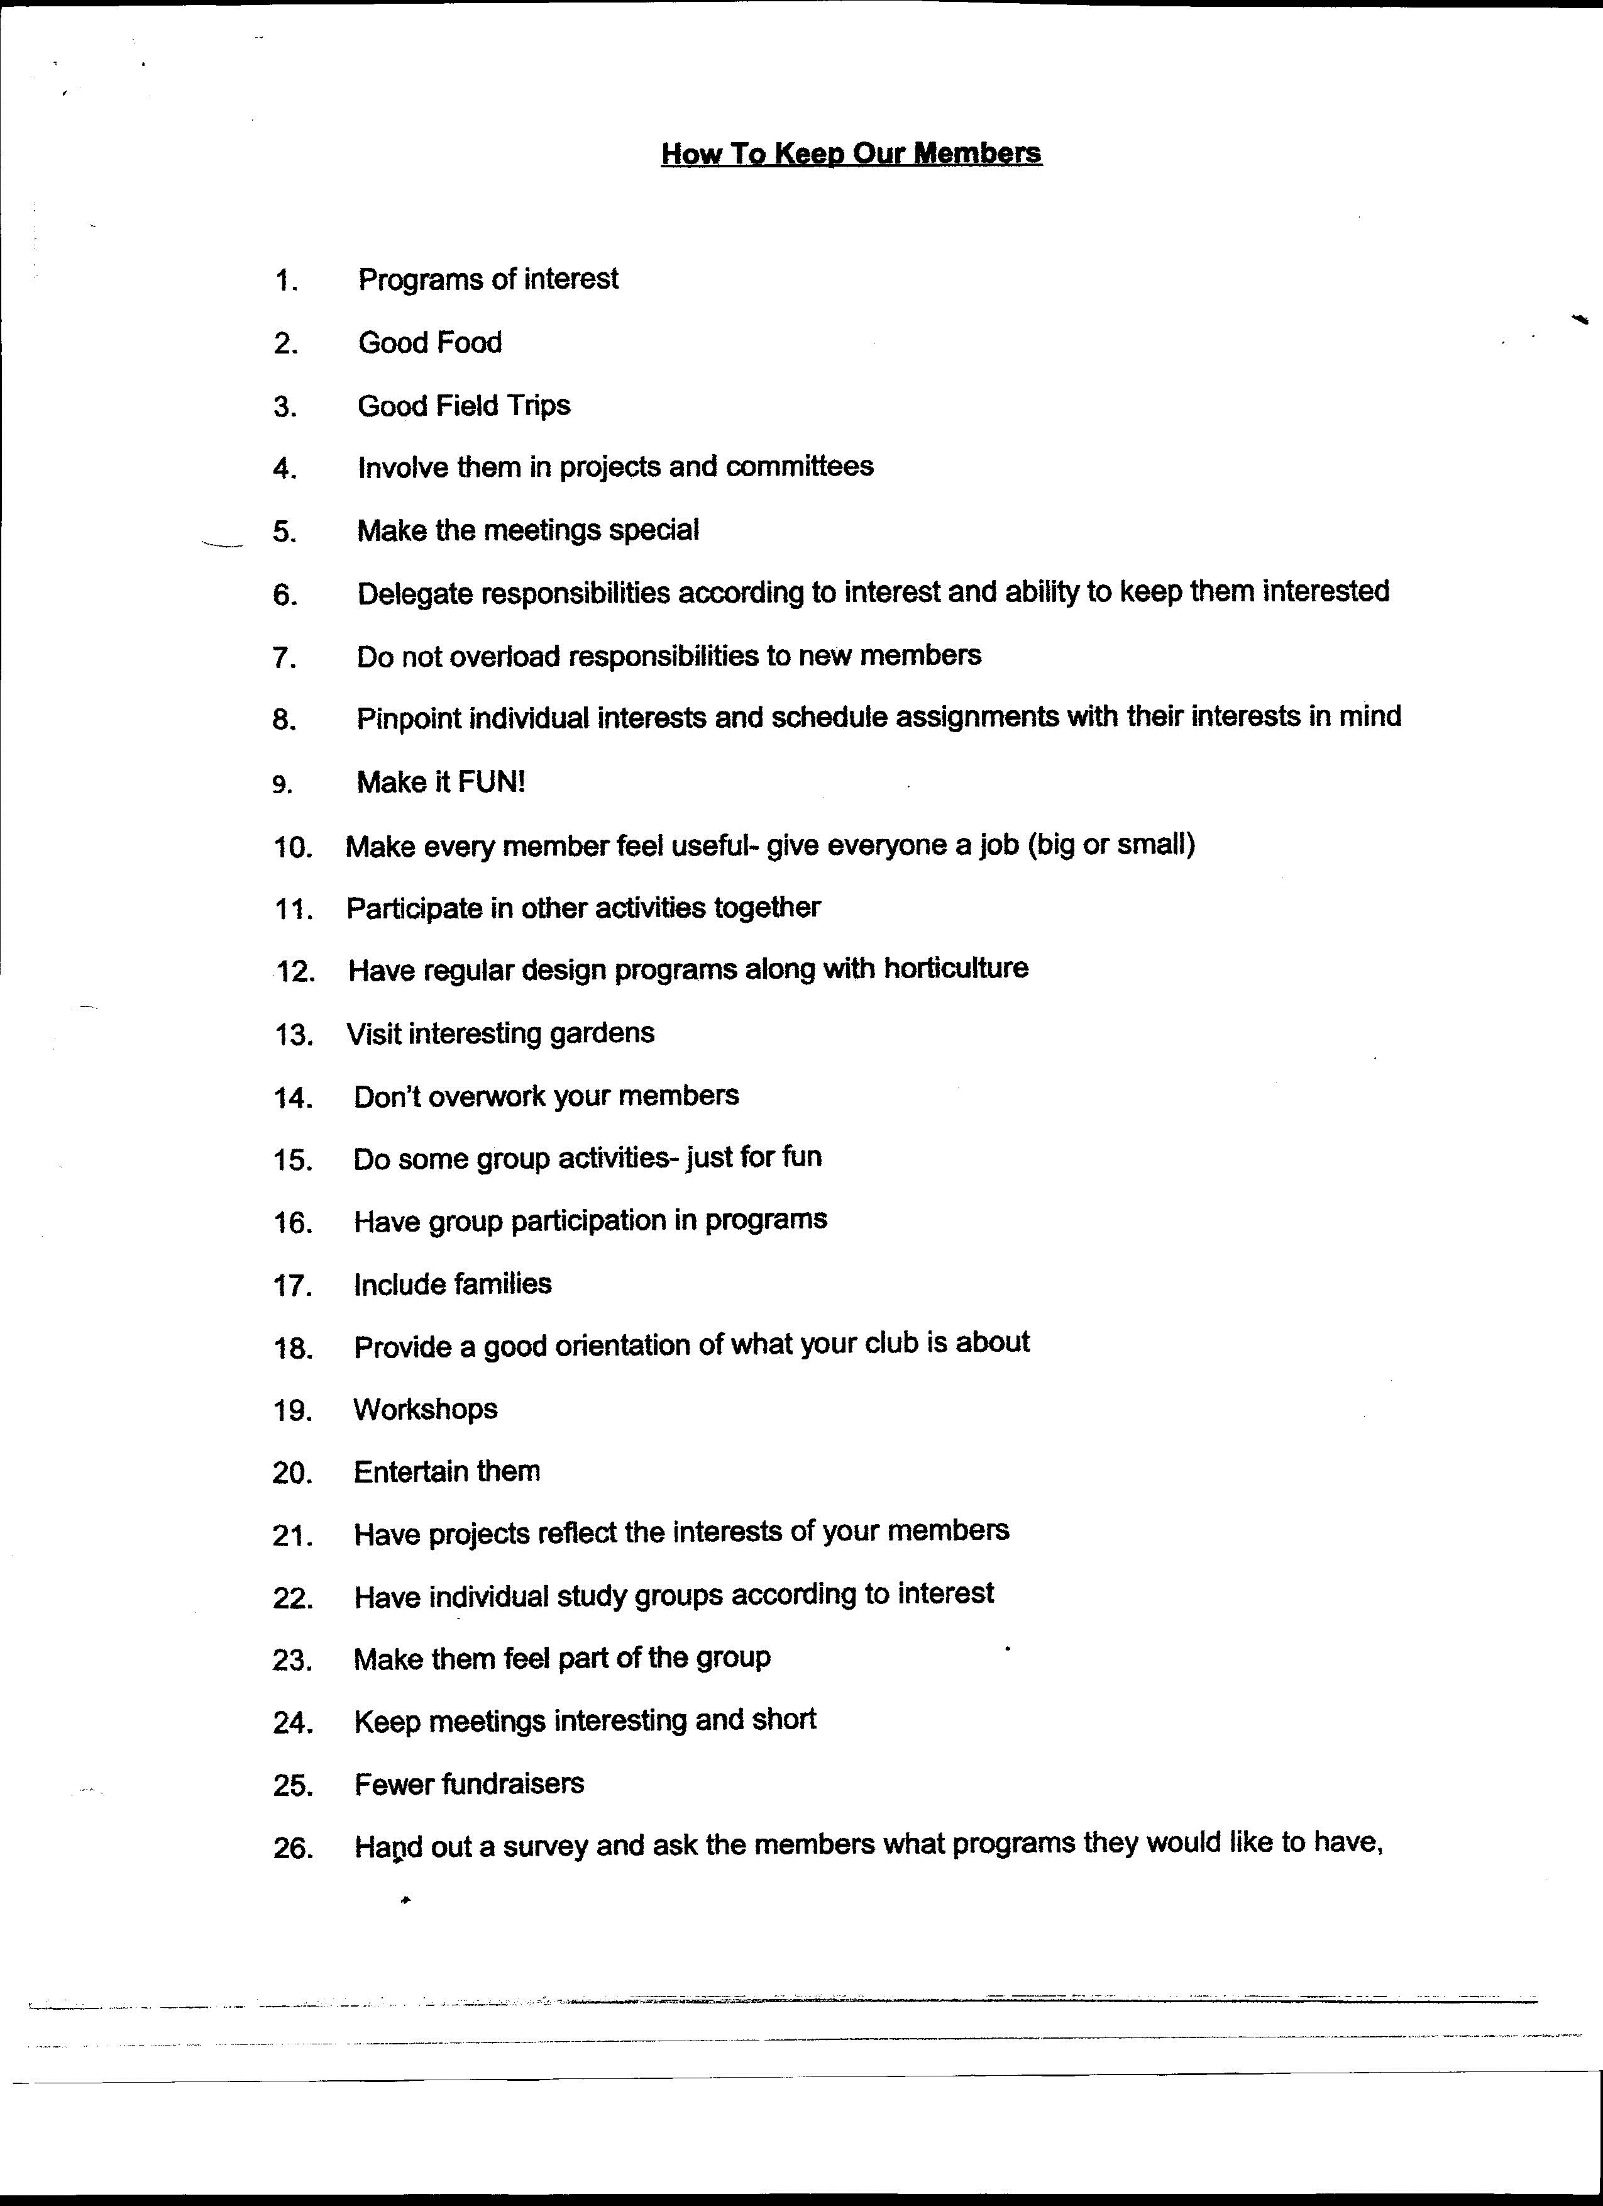
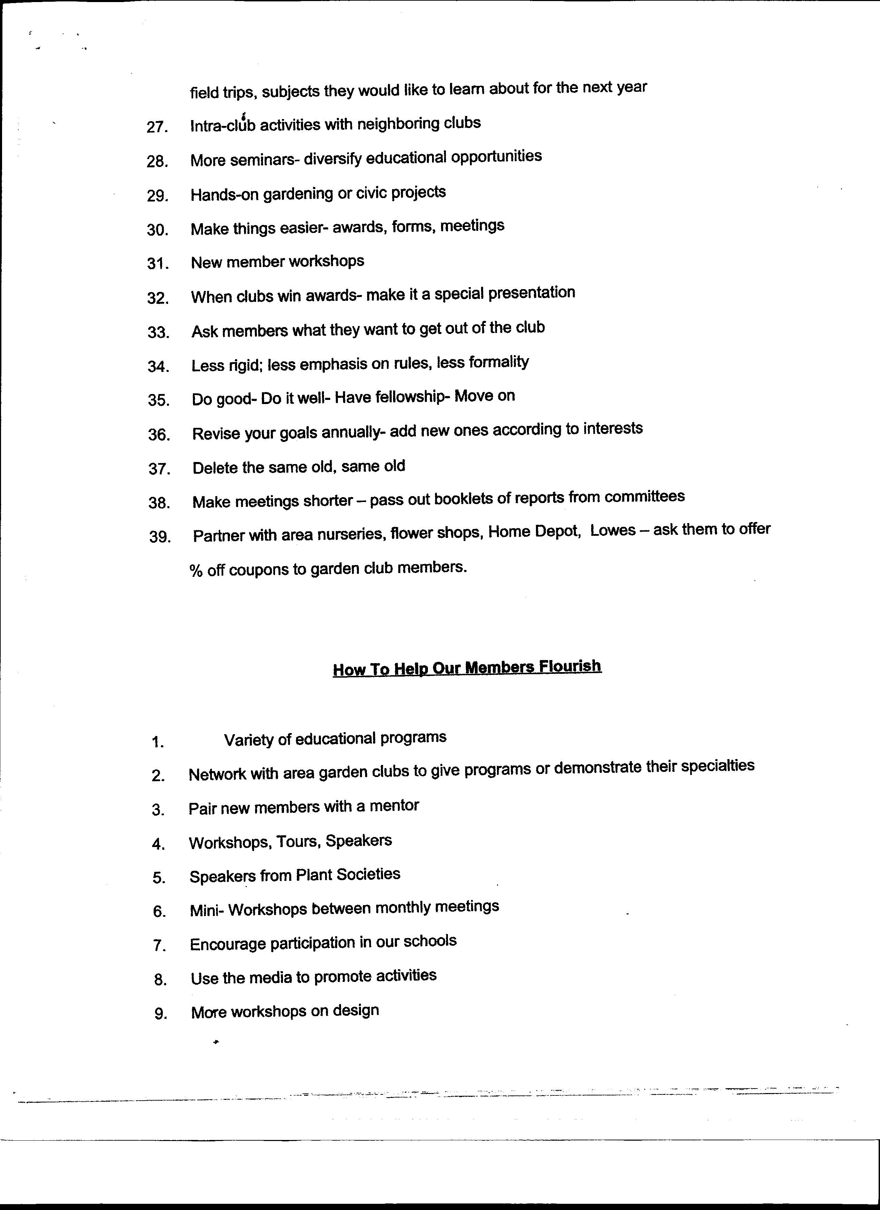
 2022-23 GCSC AWARD APPLICATION
GCSC Award # 43 Award Title: Special Achievement Date Submitted: Dec 9, 2022
Submitting club: Gardening on the Cay
Number of Members in Club: 43 Your club number in the State: 636EP
Contact name, address, email and phone number: Tara Ranson 818 Ryans Place Fort Mill, SC 29715 TDRanson@yahoo.com 803-487-3236
________________________________________________________________________________________
New Project: Yes_____ No__X___ Beginning date: 2012 End date: ongoing
Brief summary and objective of projects:
Gardening on the Cay works to combine our love for gardening and the objectives of GCSC with lots of “hands on” volunteer work to give back to our community. To that end, we partner with other non-profits and civic groups whenever possible to design club projects that best use the talents of our busy members since many in our club are still working. There are several projects (described below) that our club participates in that may not fit into an Award offered this term, so “Special Achievement” is the best category for some of our club’s strongest work.
Gardening on the Cay supports the Fort Mill Care Center (FMCC) year-round through food bank donations, special projects and by maintaining their 120 ft stone flower bed. The Fort Mill Care Center is a non- profit organization that provides food assistance to families in the Fort Mill and Tega Cay communities. At our monthly meetings, Gardening on the Cay collects items for the food pantry and makes monetary donations. In 2022 this committee led the club effort to donate a total of 527 pounds of food and $750 for the FMCC. That included hundreds of pounds of fresh vegetables we harvested from our own Tiny Sprouts Youth Garden Club raised beds late this summer. Our club participation is 100%!
For a December project, Gardening on the Cay partnered with a group of volunteers from The Humane Society of York
County on Nov 30 to fill 375 Christmas stockings and 75 gift coffee mugs for five local charities. This is our “PROJECT JOY”. All the stockings and items were donated by the two groups. Each stocking contained a book, an ornament, a toy, a stuffie, a knitted hat, some candy, and a candy cane. Twelve club members plus 7 other volunteers helped to fill the stockings and mugs. It took about 90 hours of work on this one Christmas project. These will be delivered in midDecember. The committee also maintains 150 ft stone garden planters and decorates the front of the Center seasonally.
Our involvement with Habitat for Humanity of York County continued this year with our signature project, “Habitat
Porch Warmings” for the two new homes built in our county. This is our 10th year partnering with Habitat, and over the years we have “warmed” and helped dedicate 24 porches. Gardening on the Cay purchased and placed two rocking chairs and pillows on each front porch, plus a seasonal wreath and planter were created by club members just for these homes. This project happens seamlessly because a committee of four purchases and stores the chairs each summer and delivers everything for the home dedications when they are scheduled later in the year. Ben Gair, Community Development Director for Habitat of York County, calls our club project “The Icing on the Cake!” and uses it for photo ops.
Involvement of club members and other organizations:
Our commitment to the FMCC requires 100% participation from our club members. We harvested fresh vegetables all summer, donated canned goods at every meeting as well as worked on the 375 Christmas stockings and 75 mugs. Our partnership with Habitat for Humanity is ongoing and averages 2-3 homes per year.

Project expenses and means of funding: Canned goods and all the elements for the Stockings for FMCC are donated by club members. Additional plants and mulch needed for the stone planters are debited from the club treasury, and the committee budget for this is $100. For the Habitat for Humanity Porch Warmings, our club budgets the purchase of 4 rocking chairs, 2 pillows, 2 seasonal porch planters and we make front door wreaths. That committee budget is $300.

Continuing involvement in the project, follow up, or maintenance. These projects are an ongoing JOY to participate in. They are year-round commitments, and both agencies count on our help.

Photos attached:

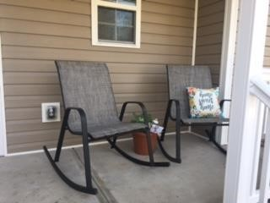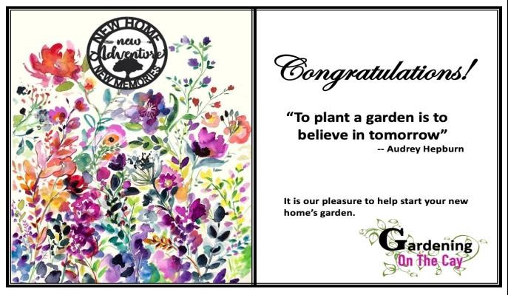

Habitat For Humanity “Porch Warming” Summer 2022. Our “calling card” for each Habitat dedication

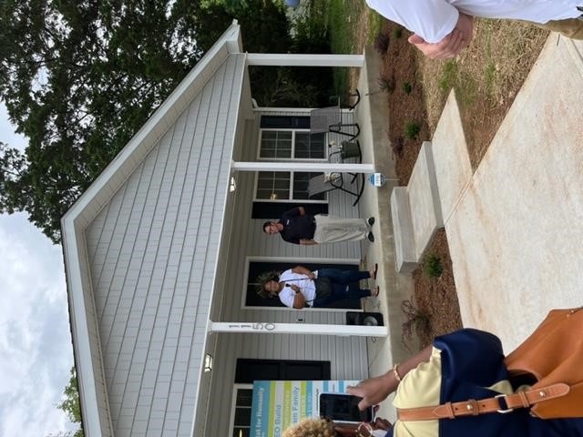

The Fall dedication of one Habitat house with our” Porch Warming” serving as a backdrop.

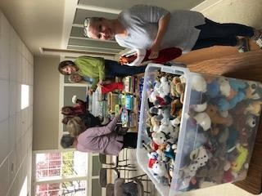

Club members met Nov 30 to build 375 Christmas stockings for local charities.
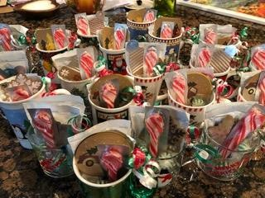

(left) 375 Christmas stockings thrifted, filled, and packed by 12 club members - ready to be delivered in mid-December to various children’s charities.
(right) 75 Christmas mugs for homeless and marginalized adults, filled with coffees, cocoas, teas, and candy.

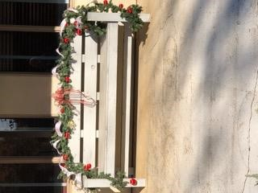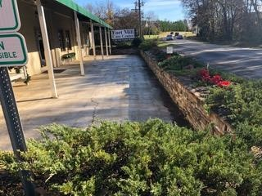

Year round, a small committee in our club maintains the 150 ft stone planter garden in front of the Fort Mill Care Center. The front bench is where the food bank clients wait to pick up their groceries. We decorate the bench seasonally to provide a cheery greeting.

2025-2026 GCSC AWARD APPLICATION
GCSC Award #: ____ Award Title: ________________________________Date Submitted: __________

Applicant Club or Individual name: ________________________________________________________
If individual award, also enter person’s name as it should appear on the award.
Number of Members in Club/Council: ___________ Your club number in the State: _________________

Contact name, address, email and phone number: _____________________________________________
________________________________________________________________________________________
Name of State Garden Club: The Garden Club of South Carolina, Inc., # in State Club-5129
State Awards Chairman, Address, Phone, Email: Michelene Sheehy, 2535West Edgefield, Florence, SC 29501 703-587-4322 © michelene.sheehy@yahoo.com
Instructions: Answer questions #1-6. Delete these instructions from your application
- Application form is limited to the fronts only of no more than three pages
Do not put photos on page 1. You do not have to use all three pages. No report covers, binders or plastic sheets allowed. For electronic submission, fill in this form, save it and then attach to an email.
- Application will not be returned: Print a finished copy for your files.
[exceptions: publications, books, cookbooks, etc. & DVD/CD’s]
Absolute Deadline: December 10, 2023. GCSC Awards Chair must forward entries to NGC by Jan. 15
and to SAR Regional Director to be received by January 25.

Your application will be judged on your answers to the below required criteria. You must answer all.

Use this application form as your first page. Complete each topic using the below numbering system.
1. New Project: Yes_____ No_____ Beginning date: Completion date:
2. Provide a brief summary of your project and your objectives.
3. Describe the involvement of both your club members and other organizations, groups, etc.
4. How was your project funded and what were your expenses?
5. Describe your club’s continuing involvement in the project, or follow up work, on-going maintenance.
6. Attach documentation, digital photos, or copies of letters of appreciation, newspaper or magazine articles
and/or landscape plan or drawings [does not need to be professionally drawn]



THE GARDEN CLUB OF SOUTH CAROLINA, INC. ANNUAL REPORT OF CLUB PRESIDENTS

Report Due FEBRUARY 1
The Garden Club of South Carolina, Inc. sincerely appreciates your hard work, dedication, contributions, participation, and enthusiasm throughout the state to increase our visibility and promote opportunities GCSC offers to benefit others.
Please report your Garden Club activity from January 1-December 31 Make three (3) copies and submit via mail/email to:
- GCSC President
- Your District Director
- Your Club/Council files

Name of Club:
GCSC Club # City:
District: Number of DUES paying members: Year Organized: Year of GCSC Federation:
CURRENT CLUB INFORMATION:
President:
Address:
Phone number: Email:
Vice President:
Address:
Phone number: Email:
LENGTH of President’s Term: Installation date (month/year):

Sent Club Roster and dues check to GCSC Treasurer treas.gcsc@gmail.com Y/N: ___
Members gained this year: _________ Members lost this year: _________
List names of deceased members during the last year:

List number of members attending the following: N/A for Councils

 | Spring District Meeting |  | GCSC State Meeting |  | SAR Convention
 | Summer EXPO |  | GCSC Convention |  | NGC Convention

Do you visit the GCSC Website: Often: Occasionally: Never:
Is the Website easy to navigate: yes: no:
Check the following that your Club/Council used for meetings/projects/events: Please check all that apply

 | Arbor Day/Trees |  | Conservation |  | Litter Control/Recycling
 | Backyard Wildlife Habitat |  | Floral Design |  | Memorial Garden
 | Birds |  | Flower Show |  | National Garden Week
 | Bees/Butterflies (pollinators) |  | Garden Therapy |  | Native Plants
 | Blue Star Memorial |  | Girl Scouts |  | Plant It Pink
 | Camp Wildwood |  | Historic Preservation |  | Roadside Beautification
 | Civic Development |  | Horticulture/Gardening |  | Youth Activities
 | Other: Environmental Studies
Number of Club/Council members having or participating in the following: Please check all that apply

 | Backyard Wildlife Habitats |  | GCSC Life Membership |  | GCSC Logo Sales
 | Landscape Design School |  | SAR Life Membership |  | GCSC Awards
 | Flower Show School |  | NGC Life Membership |  | GCSC Board of Directors
 | Judges Club |  | NGC Calendars
 | GCSC Tours |  | Grants
Does your Club/Council donate to the following: Please check all that apply
 | Camp Wildwood |  | State Scholarships |  | Five Star Honor Clubs *
 | Memorial Garden |  | District Scholarships |  | State Christmas Tree
 | President’s Projects Fundraising |  | GCSC Charitable Giving/Bequests
* Five Star Honor Clubs Project supports the following GCSC programs and projects: Blue Star Memorial, Camp Wildwood/Youth Awards/Celebrations, GCSC Headquarters, Memorial Garden. and State Christmas Tree. GCSC distinguishes Clubs/Councils that donate a minimum of $200 to the Five Star Honor Clubs Project with their name placed on the Five Star Plaque displayed at State Meeting and Convention and listed in the SC Gardener.

Please respond to the following questions on the back or separate page and attach photos for both the best program and best project.:
1. Identify your BEST PROGRAM and provide a detailed, three or more paragraph description of the program.
2. Identify your Garden Club’s MOST OUTSTANDING PROJECT and provide three or more paragraphs describing the details of the project.
3. Identify any way to improve GCSC.

