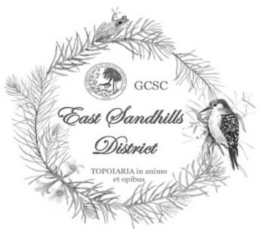

THE GARDEN CLUB OF SOUTH CAROLINA, INC.
EAST SANDHILLS DISTRCT

Invites you to attend the

2026 DISTRICT MEETING
“Blooms and Butterflies”
DATE: | March 3, 2026
LOCATION: | Freshwater Ecology Complex
 | 3742 N. Williston Road
 | Florence, SC 29506
COST: | $30.00 per person
RESERVATION DEADLINE: February 14, 2026 – no refunds after that date

GUEST SPEAKERS: Blake Mischu, Horticulturist, Moore Farms Botanical Garden

Gregory Pryor Ph.D., Professor of Biology will share his experience Modern Homesteading

AGENDA
 | 9:00 - 10:00  10:00 - 12:00  12:00 - 12:15  12:15 - 1:00  1:00 – 1:20  1:20 – 1:40 1:40 – 1:50 | Registration/Coffee Hour/Vendor Sales  Business Meeting/Guest Speaker  Break  Lunch/Vendor Sales  Second Speaker  Awards  Door Prizes  Adjourn
2026 EAST SANDHILLS DISTRICT MEETING
REGISTRATION FORM

NAME: PHONE:

EMAIL ADDRESS:

CLUB: _______________________________________________________________

CITY: ________________________________________________________________

Please reserve ___________ tickets at $30.00 each Total ____________

If registering for more than one person, please list the name, the above information, and status/title as listed below for each additional person on the back of this page.

PLEASE CHECK ALL CREDINTIALS THAT APPLY BELOW:

____ State President Former State President (year) _
____ State Officer (position) ______
__ State Chairman (position) ______
____ District Director (district) ________ _____ Assistant District Director (district) _________
___ Council President (council) ___________
___ Council Officer (position) ______
_ ___ Club President (club) __________
____ Club Officer (position) ______
___ Other (explain) __________

Will you be giving a report _____Y _______N
~~~~~~~~~~~~~~~~~~~~~~~~~~~~~~~~~~~~~~~~~~~~~~~~~~~~~~~~~~~~~~~

Please make check payable to: Florence Garden Club Council – in memo line write District Meeting
Mail check and registration form to: Florence Garden Club Council, c/o Terri Brown Registrar, 459 Edenderry Way Florence, SC 29501
Phone Number: 843-601-1721
Terri Brown email address: Teresa.s.brown@gmail.com

NEARBY ACCOMODATIONS:
Exit 160, I-95 – Fairfield Inn, Homewood Suites, Home 2 Suites, Courtyard Marriott, Aloft Florence, Springhill Suites, Hilton Garden Inn, Residence Inn Florence
Exit 170, I-95 – Holiday Inn Express & Suites

