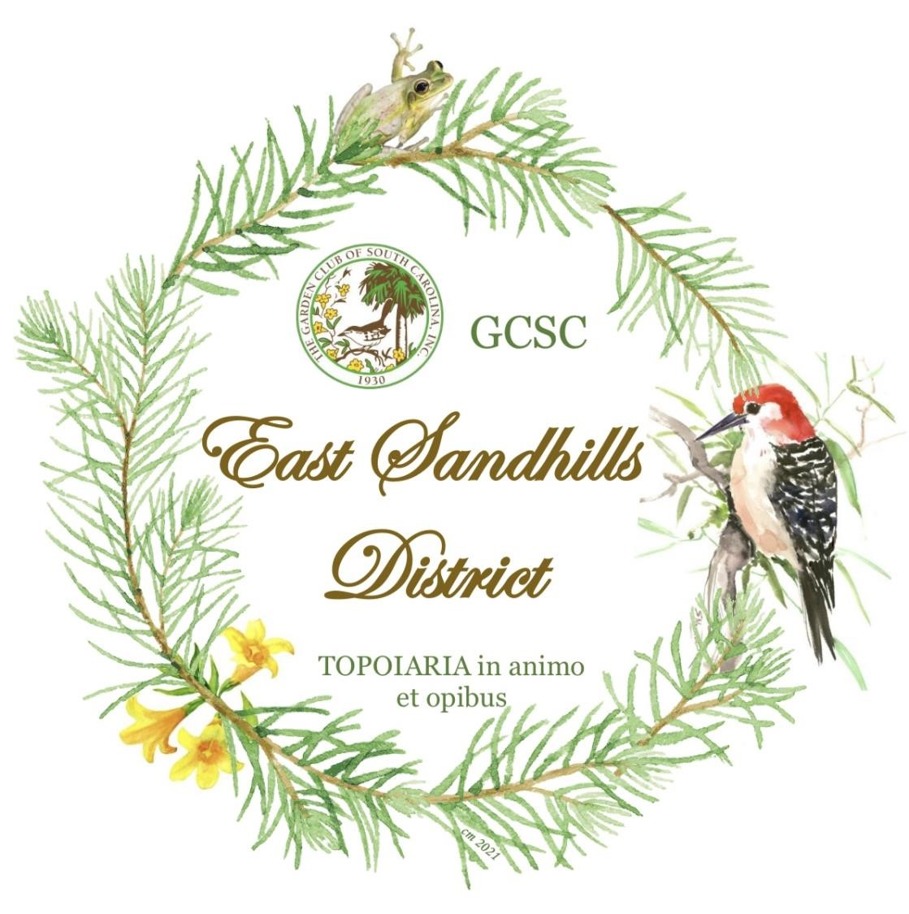

East Sandhills District

District Meeting Handbook

2023
-
- 2025 2025

““
“Creating a Heritage Through Gardening”

GUIDELINES FOR A SUCCESSFUL DISTRICT MEETING
Planning A District Meeting: as soon as you take office in the odd-numbered year, procure/assign responsibility for the next year’s District Meeting. Sometimes, the outgoing District Director may already have done this or your District may use a rotation schedule. It’s better if you do have a rotation schedule and move from one area to another within your District. This provides variety, spreads the responsibility around your district, and the clubs/councils have some idea when their turn will come up. If you have a garden council in the area where the Meeting will be held, this is ideal because they can coordinate club responsibilities within their council. The next best scenario is a large garden club; they can take the lead and seek assistance from smaller clubs in the area. If this isn’t possible seek out smaller area clubs that can work together. Establish who the Meeting Chairman will be as soon as possible.
The first Fall after taking office – September preferably – ask for an initial face-to-face meeting with the Meeting Chairman and whoever else may need to attend. Provide them with the District Meeting Chairman Information packet and start the planning process. If the meeting place has been suggested, try to visit it at that time or as soon as possible. You should definitely see and approve the event space. Be in communication with them over the next few months and then schedule another face-to-face meeting in January. By this time, you should have approved the event space, the meeting them, the workshops and the guest speakers. The District Director or the hosting group can create the Call Letter and Registration packet from the approved template. After the District Director has approved it, she will submit it to the GCSC President or designee for their approval. This should be done by the end of January. Once it is approved, the District Director will send it out to all Club Presidents for distribution to their members or, hopefully through our GCSC system, directly to all district garden club members.
It is important to promote the event! First send out a “Save the Date” flyer and put it on your District Website. Then when the Call Letter and Registration Packet is ready, it should be sent out the best way that is possible as mentioned above. After it has been sent out to your district club members, please ask to have it sent to all Board of Directors and placed on your District Webpage. If you can, promote and advertise by having it put on any club/council websites or Facebook pages. Utilize the value of social media to its fullest!
If other meetings are needed, please schedule them or attend if it’s requested by the Meeting Chairman.
District Directors please make is a point to send an invitation to our Sate President who will be planning to attend, but it’s a nice touch to receive a personal invitation!
If you are not experienced at planning events, one of the best ways to have a successful meeting is to attend other GCSC events. Visit other District Meetings whenever possible and/or attend the GCSC State Meetings/Conventions.
The District Directors Sets the Tone for the Meeting!
Please keep the Meetings Moving and be mindful of everyone’s time!

Head Table: See “Seating the Head Table According to GCSC Protocol” document which is attached. After determining seating at the Head Table, notify the Sign Chairman for the meeting so that place cards can be made and placed. Their name should be on the card facing them and on the other side facing the audience. Anyone who has a part in the Program would be seated at the Head Table according to the attached protocol. It is not necessary to provide Head Table seating for all other State Officers that are attending the meeting, except for the Chaplain if she has a role in the Program.

Honor Table: It is important to have one or more Honor Tables up front for Former GCSC Presidents, Former SAR Director, Former District Directors, State Officers and State Chairmen. The Pages need to sit at the Table immediately in front of the GCSC President and the District Director so that they can respond to them quickly. The Timekeepers will also need to be at a table in the front row by the microphone used for reporting.

Before the meeting begins, the District Director asks the Registration Chairman for a list of former Presidents, former District Directors, and visiting District Directors that will also need to be introduced. It is a courtesy for the District Director to send a note or email to those being seated at the Head Table and the Honor Table saying you are pleased that they will be with you and you have an assigned table for them.

If there is more room, you may seat the person issuing the Invitation to the next District Meeting.

The Welcome: The Meeting Chairman gives the Welcome. If a Minister or Mayor has been invited to issue a Welcome, then the Meeting Chairman introduces that person at this time.

Introductions: The Honor table attendees should be introduced first and then the Head Table. The District Director “presents” those seated at the Head Table. The GCSC President is introduced last. She/he is introduced as she/he is to address the meeting attendees.

MOST INPROTANT!!! When you PRESENT the Head table ALWAYS start with those seated to YOUR FAR LEFT, then present those seated to YOUR FAR RIGHT, ending with “and now please stand and welcome our GCSC President ___(NAME)_________ . The GCSC President will then report.

It is good Public Relations for your District to ask first-time District Meeting attendees to stand and receive welcoming applause.

Sound System: A good sound system is vital to your District Meeting. If possible have a second microphone set up away from the head table for the visiting Chairmen or other persons to use. Most churches or city buildings have sound systems available. ALWAYS test the system prior to your meeting.

Program Information: Ask to see a proof or draft BEFORE the Program is printed. You will be more familiar with what information should be included. Another set of eyes is always appreciated! If any corrections need to made to the Program, those corrections will need to be announced at the beginning of the Meeting.

The following information should be included in the Program:
- GCSC President, District Director and Assistant Director’s addresses, phone numbers and email information. Please include the GCSC President’s theme and the District Director’s theme.
- Schedule of Events
- Business Meeting Agenda
- Chairmen and clubs Hosting Meeting – Please include the Meeting Chairman’s address or anyone else to whom a thank you should be written. You may also like to place these names and addresses on the back of the Program. The GCSC President will send a thank you to anyone listed.

Timekeepers: Timekeepers are highly recommended. There should be two. One who watches the clock and one who rings the bell. The District Director may explain that in order to keep the meeting on time and in consideration of everyone, reports are limited to two minutes. If a speaker has gone over the allotted time and continues to speak after the timekeeper signals, it is acceptable for the District Director to stand and thank the speaker as an additional signal to wrap it up.

Meeting Agenda: It is helpful to have an agenda in front of you to move the meeting along. It is suggested that every District Director have a written agenda and be as organized as possible. A scripted agenda will be a lifesaver! Actually, write down everything to follow on the day of the meeting. Include all your introductions of attendees, dignitaries, guests and speakers. “A sample District Meeting Format is included in the Handbook.

Vendors: If you decide to provide vendors for your meeting, some thought should be given to how many and the fee to charge for the space. If there is space available, this can be a source of income to offset the cost of the meeting. There should not be more than 10 vendors because if you have too many, the vendors may not make enough money to justify the vendor fee. Also, consider the space available. They should be limited to a 6 foot banquet table per fee and allow a three foot minimum between tables for each vendor. The fee to charge should be in the $30-$50 per table range or some combination thereof. For example, if your fee is $50.00 and a vendor want two tables, you might give them a break by charging two tables for $75.00 instead of $100.00. Do not make the table fee too low unless you are having trouble finding vendors. Usually, the better more experienced vendors are willing to pay $50.00 per table. In the case of craftsmen, many of them will get follow-up orders after the event is over. This is something that is flexible according to each meeting and what special circumstances may exist. Let the hosting club(s) make the final decision because they are responsible for the budget, keeping the ticket cost as low as possible, and not losing money! You are there to guide them, especially if they don’t have experience with event planning. Always require a written vendor contract with payment in advance and no refund if the vendor needs to cancel. The Vendor Contract is included in the Handbook. If garden clubs and/or councils wish to do fundraising at the District Meeting, they should enter into a vendor contract if they will require a table to sell from.

You may provide a courtesy table for clubs to put flyers out to advertise an event. They can sell tickets at the meeting but not from a table unless they have paid a vendor fee.

.
SEATING THE HEAD TABLE ACCORDING TO GCSC PROTOCOL
To get this right you are standing at the head table FACING THE AUDIENCE, the American flag is on the RIGHT of the podium. The GCSC flag is on the LEFT of the Podium.
A comfortable number to have at the head table is usually eight people seated as follows:
To the RIGHT of the Podium: Presiding Officer/District Director
To the RIGHT of the Presiding Officer: GCSC President
To the RIGHT of the GCSC President: GCSC First Vice President or Speaker
To the RIGHT of the Speaker: the person who will introduce the speaker
To the LEFT of the Podium: Assistant District Director
To the LEFT of the Assistant District Director: District Meeting Local Chairman
To the LEFT of the District Meeting Local Chairman: Local Co-Chairman
To the LEFT of the Local Co-Chairman – Mayor or honored speaker, if she/he leaves right after he/she speaks make sure to fill the seat with another honored individual

DISTRICT MEETING FORMAT

The business meeting may be held in a separate room or the same room where the luncheon will be served. Space is required for the following:

Registration Table near the entrance
Vendor space (the number may depend on the space allotted)
Workshop Area
Space for the Design and Horticulture Coordinators

The schedule for the spring district meeting will be as follows:

9:00 a.m. – 10:00 a.m. Registration, Hospitality, Vendor Sales
9:15 a.m. – 9:45 a/m/ Workshop(s)
Meet the President – It would be nice to have a special room or area for the GCSC President to meet with the Club/Council
Presidents for an informal get together.
10:00 a.m. – 12:00 p.m. Business Meeting – Elections, Horticulture Program, Reports,
Speaker, and possibly some of the District Awards
12:00 p.m. – 12:15 p.m. Break
12:15 p.m. – 1:00 p.m. Luncheon
1:00 p.m. – 2:15 p.m. Design Program, Announcements, Remainder of District Awards, Door Prizes,
Adjournment

CREDENTIALS REPORT

______________________________________ District Meeting

_________________________________________ Meeting Theme

__________________________________________ Date

I have the following to report:

___________ Registrations

___________ Garden Clubs represented

___________ GCSC President

___________ Former GCSC President(s)

___________ GCSC Officers

___________ GCSC Board Members

___________ Current District Directors

___________ Former District Directors

___________ Club/Council President

DISTRICT MEETING CHAIRMAN INFORMATION

The local Meeting chairman will need the following chairmen and/or Committees to help coordinate and plan the District Meeting. Hopefully, it is a time to work together “on a project” and get to know members from other garden Clubs. Some of the duties may also be combined. The list of Chairman includes these committees:

- Meeting Co-Chairman
- Cleanup
- Decorations
- Dorr Prize/Favors
- Hospitality (Coffee Hour)
- Nametag/Place Cards
- Pages/Timekeepers
- Program/Call Letter
- Publicity
- Registration
- Signage
- Vendors

Meeting Chairman/Co-Chairman: The hosting club(s) should have already been picked by the outgoing District Director from the rotation list in your District. If the Meeting Chairman or Co-Chairman have been selected, one of them should have presented the Invitation to the District Meeting at the meeting prior to the one they are Chairmen. The District Director and the host club(s) chooses the site, theme, and program.

Present the Invitation to the District Director by January 1st. The Meeting chairman will appoint the other chairmen from the host clubs. He/she will appoint chairmen to fill the necessary chairmanships for the meeting. It is helpful to spread out the duties among the host clubs, so all feel part of the meeting.

Cost of Meeting: The District Meeting is not intended to be for profit, just cover the expenses for the meeting. The cost depends on the cost of meal and any charge of the meeting facility. Hopefully, all other expenses will be donated by the Host clubs, i.e., table designs, nametags, etc. Try to keep the cost of the meetings around $30.00. The District Director and the GCSC President are guests and do not pay for lunch or require a Registration Form. Don’t forget to add them to your Registration and Nametag Lists.

Cleanup: Depending on the facility where the meeting is held, this may not be necessary. It may be minimal or extensive depending on the location.

Decoration Chairman: This chairman should have a committee to work with her on the table arrangements and additional decorations reflecting the theme for the meeting. The table arrangements may be sold to offset expenses or given as Door Prizes.

Door Prizes Chairman: Door prizes are always a nice touch and appreciated, but not required. Sometimes the arrangements on the tables are given as door prizes. Door prizes are given out at the end of the meeting. Think of a clever way to award door prizes that does not require very much time, e.g., a colored dot on the program or nametag or call out registration numbers.

Hospitality Chairman: This chairman arranges the Coffee Hour during the registration. If the meeting is being held at a Country Club or a location that prepares food, generally, this is arranged with the facility. If the meeting is being held at church or location where food may be brought in, it is nice for one club to provide light refreshments and a choice of coffee, water, and juice.

Nametags/Place Card Chairman: This chairman will work closely with the Registrar during Registration to see that all attending have a nametag. It is always a good idea to have several extra blank nametags to use for those that come and have not registered. She will need the list of members sitting at the Head Table to make the Place Cards and the list of those registered to make the nametags. The place cards should have the name on both sides – front and back. The audience needs to see the names of those sitting at the head table as well as sitting at the head table need to see their name so they will know where to sit.

Pages/Timekeepers Chairman: It is helpful to have a page for the GCSC President and the District Director. Additional pages may be needed for a guest speaker and or workshop presenter.

It is helpful to have two timekeepers. State Officers, with the exception of the President, are allowed three minutes to report. State and District Chairmen are allowed two minutes to report. It is helpful to have one timekeeper stand when 30 seconds remains for a report and a bell or timer to ring at the end of the allotted time.

Program Chairman: The Program Chairman is responsible for designing and printing the program for the meeting. The chairman will work with District Director and Meeting Chairman on the theme, format and information. If you wish to coordinate the theme of the meeting in the signage, nametags and program, also check with the appropriate chairman. The program should include the date, place and title of the meeting on the front cover. Include the name and theme of the GCSC President and the District Director. It should also recognize the meeting chairman, hostess clubs, and any other entity or individual making a contribution to the meeting. This chairman is also responsible for completing the call letter.

Send a rough draft to the District Director for any editing and then for approval before printing the final version. The Registrar can provide the information for the number of programs needed.

Publicity: Depending on the circumstances, the duties may be flexible. It may require creativity, computer/social media skills and writing/photographic skills. An example might be to take phots and write an article for The South Carolina Gardener magazine.

Registration Chairman: This chairman receives the registration forms and money for the meeting. Keep an accurate list of the names, contact information, credentials, and amount paid. The forms will include the information for the Credentials Report to be given during the meeting. After the deadline date, provide the District Director and Nametag/Place Card Chairman with a copy of those registered with their credentials. Especially provide the district director with the names of Past Presidents and Past District Directors (to your district only) that will be attending the meeting.

The Registration table (s) should be set up in a spacious, prominent location near the entrance. Provide plenty of space for the nametags. Arrange nametags for State Officers and State Chairmen on one side of the table with Club/Council Presidents and Club Members on the other side. Signage is helpful in designating the areas.

Sign Chairman: Signage is needed to direct attendees to the event, front door, Registration Table, Vendor area, Workshops, and Restroom facilities. Also mark reserved parking places near the front entrance for the GCSC President and District Director.

Vendor Chairman: This committee will find vendors and secure contracts with them.

SAMPLE AGENDA FOR BUSINESS PART OF DISTRICT MEETING
(For the District Director’s Script and Program Only)

This is a format for the District Meeting Program. Please write yourself a script to follow, especially when you introduce the head table, so there will not be any mistakes.

Call meeting to order District Director
Invocation Church Pastor or Appointed Club Member
Pledge of Allegiance Appointed Club Member
Pledge of Allegiance to GCSC Flag Appointed Club Member
Welcome City official, introduced by local chairman
Presentation of Honor Table District Director
Presentation of Head Table District Director
GCSC President is introduced last as he/she will report at this time District Director
Report of District Director District Director
Business Meeting Called to Order District Director
(any voting should occur at this time)
Reports of GCSC State Chairmen, District Chairmen (2 min) District Director
Introduction of Guest Speaker Assistant District Director or Local Chairman
District Awards * Assistant District Director
Credentials Report Registrar
Break/Shop with Vendors
Blessing and Lunch Instructions Church Pastor or Appointed Club Member
Lunch
Design Program (usually during lunch or dessert) Local Chairman
Second Half of District Awards Assistant District Director
Door Prizes Local Chairman
Adjournment

*If there are a large number of Awards to be given, consider dividing them between the morning and afternoon to keep the meeting moving and interesting. For example, give the Presidents’ Reports and Yearbooks in the morning and the competitive club awards in the afternoon. A secondary benefit of dividing up the awards is to help ensure that attendees stay until the end and do not leave early.
The Call Letter should only be one page. The Registration Form should be page two, directions page three.
Space is required for the following:
Registration table near the entrance
Vendor space (including GCSC Logo sales)
Workshop area if you are having one
Design Program
GCSC Projects/Fundraisers if requested by President of Chairman

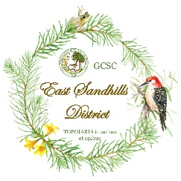
East Sandhills District Meeting 2022
Vendor Space Registration Form
March 24, 2022

Meeting Location: FMU - Freshwater Ecology Conference Center and Laboratory, 3742 N. Williston Road, Florence, South Carolina

Theme of Meeting: "Onions, Carrots and Peas, Oh My; Farm to Table, Let's Grow”

Vendor Space: $30.00 (includes one 8’ table, per space)
$10.00 for any additional tables needed

Registration Deadline: Monday, February 28, 2022 (Priority given as received)

Vendor Contact (Chairman):

Phone: Email:

(please cut and attach with payment)

Name of Vendor: ______________________________________________________

Address: ___________________________________________________________
____________________________________________________________

Phone: ____________ Email: ________________________________________

Brief description of items to be sold: ____________________________________

Additional Tables Needed for your Vendor Space: _______ ($10.00 per each additional table)

Total Amount of Vendor Space Payment: ____________

CONDITIONS:

- Indemnity: The undersigned herby agrees to indemnify and hold harmless the Garden Club of South Carolina, Inc., its hosting district, hosting Council and its participating Garden Clubs, and/or the hosting establishment from any claims, actions, liabilities, and expenses caused by or arising from any act or omission of the undersigned. NO refunds will be issued.
- Vendor space to be set up by 9:00 am on day of meeting, Thursday, March 24, 2022, and remain open until close of meeting. Vendors are welcome to set up their space the day before the meeting date on Wednesday, March 23, 2022, from 9:00 am – 4:00 pm.
- An 8’ banquet table with black table cloth will be provided for all registered vendors. For the use of any additional tables there will be a charge of $10.00. Please indicate if there are any additional tables (with table cloth) needed for your vendor space.
- A lunch and refreshments will be provided for each Vendor.
- Vendors are responsible for removal of all litter and unwanted items.
- Please make checks payable to: ____________Garden Club (this club is the registrar for the East Sandhills District Meeting – 2022)
- In your Memo or For line please indicate: VENDOR
- Please send this registration form and check to:

_______________ Garden Club
East Sandhills District Meeting
%– Vendor Chair
Street
City, State Zip Code

I have read and agree to the conditions as listed above.

Signature: ____________________________________________________

Date: ________________________________________


THE GARDEN CLUB OF SOUTH CAROLINA, INC.
2021 - 2023
Let’s Grow, South Carolina

The Council of Garden Clubs of Sumter, Inc. invites you to the

East Sandhills District Meeting
“Growing the Future”

Date: Tuesday, March 21, 2023

Location: First Baptist Church 107 East Liberty Street Sumter, SC 29150

Cost: $30.00 per person

Reservation Deadline: March 7, 2023

Schedule: 9:00 - 10:00 am Registration, Hospitality, Vendor Sales
10:00-12:00 Business Meeting
Speaker
12:00 - 12:15 Break
12:15 Lunch
Flower Show Design Presentations
Awards
Door Prizes
Announcements
Adjournment

REGISTRATION FORM

East Sandhills District Meeting
Tuesday, March 21, 2023

Name_____________________________________________________________

Phone_______________________ Email________________________________

Club__________________________________City__________________________________

Please reserve ____ tickets at $30.00 each Total__________

Make check payable to The Council of Garden Clubs of Sumter, Inc.

If registering for more than one person, please list the name, the above information and status/title for each additional person on the back of this page.

Registration deadline: March 7, 2023 No refunds after March 7, 2023

Mail registration form and check to: Designated Registrar
Street, City, State, Zip Code

Please advise of any dietary restrictions_________________________________________

Please check your current status/title:
_____State President _____Former District Director
_____State Officer _____Former State President
_____State Chairman _____Council President
_____District Director _____Club President
_____District Assistant Director _____Club Member
_____Visiting Director _____Guest

Will you be giving a report? _____Y _____N

Hotel accommodations:
HYATT PLACE SUMTER/DOWNTOWN 18 North Main Street, Sumter 29150 hyatt.com
TRU by HILTON 2607 Broad Street, Sumter 29150 hilton.com

DIRECTIONS

From Florence via I 95 S: Continue to Exit 135. Turn Right onto US 378 W.
Exit Left onto SC 763 S to Sumter.
At triangle intersection with Business US 76, turn Left onto East Liberty Street.
Destination is on the Right.

From Columbia via US 378 E/US 76 E: Continue on US 378 E. Turn Right onto Patriot Parkway at traffic light at McDonald’s.
Make a slight right turn onto SC 204/Loring Mill Road (just past Willie Sue’s restaurant.)
Turn Left onto Hwy 763 N/Wedgefield Road (Food Lion will be on the left as you turn.)
Turn Left onto Liberty Street past Food Lion.
Cross Main Street (see Fountain).
Destination is on the Left.
