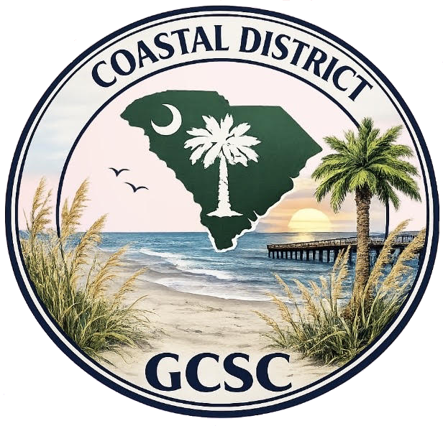
2025-2027 COASTAL DISTRICT APPLICATION FOR
DAVID E. STOUDENMIRE, JR. LEADERSHIP AWARD

Coastal District Award #: Award Title: Date Submitted:
Coastal District Awards Chairman: Juanita Burnett JCEEBRZ@gmail.com
202 Magrath Ave
Conway SC 29526
Applicant Club and Individual name:
Enter the nominee’s name as it should appear on the award.
Certificates will NOT be reprinted. All award applications submitted become the property of GCSC, INC. and/or Coastal District to be used on social media, the Internet, etc. to promote GCSC, Inc. and the Coastal District.
Number of Members in club/council: Your club number in the State:

Club contact’s name, address, email, and phone number:

Name of State Garden Club: The Garden Club of South Carolina, Inc.

Instructions for submission: Address topics below. Delete these instructions from your application.
●Application form is limited to the front only of no more than three pages
You do not have to use all three pages. No report covers, binders, or plastic sheets
●Submission: Please mail 3 hard copies of each award to Juanita Burnett; also send an electronic submission attached to an email to JCEEBRZ@gmail.com. In the subject line, add the name of your club and the award number/name. The application will not be returned: Print a finished copy for your files.[exceptions: publications, books, cookbooks, etc. & DVD/CDs]

Absolute Deadline: February 1

Your application will be judged on your answers to the required criteria below. You must answer all.
Use this application form as your first page. Complete each topic using the below numbering system.
Provide evidence of the nominee’s leadership and character traits:
1. Ability to communicate well
2. Ability to motivate their team/group through positive communication
3. Ability to build trust and camaraderie among others
4. Ability to delegate and divide the work
5. Integrity and self-awareness
6. Organizational skills
7. Encourages leadership in others
8. Show gratitude to others for participation
9. Documentation: Supporting data (as applicable), clear, well-labeled, and neatly attached: photographs, letters of appreciation, community awards, newspaper/magazine articles (if possible), radio or TV script (if possible), etc. Photocopies are permitted.

